Primary 2 Homework Tuesday 24th October
P1/2 W will have Outdoor Learning on Wednesday 25th October.
Common Words | Please try to read and spell all common words daily. (did, and, are)  The spelling activity grid in each homework folder will give you some ideas.
Phoneme Strips | 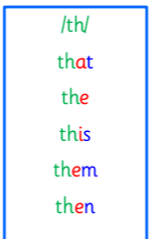  Please try to read and spell all phoneme words. This week we will be finding out about “th” sound  Please try to say the sound and show the action for each sound.
Reading Book(s) | Try to read your book daily.  Please use the Active Reading mat to ask your child questions about their reading book.
Numeracy | Develop your ability to find numbers in between 0-20. Choose find a number and click the In Between 1-100 option.  https://www.topmarks.co.uk/learning-to-count/helicopter-rescue  or use this QR code  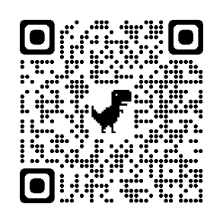
Challenge | 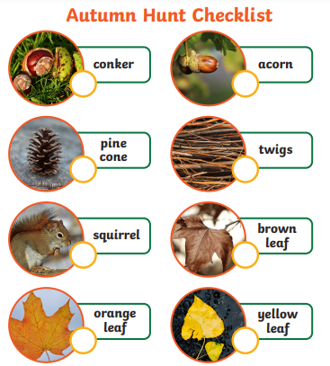
If you have any issues about homework please contact Miss Whiteford on eavictoria.whiteford@glow.sch.uk
or Mrs Henderson on eacarol.henderson@glow.sch.uk
or Miss Barrett on eajaye.barrett@glow.sch.uk

We would very grateful if your child could bring their reading book and homework folder to school each day. Thank you.

