Common Words | Our common words this week are  funny, very, any, only  Spell these words by yourself or with someone at home. You could write them using look, cover, write, check or use a tablet or a phone to type your words.
Phoneme Strips | Our phoneme this week is  y (making the ee sound)  With words like sky, fly, try, cry, spy, fry, dry, why, shy  Try spelling your words using the say, break, make, blend, read and write strategy.
Reading | Please try and read your book. Follow the words using your fingers and answer questions such as who, what, where, when in your book.
Numeracy | Try this activity to recap your quick answers with number bonds to 10.  https://toytheater.com/connect/  or use the QR code below  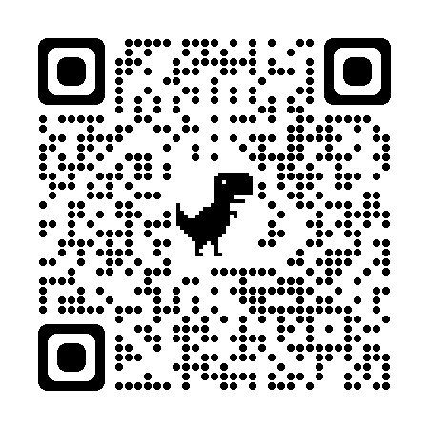
Lost Property | We have a few jumpers and cardigans in the classroom, just in case your child is missing one.  We would also be grateful if you could ensure that all clothing is labelled. Thank you.
If you have any issues about homework please contact
Miss Whiteford at victoria.whiteford@glow.sch.uk

We would very grateful if your child could bring their homework folder to school each day. Thank you.

