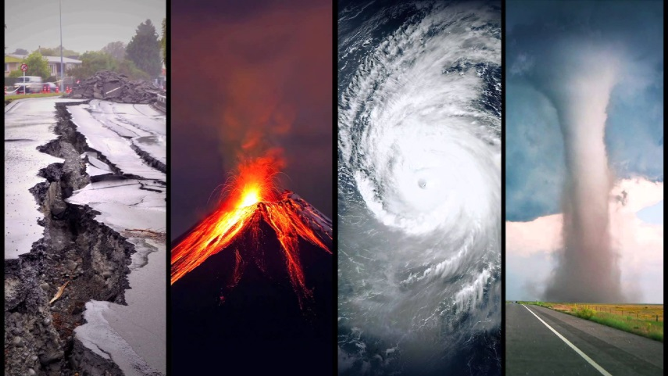
Natural Disasters Homework
Your task is to create an interesting presentation on Natural Disasters.

You can choose to complete a poster, model or PowerPoint on a topic of your choice. Be creative and think of the best way to present your information.
For example: Volcanoes, Tsunamis, Earthquakes, Forest Fires, Avalanches …
You should be prepared to talk to the class for approximately 3 – 5 minutes. Remember! The more you practise at home, the more prepared you will feel when you present to your peers.
Look carefully at the Speaking Rubric as this gives an idea of what I’ll be looking for on the day.
Let me know if you need any resources from school such as card or glue. Also, if you need internet access I can give you some time in class.
Although you may need some adult help, the majority of the work should be your own.
Please hand in on Monday 1st June

