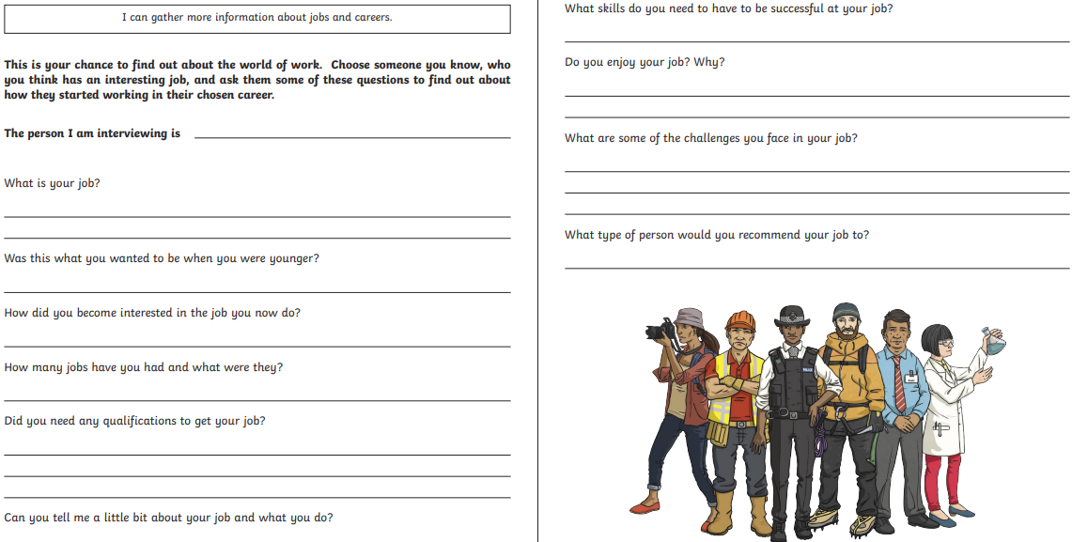
Homework- 16-20th March -This is the second week of STEM fortnight. As part of our STEM and World of Work fortnight, interview someone you know about their job.

