Pencil Control Activity Grid
Place golf tees into playdough. Can you balance a marble on each one? | 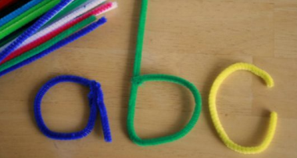  Make letters using pasta, pipe cleaners, sticks or string. | Use scissors to cut along straight, wiggly and zig zag lines. | 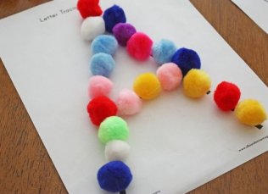  Use pom poms, beads or buttons to make letters.
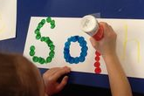  Write your name. Use a bingo dabber to dab along each letter. | Cut drinking straws into 1 inch pieces. Tread them onto pipe cleaners, laces or string. | 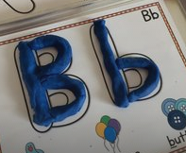  Make letters using playdough. | Zip or button up your coat independently.
Peg socks onto a washing line or attach pegs to a piece of paper. | 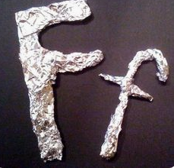  Make letters using tin foil. | Stack together small pieces of paper. How many pieces can you paperclip together? | 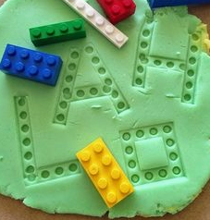  Use Lego to print letters in playdough.

