Letter Formation Activity Grid
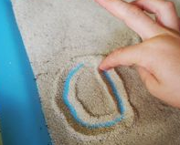  Use your finger to write your letters in a baking tray of sand, salt etc. | Use your finger to trace your letters in the air or on the carpet. | 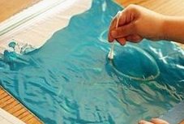  Put paint in a freezer bag. Use a cotton bud to write your letters. | Use a toy car to trace out your letters on the floor. Add paint to trace them on paper.
Trace over dotted handwriting sheets with your finger or a pen. | Write your letters in shaving foam, custard, yogurt etc.  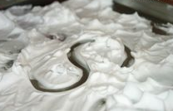 | Trace your letters on a friend’s back. Can they guess the letter? | Use chalk to write your letters then trace over with a wet sponge or paintbrush.
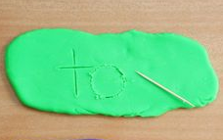  Use a cocktail stick to trace your letters into playdough. | Write a letter with a pencil. Trace over with 4 different coloured pencils to create a rainbow letter. | 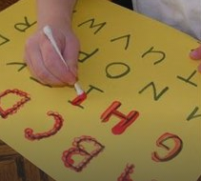  Trace over letters using paint and a cotton bud. | Write your letters on a whiteboard and trace it with your finger to wipe it off.

