Names: __________________________________________________________________

ee |  | ea |  | e_e |  | ey |  | y
Monkeys  Wheel  Screen  Pandas  Screech  Agree  Coffee |  | Monkeys  Nearly  Dream  Leave  Pandas  Season  Peaceful  Teacher |  | Monkeys  Here  These  Theme  Pandas  Sphere  Delete  Extreme |  | Monkeys  Money  Monkey  Pandas  Journey  Kidney  Curtsey |  | Monkeys  Firstly  Friendly  Quickly  Pandas  Surely  Library  February
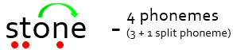


-

4
phonemes

