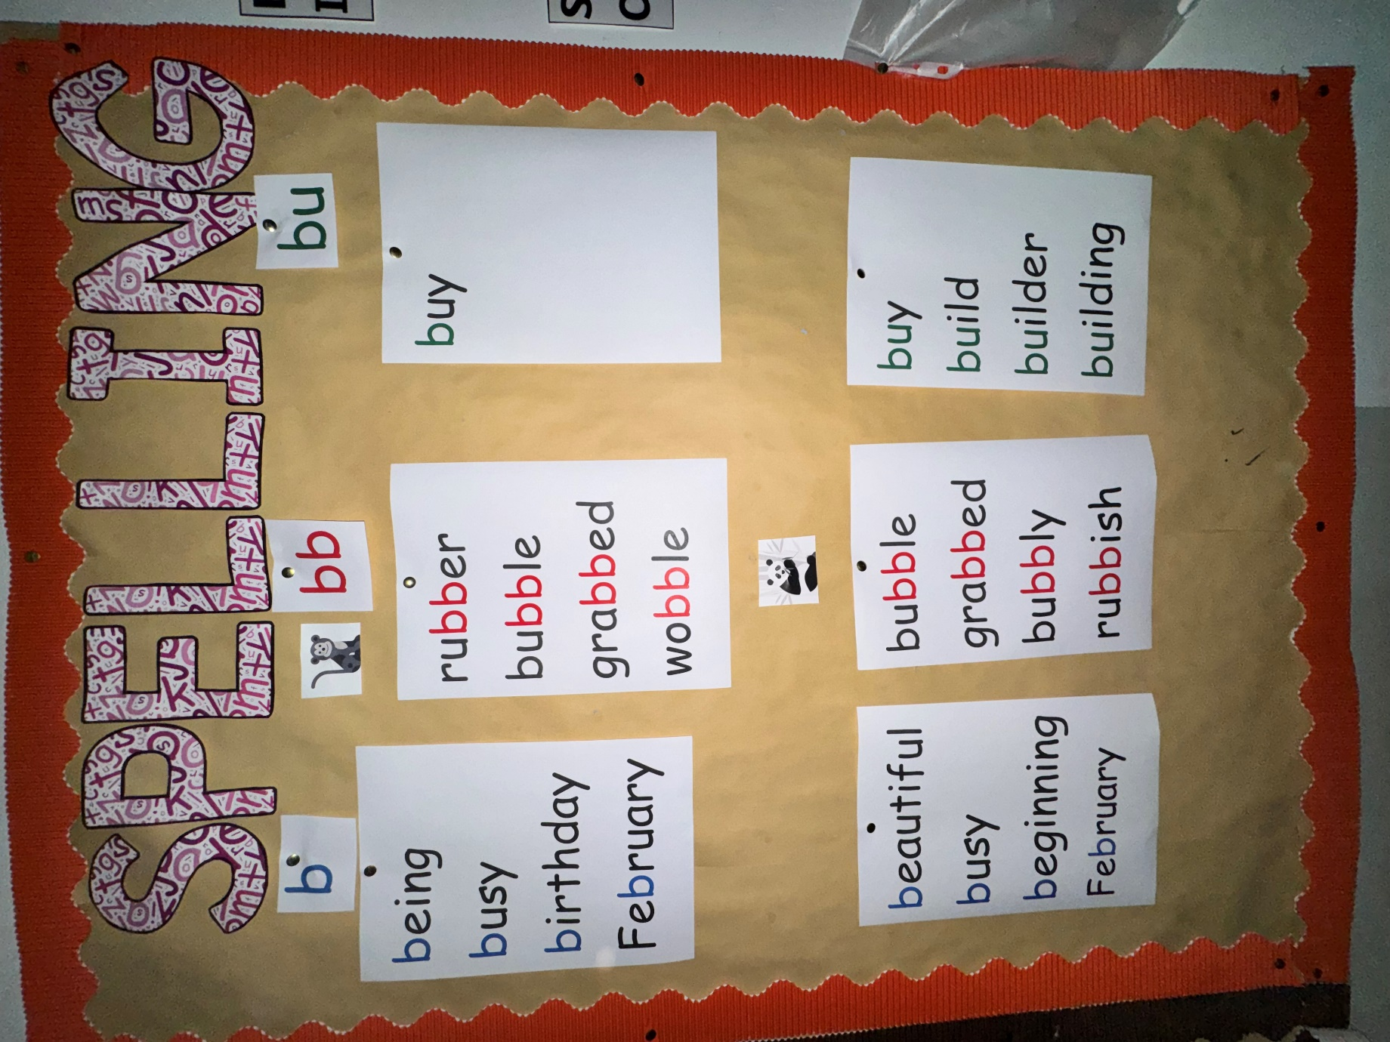
Spelling words for Monday 24th November – Friday 5th December 2025.

