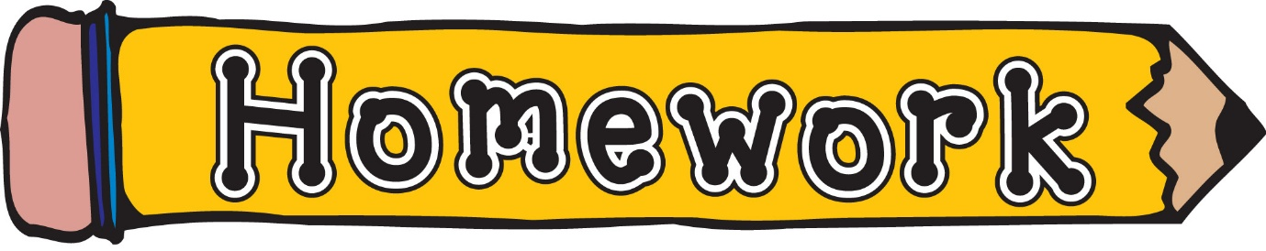
Monday 25th May
- New reading books will be issued today. If you have not yet returned your book from last week, please do so that we can issue a new one.
- Phonics/spelling task (see front page of homework jotter)
- Numeracy – Hit the button, practise times tables you feel less confident with.

Remember to always challenge yourself!

