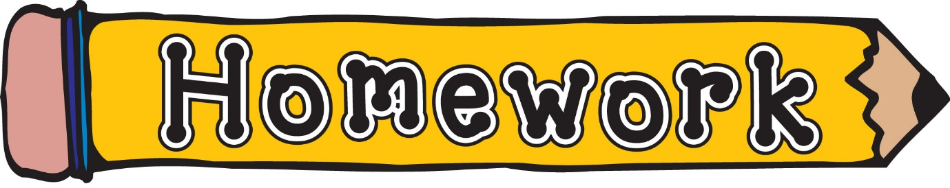
Monday 11th May
- New reading books will be issued today. If you have not yet returned your book from last week, please do so that we can issue a new one.
- Phonics/spelling task (see front page of homework jotter)
- Maths –Shape escape, level 2: practise naming 3D objects
https://ictgames.com/mobilePage/shapeEscape/index.html

OR
- Identifying 3D Shapes game
https://www.mindlygames.com/game/identifying-3d-shapes-fast-food

Remember to always challenge yourself!

