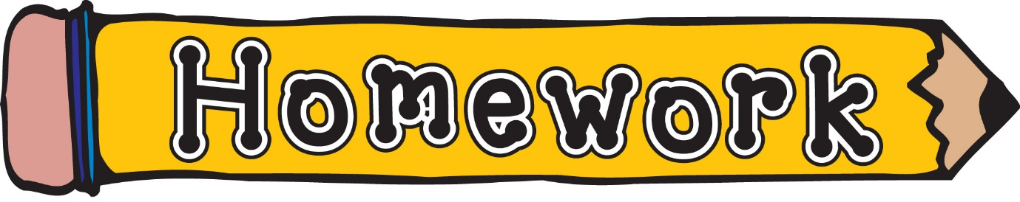
Monday 16th March
- New reading books will be issued today. If you have not yet returned your book from last week, please do so that we can issue a new one.
- Phonics/spelling task (see front page of homework jotter)
- Numeracy – Hit the button: practise 2,4, 5 or 10 times table or practise halves.
Remember to always challenge yourself!

