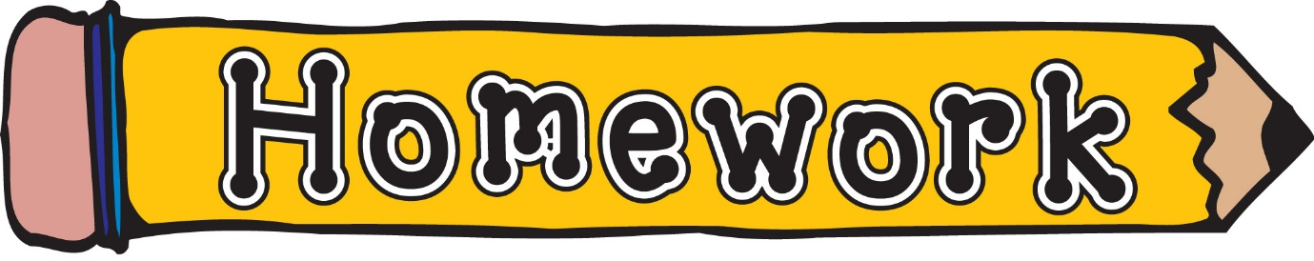
Monday 23rd February
- New reading books will be issued today. If you have not yet returned your book from last week, please do so that we can issue a new one.
- Phonics/spelling task (see front page of homework jotter)
- IDL – Knight & Castles homework, see below.
Remember to always challenge yourself!

