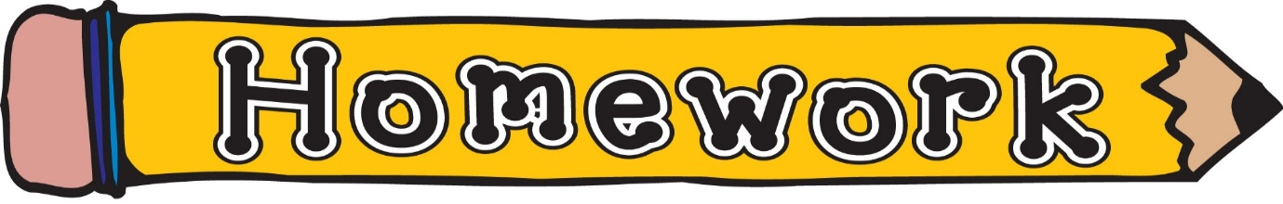
Monday 2nd February
- New reading book issued (see book wallets in school bags)
- Phonics/spelling task (see front page of homework jotter)
- Sumdog challenge – times table practise

