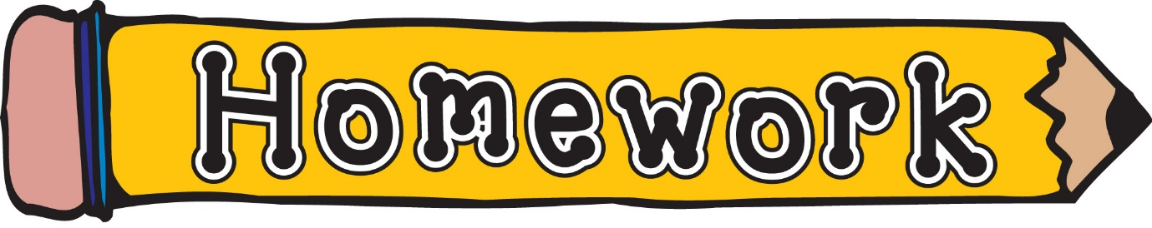
Monday 26th January
- New reading books will be issued today. If you have not yet returned your book from last week, please do so that we can issue a new one.
- Phonics/spelling task (see front page of homework jotter)
- Maths – Practise 2 times table. Play hit the button 2x table for practise.
https://www.topmarks.co.uk/maths-games/hit-the-button
Remember to always challenge yourself!

