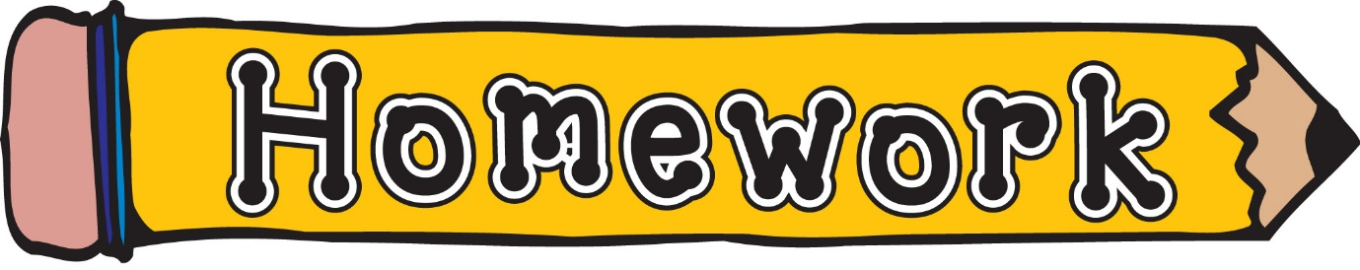
Monday 19th January
- New reading books will be issued today. If you have not yet returned your book from last week, please do so that we can issue a new one.
- Phonics/spelling task (see front page of homework jotter)
- Scots Poem – please take time to learn this for our Scots poetry competition, finalists will be chosen this Friday (23rd).
Remember to always challenge yourself!

