P7 Residential Trip to Galloway Activity Centre
Wednesday 3rd June – Friday 5th June 2026
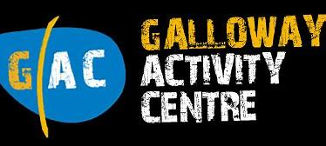
Kit List
• Sleeping bag or duvet/linen
• Towels
• Swimming things
• Waterproofs
• Sensible outdoor shoes (trainers, walking boots, wellies)
• Spare old trainers (for getting wet)
• Lots of changes of clothes
• Warm clothing
• Any medication required (to be in the hands of staff)
• Tooth brush/tooth paste and wash items
• Plastic bag for returning with wet clothes
• Nothing special is required, wellies, old trackies, pack a mac – it’s not a fashion show you’ll get muddy and dirty!

