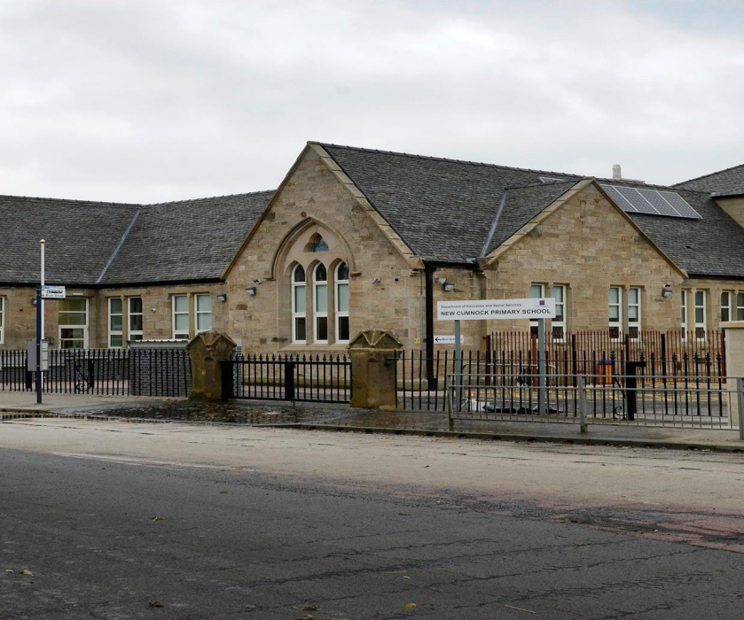

New Cumnock Primary School
Castle
New Cumnock
KA18 4AH
Telephone No: | 01290 338404
Email: | Joanna.McMurdo@eastayrshire.org.uk
School Blog: | https://blogs.glowscotland.org.uk/ea/newcumnockprimaryschoolea/
Twitter: | https://twitter.com/NewCumnockPS
School App: | Available on appropriate mobile devices
Denominational  Status (if any): | Non-Denominational
School Roll: | P1 – P7  Current Role: 214 pupils
Further information: | http://www.east-ayrshire.gov.uk/schoolhandbooks

SECTION 1

Welcome Message
New Cumnock Primary serves the village of New Cumnock in East Ayrshire. This is a mixed catchment area with children living in the farming community, council estates and private property. The refurbished school building was opened officially in December 2012 by Sir Tom Hunter. The building is a mixture of traditional and modern design with many of the features of the original Castle Primary School retained. There are nine classrooms, an ICT suite, Music/ Drama room and a research area/ Library. Infant classrooms are located on the ground floor, with middle and upper classes on the first floor. In addition, there is a PE hall and dining hall, a modern fully fitted kitchen, administration areas, meeting room, parent’s room and medical room. Entrances/ exits are by means of security doors which are alarmed and the building is fully disability discrimination compliant. We pride ourselves on being a nurturing school and we provide a Nurture class for identified children at various stages in the school.
Yours Sincerely,
Mrs Joanna McMurdo

School Name
New Cumnock Primary School
Address and Postcode
Castle, New Cumnock, KA18 4AH
Telephone Number
01290 338404
Email
Joanna.mcmurdo@east-ayrshire.gov.uk
Website address
https://blogs.glowscotland.org.uk/ea/newcumnockprimaryschoolea/
The Stages of Education Provided for
P1-7
The Current Roll
P1- 22
P2- 19
P2/3- 22
P3/4- 25
P4/5- 25
P5- 23
P5/6- 25
P6- 26
P7- 27
The Denominational Status
Non Denominational

New Cumnock Primary School Vision
In New Cumnock Primary School, we work together to ensure a welcoming, nurturing and innovative environment which allows everyone to excel on the journey to excellence.
Values (DREAM)
Determination
Responsibility
Equality
Ambition
Mutual Respect

Aims
Curriculum
We aim to provide challenging and enjoyable learning experiences to develop enquiring minds, in a broad and inclusive curriculum, where pupils, parents and staff are valued and success is celebrated.
Support for Pupils
To provide support for pupils to ensure that their social, emotional and educational needs are being met to enable them to reach their full potential as learners.
Attainment
To ensure every child is supported and challenged to make maximum progress and achieve the best of his/her ability.
Ethos
To create an inclusive environment which nurtures confident, resilient children, who are given a voice to take ownership of their learning and to celebrate success.
Management
To manage the school effectively by establishing an ethos of professional learning amongst staff and creating approaches to self-evaluation, through utilising a range of data through monitoring and tracking systems, to provide a positive impact on learners and achievements.
Learning and Teaching
To create a high quality learning and teaching environment, where teachers facilitate, encourage and support children to believe in themselves, recognise their next steps and reach their potential as life-long learners.
Resources
To provide a positive, stimulating and safe learning and teaching environment, using high quality materials and working in partnership with parents and the community.

Opportunities Provided for Parents/Carers

We want the best start in life for every young person in East Ayrshire, including those who are not yet born. Your role as a parent is vital and we know you will want to play an active part all through your child’s educational journey.

You are automatically part of the Parent Forum which can form a smaller body called the Parent Council to represent them. The Parent Council represents parents’ views and supports the school/centre in its work with pupils, reporting back to the Parent Forum. In addition, the Parent Council organises fund-raising events and encourages links between the school/centre, parents, pupils and the wider community.

Parent helpers/volunteers are welcome and by contacting the school, we will be able to advise on the opportunities available to assist at events and activities. To get involved as a volunteer, you will have to undergo a Disclosure Scotland PVG check before you can help in the school.

How the School will Provide Information, Advice and Support to Parents/Carers to Support their Child’s Learning at Key Stages.

We will keep you informed of your child’s progress in terms of learning and achievement. This may include telephone calls, letters, emails, written reports, parents’ workshops and/or parents’ evenings. Your child’s teacher may also share ideas about how you can help your child’s build on their strengths as well as working on progress and development needs.

SECTION 2
Transitions
Starting school (Early Childhood Centre to Primary)

When you enrol your child, their original birth certificate will be needed. A copy of this will be taken and the original will be returned to you. We do this to comply with the terms of the Family Law (Scotland) Act 2006 and to help determine who has parental rights for a child.

For children born after May 2006, if both parents are named on the birth certificate, then both have parental rights and we will record both names on our system. Parental rights are different for children born before May 2006. In this case the father will only have parental rights if he is named on the birth certificate and if he was married to the mother at the time of the child’s birth.

A child’s name cannot be changed and a parent cannot be removed from the system without written consent from all parties with parental rights for the child.

Primary to Secondary transition

Our P7’s will take part in a variety of transition events in preparation for their move to Robert Burns Academy. This will include:

- Secondary staff visiting the Primary to support with curricular lessons.
- Attend a variety of visits to Robert Burns Academy

Associated Secondary School

Robert Academy
Barony Campus
Auchinleck Road
Cumnock
KA18 1FQ
Tel: 01290 427280
Headteacher: Tracy Stewart
Tracy.Stewart@eastayrshire.org.uk

Support for Children and Young People and Parents/Carers
Our Teachers and Staff

We aim to recruit the best teachers and staff to deliver a superb education for your child.

Recruitment and selection procedures are rigorous and consistent and the recruitment process includes a security check – through the Protection of Vulnerable Groups (PVG). All teaching staff are registered with the General Teaching Council Scotland (GTCS).

Senior Management Team
- Head Teacher Mrs. Joanna McMurdo
- Deputy Head Teacher Mr. Gary Hastings
- Principal Teacher Mrs. Danielle McNulty

Teaching Staff
- Mrs. Donna Clarke – P1
- Mrs. Larraine Elliot– P2
- Mrs. Claire Johnstone– P2/3
- Mrs. Karen Petrie– P3/4
- Mrs. Lesley-Anne Armour– P4/5
- Miss. Christina McQueen – P5
- Mrs. Jodie White – P5/6
- Mrs. Laura Ramsay/ Miss. Danielle Nicholl– P6
- Mrs. Claira Frew – P7
- Mrs. Laura Ramsay/ Miss. Corrine Mason/ Mrs. Danielle McNulty – NCCT Cover
- Miss. Francene Esquierdo (EAST)

Ancillary Staff
- Senior Clerical Assistant Mrs. Ashley McPike
- Clerical Assistant Mrs. Laura Hope
- Janitor Mrs. Marion Morrow
- Classroom Assistant Mrs. May Donnelly
- Classroom Assistant Mrs. Janice Brown
- Classroom Assistant Mrs. Heather Johnsone
- Classroom Assistant Miss. Yvonne Ferrans
- Home Link Practitioner Mrs. Tracey Bradford

Contacts for Parents where a Concern Requires to be Raised
If you have experienced a problem with a service or have a complaint to make, the quickest way to get it resolved is to talk to the school or head teacher.

Provisions Made for Children and Young People with Additional Support Needs

Additional Support for Learning
Occasionally, a child may face difficulties preventing them from effective learning. We identify them as having additional support needs, which may be short term, or for their whole school journey.

Children and young people who have been identified as having additional support needs will be supported through an Action Plan (AP), Individual Learning Plan (ILP) or in some cases a Coordinated Support Plan (CSP).

You and your child will be fully involved in developing these plans at all stages.

Additional and more specific information on Additional Support Needs can be found on our website:

www.east-ayrshire.gov.uk/EducationAndLearning/SupportForPupils/AdditionalSupportforLearning.aspx

SECTION 3
The School Day and Year

The school day begins at 9am.
Morning break is from 11.00am until 11.15am
Lunch break is from 12.15pm until 1.00pm for P1-P3/4, and from 12.30pm until 1.15pm for P4/5-P7.
The school day finishes at 3pm.

The School/Centre Holidays and In-Service Days
The Scottish Government requires that holidays taken during term time should be recorded as unauthorised absence unless there are special, exceptional circumstances.

Should you wish to remove your child from school/centre to attend a family holiday you must inform the head of establishment. This will be recorded as unauthorised absence, though there may at times be exceptional family circumstances, which should be discussed with the head teacher well in advance.

Parents are advised to limit the number of holidays taken during term time, to minimise disruption to a child’s education. For annual holiday dates for East Ayrshire schools, please visit the following website, or contact the schools office.

www.east-ayrshire.gov.uk/EducationAndLearning/SchoolHolidays.aspx

Attendance and Timekeeping
The law requires all parents to provide an education for their child. We take attendance at school seriously and follow up on unauthorised absences, or continued absence from school, involving other partners if necessary.

You are responsible for ensuring that your child attends school regularly and arrives on time. You are responsible for ensuring the safety of your child on their journeys to and from school, except when they are on any school transport we provide. Regular and punctual attendance is linked closely to achievement and staff will work with parents to ensure that children can achieve their full potential.

Reporting an Absence

The law requires that educational establishments maintain an accurate record of attendance and absence of each pupil. Parents are requested to assist in this process by informing the school or centre if children are to be absent for any reason.

This is how absence is recorded in our school:

- Primary schools note attendance twice a day - morning and afternoon.
- Where your child’s absence is approved, for example a medical appointment or the school or centre is notified of a sickness absence, it is marked as an authorised absence.
- Where an absence is unexplained by the parent the absence is marked as unauthorised.
- If your child is not going to be attending, please let us know by 9.15 am on the first day of absence, explaining the reason. When your child returns, please send them with a note, confirming the reason for absence.

Where a child exhibits a pattern of absence which may warrant investigation – and if we cannot contact you, or your other emergency contacts – then other appropriate support services may be contacted.

This might include other family members, a social worker, a health visitor or other concerned party, requesting that they visit your home to investigate and report back on their findings.

The school SEEMIS messaging system holds one main contact and will send attendance notifications to the main contact only. It is not possible to generate the automated message necessary to inform all parents/carers. However, should a parent/carer have a significant concern that the main contact is not sharing key information regarding attendance, they should contact the school to discuss possible alternative solutions.

Anti-Bullying

We want every child in East Ayrshire to grow up free from bullying behaviour and we’re fully committed to making sure children and young people become confident individuals and responsible citizens.

We take bullying very seriously and work to prevent it.

Should an incidence of bullying occur, we will respond quickly and effectively. You can find more information on our Respectful Relationships Policy at: https://www.east-ayrshire.gov.uk/EducationAndLearning/SupportForPupils/Anti-Bullying.aspx

New Cumnock Primary School Dress Code
Given that there is substantial parental and public approval of dress codes, schools in East Ayrshire are free to promote their own dress code. In encouraging the dress code, account must be taken in any proposals to prevent any direct or indirect discrimination on the grounds of race, gender, religion or disability. Any proposals will be the subject of widespread consultation with parents and pupils. Against this background it should be noted that it is the policy of the Cabinet not to insist on pupils wearing uniform or having specialist items of clothing as a prerequisite to their attending and engaging in all of the activities of the curriculum.

Those who desire may wear the school colours which are:
Skirt, trousers black or grey
Blouse/shirt white
Sweatshirt red
Polo shirt white
Tie red and white
Sweatshirts, polo shirts, fleeces and rain jackets can be purchased anytime from Donsport and Kenny’s within 0290 in Cumnock. Children do need gym shoes and shorts. Incorrect clothing could be a safety hazard during P.E. lessons. Pupils must remove all jewellery before participating in P.E. There are forms of dress which are unacceptable in school, such as items of clothing which:

- potentially, encourage rivalry (such as football colours)
- could cause offence as a result of wording or pictures
- could cause health and safety difficulties (such as loose fitting clothing, dangling earrings)
- are made of flammable material (such as shell suits in practical classes)
- could cause damage to flooring
- carry advertising, particularly for drugs, alcohol or tobacco
- could be used to inflict damage on other pupils or be used by others to do so
- earrings or other body piercing jewellery should not be worn for any PE related activity

Security and Visitors
All visitors are asked to report to the front office. Here they will be welcomed by member of staff and sign in the visitors book. All visitors to the school will be asked to wear an ID Badge at all times.

School Canteen Facilities
All children in primaries 1 to 3 are entitled to a free school meal.

This is a great opportunity for children to enjoy the social interaction of eating in an environment where they can try different foods every day and it can also help to increase their concentration for their afternoon classes.

Our award winning meals service offers nutritionally balanced, well-presented food in an environment that is sensitive to the needs of pupils.

We are the only Council to have achieved nine consecutive Gold Soil Association Food Awards since 2008. We also back using valued local suppliers for our fresh ingredients.

School meals provide a good lunchtime experience with an important break in the day away from the classroom, while still being in the safety of the school.

School lunch breaks should be an interesting and enjoyable time and our philosophy is to help children towards a good diet by providing an attractive and interesting range of wholesome, cooked food, made from excellent, fresh, quality ingredients.

Menus and other information can be found at: www.eac.eu/schoolmeals.

The management of the Catering Service in your school is provided by the Council through Onsite Services. The Schools (Health Promotion and Nutrition) Act 2007 sets out in detail the national nutritional food standards we follow.

Online School Payments
A safe and secure system of online school payments is being introduced to all primary and secondary schools, removing the need for your child to carry cash. The payment service is being provided by ParentPay: https://www.parentpay.com/

ParentPay is a secure online payment system allowing parents to pay for school meals, trips, uniforms and much more.

Parents who do not have access to online facilities or wish to continue to pay in cash can do so by paying through Paypoint facilities at local shops.
Benefits for parents:

- make payments whenever and wherever you like
- no need to worry about your child carrying cash to school
- monitor and make payments by instalments for larger items such as school trips
- a single login for all your children regardless of which school they attend
- alerts for low balances via email and/or SMS text

Further information on online school payments is available online at: www.eac.eu/onlineschoolpayments

  - Cashless Catering
Cashless catering systems are also being introduced to all primary and secondary schools in East Ayrshire in conjunction with the introduction of Online School Payments. Cashless catering will be provided by Nationwide Retail Systems Limited.

It means you will be able to pay for school meals and snacks using the Online Payments system and will be able to view your child’s menu choices, as well as track their spending.

Primary 1 to 3 pupils and other pupils who are entitled to free school meals will have their meal allowance added to their account every day.

A biometric thumb image will be used in the majority of schools to identify pupils and link them to their record on the cashless catering system.

To access the service, you need to consent for your child’s biometric data to be stored on the cashless catering system. It’s incredibly safe and anonymous.

Further information on online school payments is available at: www.eac.eu/onlineschoolpayments

Complaints Handling
If you have experienced a problem with a service or have a complaint to make, the quickest way to get it resolved is to talk to the school or head teacher.

- Stage 1: If the head teacher is unable to provide a satisfactory resolution to your enquiry or complaint, you can raise a formal complaint via the Council’s Complaints Procedure. Your complaint will be reviewed by a manager within education and a response provided within five working days.

- Stage 2: If you are not satisfied with the response received, you can ask for a further review of your complaint by senior management and we will aim to respond within 20 working days.

If you have completed the Council’s complaints process and you are still unhappy, you can ask the Scottish Public Services Ombudsman to look at your complaint. Further information is provided in the leaflet a guide to making comments, suggestions and complaints or on the Council website www.east-ayrshire.gov.uk/complaints

Emergency Procedures / Medical Matters
It’s essential that you let us know of any particular medical conditions or requirement(s) your child might have. Written parental consent is also required for the administration of medicines.

Please let the school/centre know of any change in your contact information, any change in a child’s medical condition and of arrangements we should make should your child become ill, or need to be taken home.

Data Protection
Sharing information
We are keen to help all our children and young people do well in all aspects of school life and achieve better examination results.

To make the best decisions on how to improve education, the Scottish Government, local authorities and other partners such as the SQA and Careers Scotland need accurate, up-to-date information.

We transfer data to the Scottish Government through the ScotXed programme – a system of collecting, processing and sharing the information required for the planning, management and monitoring of Scottish education services.

More detail of the uses of this data can be found at: www.scotxed.net. The data is held securely and no information on individual pupils can or would be published by Scottish Government – it is only used for statistics and research.

Freedom of Information (Scotland) Act 2002
The Freedom of Information (Scotland) Act, 2002 gives you a right of access to a wide range of information held by Scottish public authorities.

Subject to some exemptions, anyone who makes a request to a public authority for information under the Act will be entitled to receive it. In line with other Councils and public bodies, the Council has a ‘publication scheme’ – a range of material online, routinely made available to the public.

Such material is exempt from requiring a specific response under the Freedom of Information legislation. To request information e-mail: freedomofInformation@east-ayrshire.gov.uk

New Cumnock Primary School Parent Council
The Parent Council is a group of parents who meet in the school at least once a term in the evenings. The group is made up of parents, but school staff and other invited guests can also attend. The Parent Council allows parents to have an input in school decision-making, and also enables school staff to keep parents informed about the life of the school. We discuss any items that affect the School.

Purpose of the Parent Council?
- To work in partnership with school staff to create a welcoming school which is inclusive for all parents.
- To promote partnership between the school, its pupils and all its parents, and to enhance relationships.
- To develop and engage in activities which support the education and welfare of the pupils.
- To promote community involvement between the school, its pupils, its parents and the wider community of New Cumnock through events, fundraising etc.
- To identify and represent the views of parents on the education provided by the school and other matters affecting the education and welfare of the pupils.
- To ensure confidentiality is respected in relation to the individual pupil, staff and parent.

SECTION 4
Curriculum for Excellence

The Curriculum for Excellence is Scotland’s national curriculum. It provides a coherent and inclusive curriculum from 3-18 years, wherever learning is taking place including: Early Childhood Centres, schools, colleges and community learning.

There are five levels and these are flexible, depending on pupils’ needs and abilities.

- Early - the pre-school years and P1 or later for some.
- First - to the end of P4, but earlier or later for some.
- Second - to the end of P7, but earlier or later for some. We work closely within our Education Groups and P7 pupils and parents to facilitate the transition from primary to secondary school.

- Third and Fourth – S1 to S3. S3 marks the end of the broad general education phase and is a time when pupils choose courses which will lead to national qualifications. The fourth level broadly equates to Scottish Credit and Qualifications Framework level 4. The fourth level experiences and outcomes are intended to provide possibilities for choice and refine your child’s education.

Senior phase - S4 to S6, and college or other forms of study. In S6, pupils will have opportunities to study programmes involving independent and blended learning with partners from Higher and Further Education and the business community.

Our Curriculum
The curriculum offered by our establishment reflects the principles of a Curriculum for Excellence. What your child learns will be relevant to the present and future needs of young people in society. To help your child develop his or her full potential, children are offered a range of activities and opportunities balanced across seven years of primary education. In line with council policy our curriculum and our organisation of teaching and learning reflects the principles of equality of educational opportunity regardless of pupils’ sex, race, colour or personal circumstances, as well as reflecting awareness of cultural diversity.
Our curriculum is planned to provide opportunities for children to be actively involved in their own learning experiences, to develop areas of interest, to learn at their own pace through group and individual work, while being challenged by high expectations of success. Above all we plan our teaching with the intention that our children enjoy their primary education.
Literacy and English
Our main Language programme is Active Literacy but we use also use a wide variety of textbooks, resources, methodologies and interactive learning strategies to engage our learners. The art of communication through language is of vital importance in everyday life and your child will follow structured programmes for Listening, Talking, Reading and Writing as well as reinforcement of skills through interdisciplinary learning activities to make learning relevant and to promote lifelong learning.
Mathematics and Numeracy
We use a wide variety of textbooks, resources, methodologies and interactive learning strategies to consolidate and extend learning. Number talks and mental agility is incorporated into every Mathematics lesson and pupils are taught problem solving strategies through active learning/ Critical Skills challenges. Wherever possible mathematical concepts are taught through interdisciplinary learning to teach skills in context and to promote lifelong learning.
Health and Well Being and Citizenship
Our Personal, Social and Health Education Programme is designed to equip children with the life skills needed to live a healthy, satisfying life and earn a living in the changing society of the future. PSHD permeates all areas of school life and covers:
Personal Development
Citizenship
Personal Safety
Developing positive relationships
Drug education
Anti-racism
Awareness of cultural diversity
Enterprise in Education
Sexual health, relationships and parenthood
Parents will be informed via a letter about sensitive aspects of learning such as sexual health, relationships, parenthood and drugs awareness. If you wish further information, please do not hesitate to contact the school.
New Cumnock Primary has achieved School Sports Award Gold status. The children are encouraged to take personal responsibility for their own health choices at all time and we support them by promoting a healthy lifestyle, providing activities relating to health issues and exercise, providing a Healthy Snack at the morning interval, having a Sports Committee and a bi-annual Health Week. Children are given opportunities to learn skills in a variety of sports, for example, Netball, Football, Dance.

SECTION 5
Achievement and Improvement
The main achievements of the school over the last 12 months is contained in our Standards and Quality Report. This includes our improved stadards in relation to Literacy, Numeracy and Health and Wellebing. This can be accessed via the school website:
https://blogs.glowscotland.org.uk/ea/newcumnockprimaryschoolea/

Plans for Improvement of the Establishment Performance

Every young person in the school was involved in creating this session’s School Improvement Plan. Whole school Get Togethers based on the National Improvement Framework, allowed every child to offer their views about how we could make improvements within the four priorities.
Next session we will continue to use whole school Get2gethers and House Meetings to ensure all children are involved in the consultation process regarding particular aspects of school life. For example, policy and practice.
There are many meaningful opportunities for children to share their views throughout the school year. Rich Task Groups will continue to give children opportunities to make their views known, identify how they can make improvements to enhance the school and drive these improvements forward.
Representing the wider pupil body, the Pupil Council will discuss and action operational issues with the Senior Leadership Team.
The Parent Council will:
- Drive parental consultation by planning and organising events to include the wider parent body in the decision-making process. GLOW Forms will be used frequently to involve parents in the decision-making process. The staff and pupils will support parents with the use of Forms.
- Plan, organise and support school improvement activities linked to the National Improvement Framework priorities.
- Be represented on key appointment panels and authority reviews as and when they arise.

School Improvement Priorities
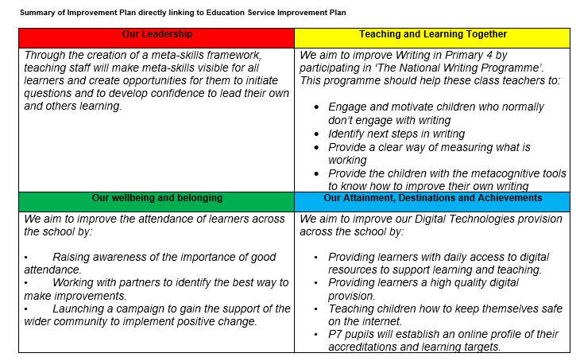
More details can be found on our school website:
https://blogs.glowscotland.org.uk/ea/newcumnockprimaryschoolea/home-page/downloads/sip-2025-2026/
SECTION 6
Assessment of Pupil Progress
Our school implements Quality Assurance Procedures to ensure that your child is being challenged/supported at their appropriate level. These procedures include:
- Pace and Challenge Meetings
- Class Observation
- Jotter Monitoring
- Tracking and Monitoring Assessment Periods
- Moderation

Reporting
Throughout the school year, we will communicate with you regarding your child’s progress through the following procedures:
- One formal written report on your child’s progress.
- An opportunity to have two meetings with your child’s class teacher or teachers.

