Welcome to Primary 1

at

New Cumnock Primary School

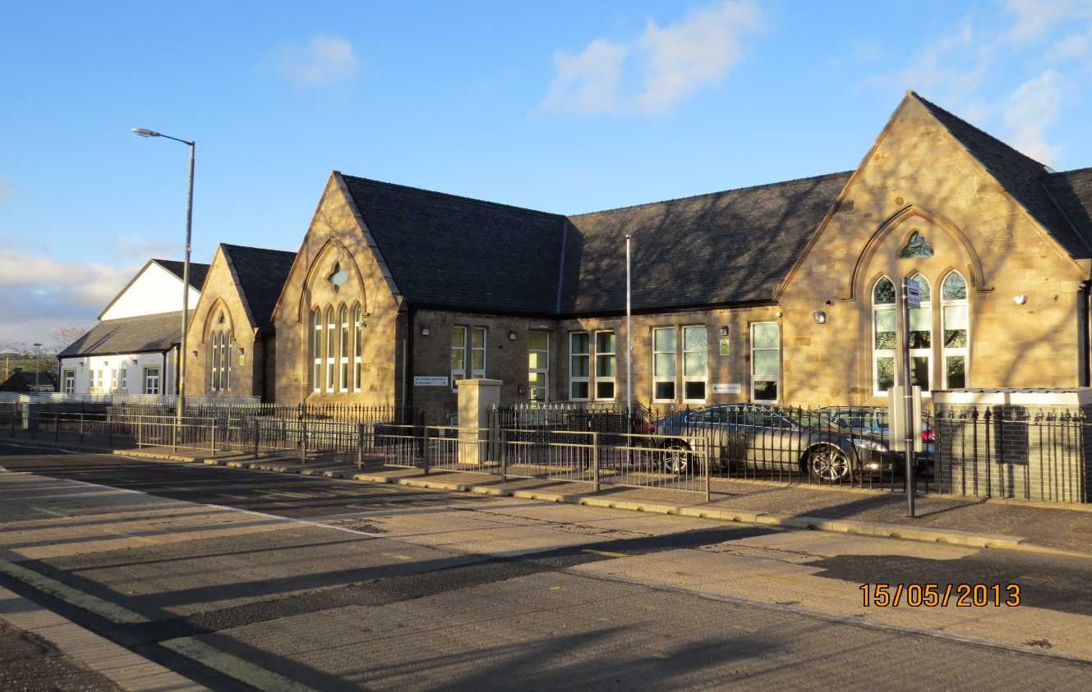

When I come to New Cumnock Primary School, I will meet Mrs Elliott and Mrs Clarke.

Mrs Clarke is one of the Primary 1 class teachers.

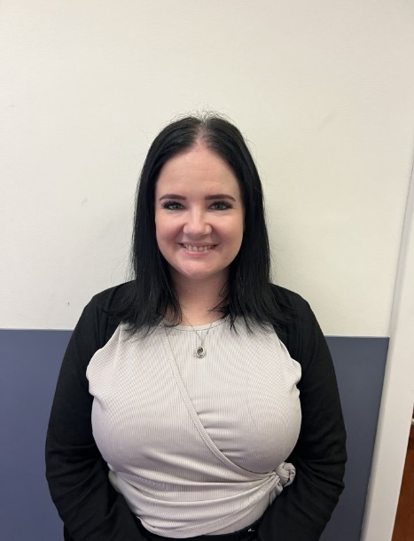

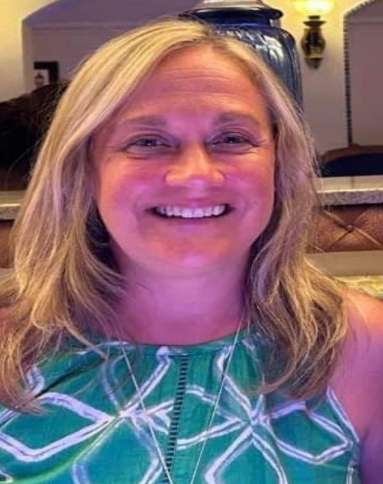

Mrs Elliott is one of the Primary 1 class teachers.

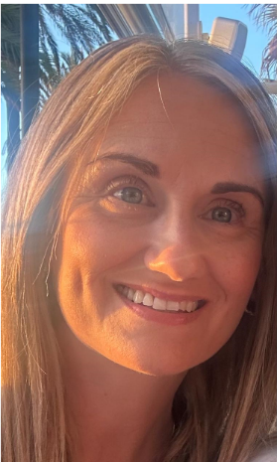**Other adults I will meet are** -

Mrs McMurdo is our Head Teacher.

Mrs McNulty is our Principal Teacher.

Mr Hastings is our

Depute Head Teacher.

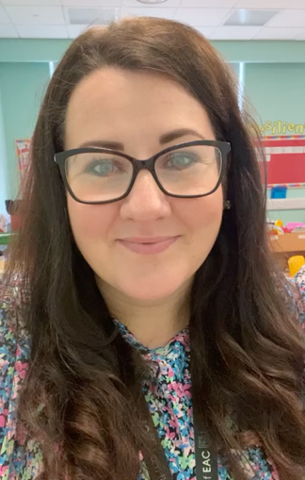

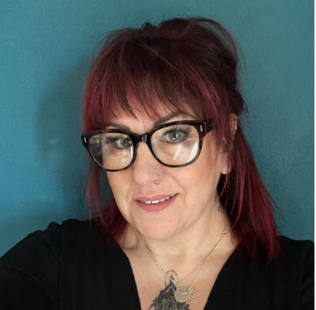

Mrs Bradford is our Home link Practitioner – she helps in lots of different ways – giving families support, being a listening ear, offering advice on where to get help if any is needed.

.

**My Daily Routine at School:**

In the morning between 8:45 – 9:00 I can be dropped off by my parent/carer/adult at the school gate where an adult from the school will be there to welcome me.

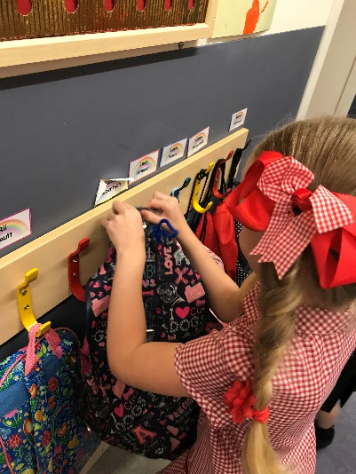

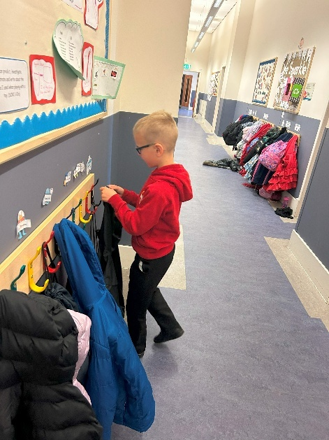

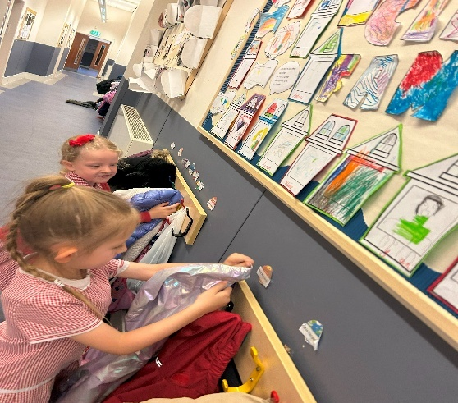

I will hang my jacket on my peg in the corridor. My peg will have my name on it. (I will need my name on my clothes, so we don’t get mixed up.)

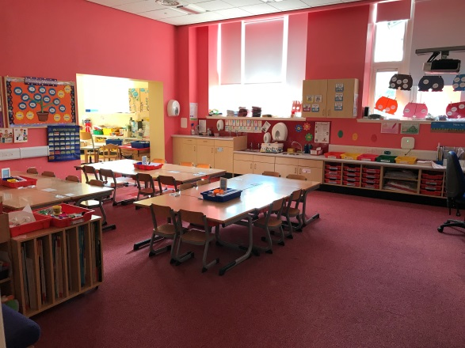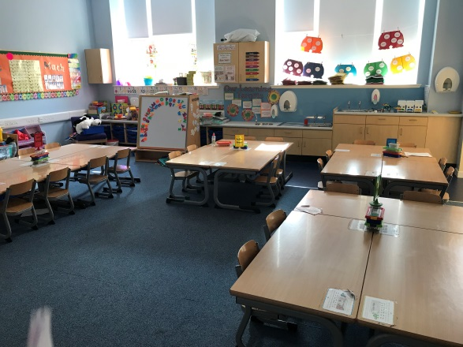

I will make my way into my classroom and sit on the carpet with my friends.

My teacher will take the register and welcome everyone to class.

At home or in school I can choose what I want for my lunch.

There will be a choice of soup, 3 main courses and fruit as a pudding.

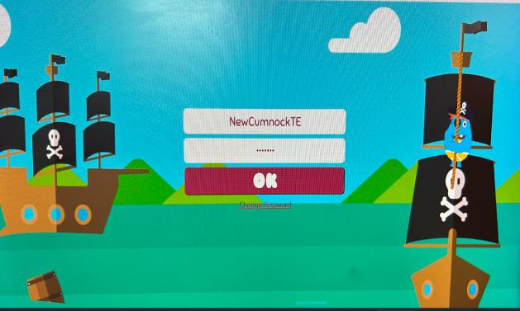

**Playtime**

When the bell rings at 11am, Mrs Elliott or Mrs Clarke will encourage me to go to the toilet and collect my jacket to go outside for playtime.

I will get my snack or free fruit form the dinner hall and go out and enjoy playing with my friends.

I can play games with my friends and eat my snack. When the bell rings again, I must line up with my class to go back into school to work hard again.

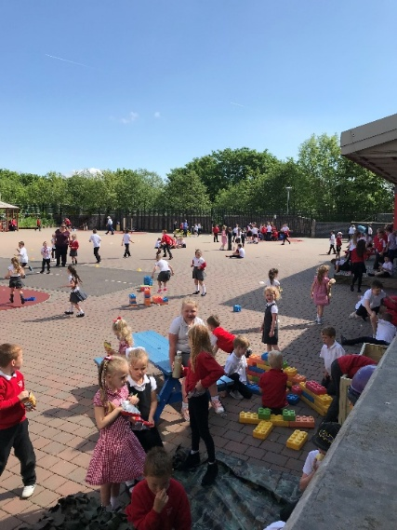

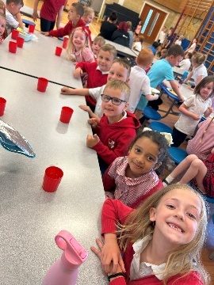**Lunchtime**

When the bell rings at 12:15pm, it is lunchtime. Mrs Elliott or Mrs Clarke will then walk me along to the dinner hall and I will sit at the table and be offered water or milk to drink.

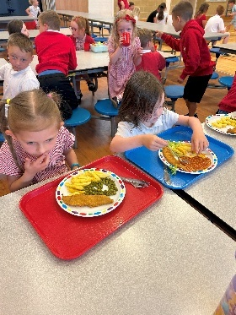

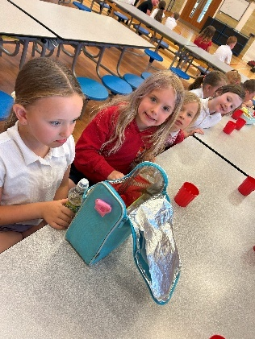

The dinner ladies.

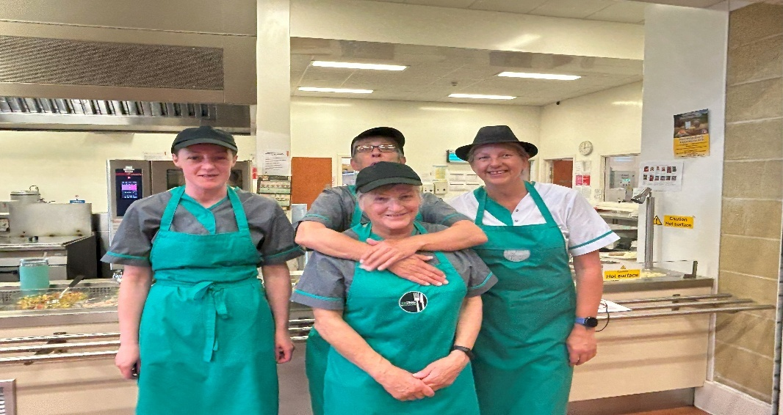

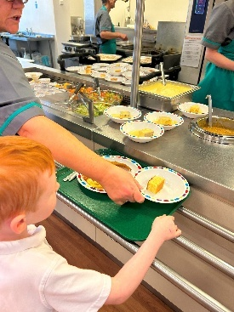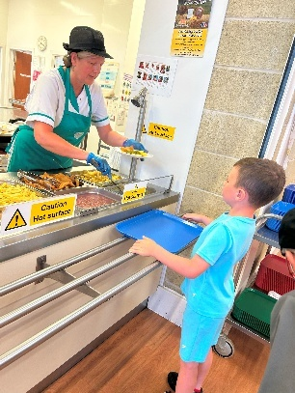

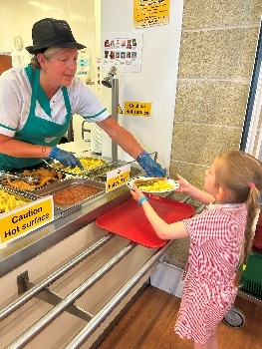

I can also have a packed lunch, I will collect it from the trolley and sit at the table with the other children who have chosen to bring a packed lunch.

I will then line up and the ladies will serve me my meal and I will take it back to my seat and eat. When I am finished my lunch, I will tidy my things away and then go outside to play until the bell rings at 1pm and I will line up to go back into school.

**Home time**

At home time, Mrs Elliott or Mrs Clarke will encourage me to collect my jacket and school bag.

My teacher will take me outside and I will wait with her until someone collects me.

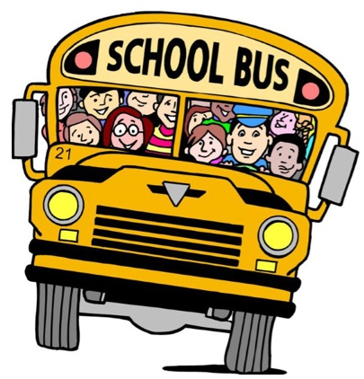

If I get the school bus to school and back home, Mrs Elliott or Mrs Clarke will show me where the bus children line up and a Classroom Assistant will check the register and then take me to the bus at home time.