Transition Information for Parents/Carers

New Cumnock Primary School



# Getting Started



First Day of School - Wednesday 20th August 2025

We look forward to welcoming our parents and new Primary 1 children to the New Cumnock Primary School community. Our school day is 9am until 3pm.

# Staff

## Head Teacher – Mrs McMurdo

## 

## Depute Head Teacher – Mr Hastings



## Principal Teacher – Mrs McNulty

## Primary 1 Teachers

## Mrs Clarke Mrs Elliott

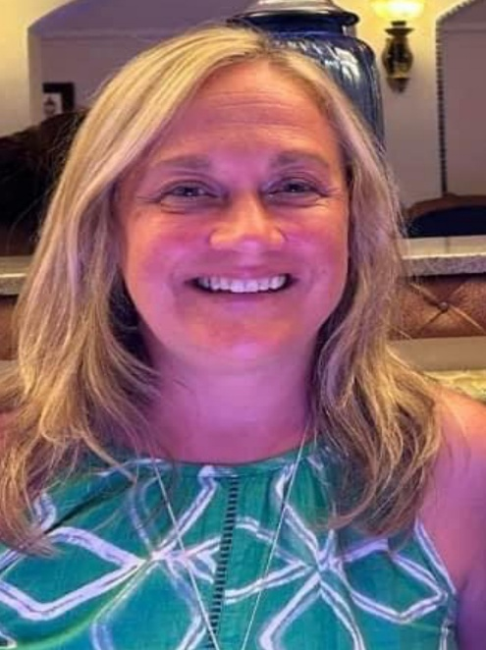 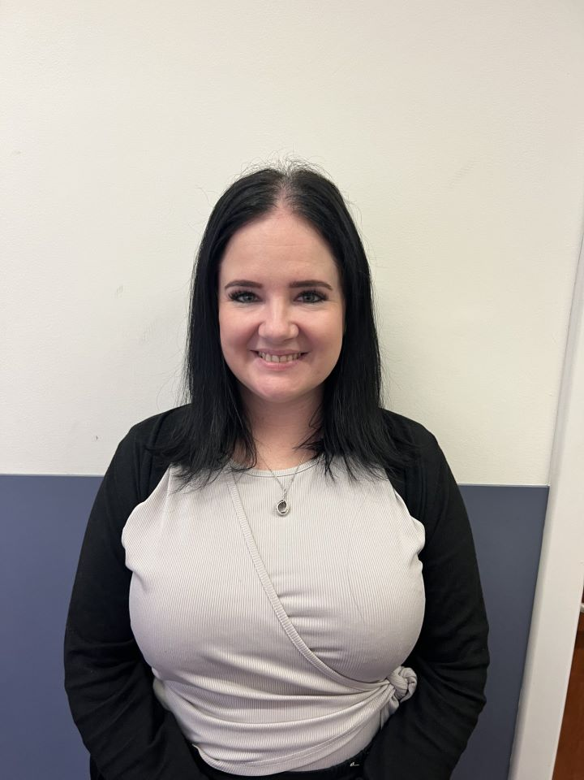

**Home Link Practitioner**

**Mrs Bradford**



# The Curriculum

At New Cumnock Primary School we deliver a Curriculum for Excellence where we aim to develop Successful Learners, Confident Individuals, Responsible Citizens and Effective Contributors.

Our curriculum in the early stages is designed to be practical and interactive. This delivery of the curriculum is of a similar style to the Early Years Childhood Centre where play is the approach used to encourage learning throughout all curricular areas.

**Our vision: “In New Cumnock Primary School, we work together to ensure a welcoming, nurturing and innovative environment which allows everyone to excel on the journey to excellence.”**

## Literacy

Active Literacy, Big Cat reading books, Foundation of Writing and a wide range of East Ayrshire literacy resources are used to introduce the children to their sounds, develop reading, teach grammar and develop confident writers. Children will have a sound booklet which will be brought home to practice the letter. Once they are confident with initial sounds their next step will be to blend the sounds to read words, and the children will be introduced to word lists to work through and develop their skills in blending and broaden their reading vocabulary. Soon after your child is able to do this, a reading book will be introduced.

**Mathematics** 

We use an active approach to teaching mathematical concepts where the children use concrete materials to allow them to develop a deeper understanding of number and calculations. We also have a daily mental arithmetic input.

**Tooth Brushing**

As part of their HWB programme, children will be encouraged to take part in daily toothbrushing. A representative from Ayrshire and Arran Childsmile will be involved at the beginning to deliver a session on how to brush our teeth and to talk about dental hygiene. Our aim within the class will be to brush our teeth after lunch every day, supervised by the class teacher.

**PE**

We ask that you provide a pair of shorts and gym shoes that your child will wear for PE. The kit will remain in the school throughout the year. If shoes become too small or dirty, we will send the shoes or shorts home with a note.

For safety reasons, as a school we encourage no jewellery to be worn while taking part in PE. We would encourage you to make sure your child doesn’t come into school with any jewellery on, particularly earrings as we are not allowed to take these out.

**Medicines/Absences**

If your child is absent, please contact the school before 9.15am on 01290 338404.

Any medication that has to be taken requires a form to be filled in. This can be collected from the school office. All medicines should be brought into school via the school office.  Children should never carry their own medicine.  Also, medicine must be prescribed to the child by the doctor/pharmacist and have the child's name and dose on it.

**Learning Journals**

We will be continuing with Learning Journals and the ECC will transfer through the information needed for us to start putting on information regarding your child’s learning progress.

**Labelling all Clothing**

Please label all clothing. We have a huge problem with lost property due to children’s names not being on clothing. Please label **jumpers**, **cardigans**, trousers, skirts, pinafores, shorts, gym shoes as these are the items that are very easily mixed up due to the children getting changed for gym lessons.

**Playtime Snacks**

Please provide your child with a small snack and drink, there is also free fruit available at the dinner hall. We have pupils within the school that have a NUT ALLERGY, therefore please ensure your child’s snack or packed lunch does not contain nuts or traces of nuts.

Children are always supervised in the playground by their P6 Buddies, Classroom Assistants and the Janitor.

**School Lunches**

Primary 1 children are entitled to free school meals. Parents are able to order their child’s meals in advance through Parent Pay or the child can order themselves in the morning. There is always soup and a choice of 3 main courses and fruit. Activation letters for Parent Pay will be sent out in August once your child has started school. Some children prefer a packed lunch which is eaten in the hall at the same time. They are always supervised in the lunch hall by the Senior Management Team and Classroom Assistants.

**Breakfast Club**

**(AT THIS POINT WE DON’T KNOW IF THERE WILL BE A SMALL PAYMENT FOR BREAKFAST. THIS WILL DEPEND IF WE CAN ACCESS FUNDING)**

Children are invited along to Breakfast Club to not only receive a nutritious breakfast, but to socialise with their friends and take part in a range of activities before the start of the school day.

Breakfast Club starts at 8.15am and children enter via the door to the back of the gym hall (at the rear of the school car park). At 8.45am, children will be released into the school playground before coming into school with their classmates, all energised for the day ahead!

**Parent Pay**

We are a cashless school – anything needing paid throughout the year, you will need to pay through Parent Pay – an activation letter will be given to you for this.

**Water in Class**

We encourage the children to drink water in class – only water, no flavoured water as a rule. Diluting juice is not allowed either.

**Parent Council**

The Parent Council represents parents’ views and supports the school in its work with pupils, reporting back to the Parent Forum. In addition, the Parent Council organises fund-raising events and encourages links between the school, parents, pupils, and the wider community.

**Contact Us**

If you have any questions, contact Mrs J McMurdo, Head Teacher.

Phone: 01290 338404

Email: [joanna.mcmurdo@east-ayrshire.gov.uk](mailto:joanna.mcmurdo@east-ayrshire.gov.uk)

School Website/Blog: [**https://blogs.glowscotland.org.uk/ea/newcumnockprimaryschoolea/**](https://blogs.glowscotland.org.uk/ea/newcumnockprimaryschoolea/)

**Apps to Download**

Apps to download in preparation for your child starting school are -

Safer Schools Scotland App



**Code 6369**

Learning Journals for parents

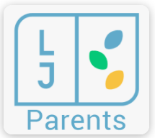

Once you receive your login details through email, when you are linked to the system, you can then login to the above app.

**Other relevant Information**

Numeracy Parental Strategies to support parents/carers.

<https://blogs.glowscotland.org.uk/ea/numeracyandmathematics/category/numeracy-strategies-for-parents-carers/>