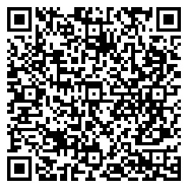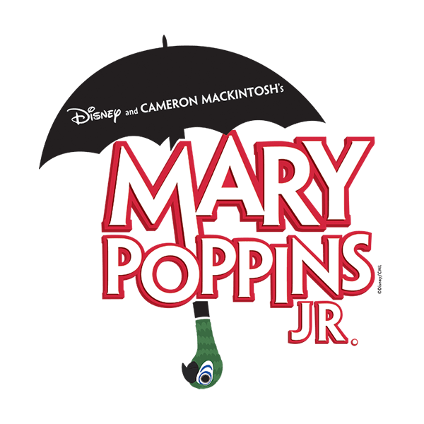

A Musical based on the stories of **P.L. Travers and the Walt Disney Film**

Original Music and Lyrics by **Richard M. Sherman and Robert B. Sherman**

Book by **Julian Fellowes**

New Songs and Additional Music and Lyrics by **George Stiles and Anthony Drewe**

Co-Created by **Cameron Mackintosh**

Adapted by **iTheatrics under the supervision of Timothy Allen McDonald**

**Tuesday 17th June 7pm & Wednesday 18th June 7pm**

(Please enter via the Community Entrance)

Tickets £5 each

Available through TicketSource (Small booking fee applies)

<https://www.ticketsource.co.uk/new-cumnock-primary-school/e-vxkbrr>

This amateur production is presented by arrangement with **Music Theatre International**

All authorised performance materials are also supplied by MTI

[**www.mtishows.co.uk**](http://www.mtishows.co.uk)

**New Cumnock Primary School**

proudly presents…