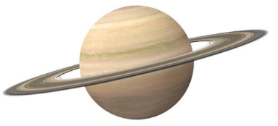**Space Theme Day**

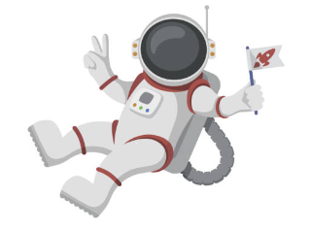 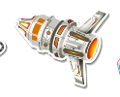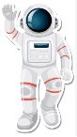

 

               

**25th April 2024**

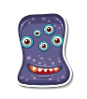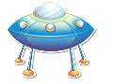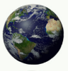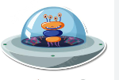

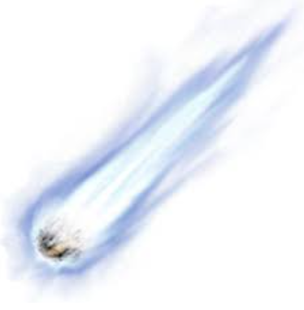

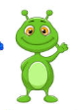

**Space ship sausage sizzlers**

**Neptune nuggets**

**Planet potato chips & Saturn Spaghetti hoops**

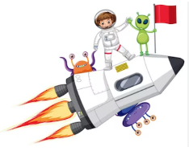**Jupiter jellies / Rocket ice lollies**

*Space ship sausage sizzlers = Hot dog Neptune nuggets = vegan nuggets*

*Planet potato chips & Saturn spaghetti hoops = French fries & spaghetti hoops*

*Jupiter jellies / Rocket ice lollies = jelly / ice lollies*

               

**Fun fact – on April 12th 1961 Yuri Gagarin was the first ever human being to be in space**