**P7 Residential Trip to Galloway Activity Centre**

**Wednesday 24th April – Friday 26th April 2024**

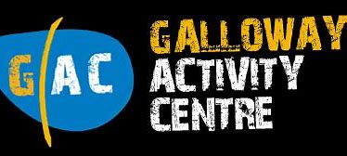

**Kit List**

*• Sleeping bag or duvet/linen*

*• Towels*

*• Swimming things*

*• Waterproofs*

*• Sensible outdoor shoes (trainers, walking boots, wellies)*

*• Spare old trainers (for getting wet)*

*• Lots of changes of clothes*

*• Warm clothing*

*• Pocket money for snacks (suggested £5)*

*• Any medication required*

*• Tooth brush/tooth paste and wash items*

*• Plastic bag for returning with wet clothes*

*• Nothing special is required, wellies, old trackies, pack a mac – it’s not a fashion show you’ll get muddy and dirty!*