Standards and Quality Report
2022-23
Establishment Context
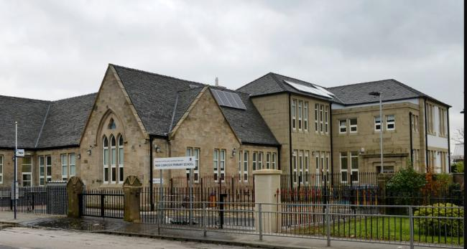
Summary
New Cumnock Primary serves the village of New Cumnock in East Ayrshire. This is a mixed catchment area with children living in the farming community, council estates and private property. The refurbished school building was opened officially in December 2012 by Sir Tom Hunter. The building is a mixture of traditional and modern design with many of the features of the original Castle Primary School retained. There are nine classrooms, an ICT suite and a library. In addition, there is a PE hall and dining hall, a modern fully fitted kitchen, administration areas, meeting room, parent’s room and medical room. Entrances/exits are by means of security doors which are alarmed, and the building is fully disability and discrimination compliant. We pride ourselves on being a nurturing school and we provide nurture groups for targeted children across the school.
Demographics
Stage Profile 2022-2023
 | P1 | P2 | P3 | P4 | P5 | P6 | P7
Boys | 20 | 23 | 18 | 13 | 18 | 10 | 18
Girls | 13 | 19 | 21 | 11 | 14 | 18 | 13
TOTAL | 33 | 42 | 39 | 24 | 32 | 28 | 31
TOTAL | 229
Exclusions
Pupils excluded | 0
Exclusion incidents | 0
Exclusion openings | 0

HMIe Inspection

Our last inspection from HMIe was carried out in October 2017. Our Summarised inspection findings published in January 2018, evaluated the Quality Indicators as follows:

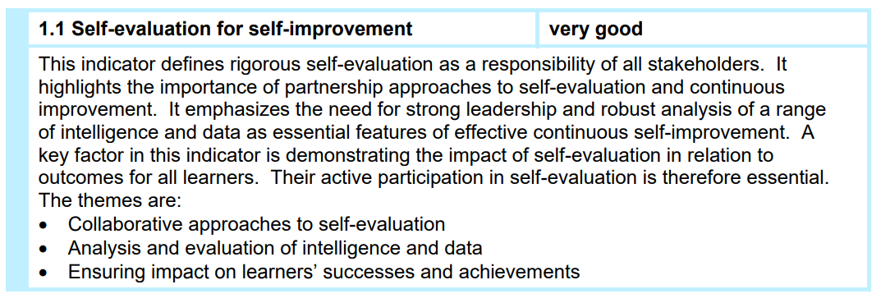

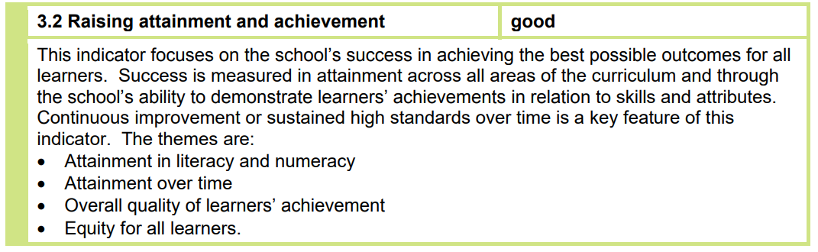

Establishment Vision, Values and Aims
As a whole school community, we reviewed our school Vision and Values during session 2018-2019. All children, staff, parents and partners were consulted through various mediums including a Blether Board at Parents’ Night and a Glow Form, accessed through email. Through this exercise we were able to determine which values the wider community feel are the most important and relevant, and therefore should be promoted. In partnership with Cumnock Academy art department we had the following posters designed. Our children speak confidently and proudly about our values. They are at the forefront of everything we do and every decision we make.
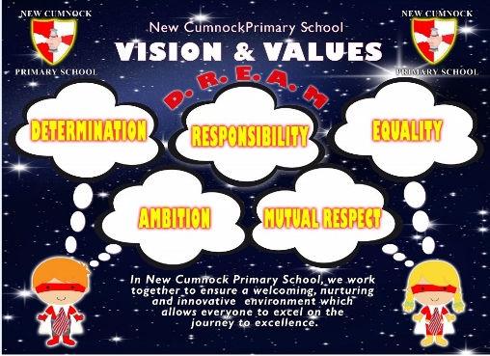

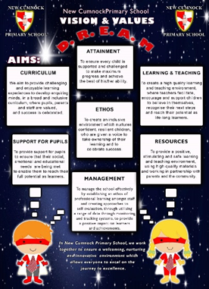

Our aims are as follows:

Aims –
- CURRICULUM - We aim to provide challenging and enjoyable learning experiences to develop enquiring minds, in a broad and inclusive curriculum, where pupils, parents and staff are valued, and success is celebrated.

- ATTAINMENT – To ensure every child is supported and challenged to make maximum progress and achieve the best of his/her ability.

- LEARNING AND TEACHING – To create a high-quality learning and teaching environment, where teachers facilitate, encourage and support children to believe in themselves, recognise their next steps and reach their potential as life-long learners.

- SUPPORT FOR PUPILS – To provide support for pupils to ensure that their social, emotional and educational needs are being met to enable them to reach their full potential as learners.

- ETHOS – To create an inclusive environment which nurtures confident, resilient children, who are given a voice to take ownership of their learning and to celebrate success.

- RESOURCES – To provide a positive, stimulating and safe learning and teaching environment, using high quality materials and working in partnership with parents and the community.

- MANAGEMENT – To manage the school effectively by establishing an ethos of professional learning amongst staff and creating approaches to self-evaluation, through utilising a range of data through monitoring and tracking systems, to provide a positive impact on learners’ successes and achievements.

Improvement Priority  (Expressed as outcomes for learners) | By May 2023, there will be improved attainment in reading and writing of children in Primary 2 to 7, resulting in most (75-90%) children being ‘on track’ in relation to their national expectation. | Rationale for improvement priority based on evidence  Through a range of quality assurance procedures, the Senior Leadership Team identified an inconsistent approach being used across the school in relation to learning and teaching. All staff believe this is as a result of COVID – new staff, staff absence and teachers having to change their approach to learning and teaching due to the mitigations in place.  Our performance information for reading and writing is below 70% for P2-P6.  Through consultation with staff, they identified writing as an area they still lack confidence in and as a result they have requested training for next session. In relation to reading, staff identified lack of quality texts and the relevance of the texts, as a barrier to improving attainment in reading.
NIF Priorities  Improvement in attainment, particularly in literacy and numeracy | NIF Driver  School improvement | HGIOS/ HGIOSELCC QI’s for self-evaluation  2.2, 2.3 and 3.2.
Progress and Impact | Summary of Impact  In an attempt to achieve this priority, a block of staff training was undertaken for writing, and our Literacy Leader was released to research suitable and relevant texts to improve reading. As a result of the training, our Literacy Leader reviewed our policy in relation to reading and writing and through quality assurance procedures the Senior Leadership Team ensured the reviewed policy was being implemented consistently across the school. As a result of the work undertaken in relation to writing, in 3 out of the 6 stages most children are achieving national expectations and in the other 3 stages, the majority are achieving. As well as this, 5 stages have an increase in attainment from last year and 1 has stayed the same.  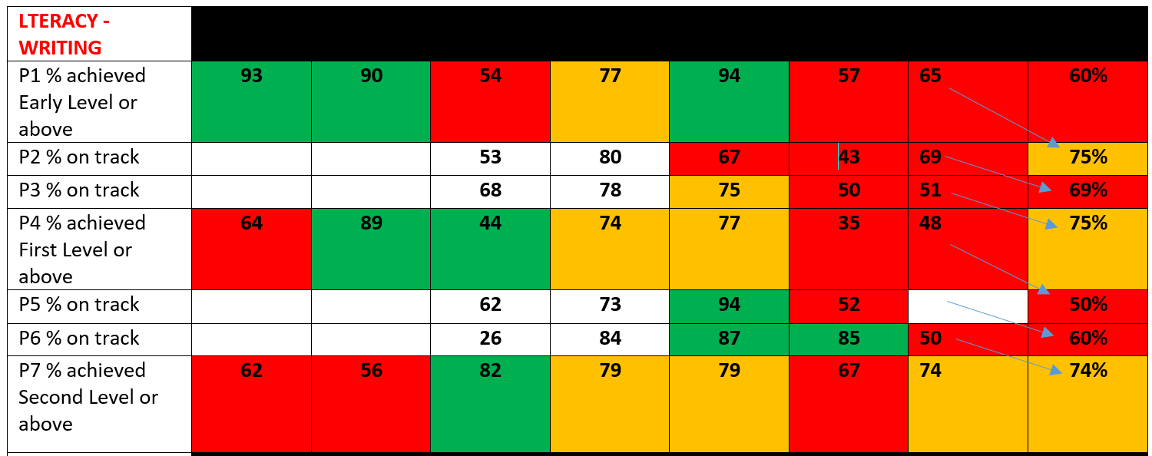  Choosing new reading materials took longer than we anticipated. However, our Literacy Leader did research and organise progressive reading materials from P1-P7. The new scheme and novels will be implemented successfully in August. The Reading section of the policy was adapted to outline expectations in relation to reading across the school. This will be ready for teachers to use in August. Unfortunately, we will not see an impact of these actions until next session.  Writing Training for Staff  Progress  Our term 1 Collegiate Sessions were dedicated to writing training which was delivered by Gail Elder, Literacy Co-ordinator, for East Ayrshire Council. The sessions included a whole school, writing self-evaluation session and a genre mapping exercise for P1 to P7. Staff then explored the Reading into Writing approach and familiarised themselves with the Scottish Attainment Challenge, Creating Outstanding Writing, resource. Mock literacy timetables were created to support staff’s implementation of the pedagogy, before staff then moderated some writing pieces using the EAC Writing Assessment Tool.  Impact  From 7 teachers asked, 85% believe that the writing training they participated in, has helped to raise attainment in writing. Some of the benefits include:  “The SAC training was a valuable opportunity to look at the planning and assessment procedures for writing, particularly in the upper school. Moderation of writing provided clarity for staff when using the East Ayrshire marking criteria. Using the teacher toolkit also ensures there is consistency amongst staff when delivering different genres of writing.”  “I loved the ideas of getting the children to share their sentences/ideas/introductory sentences etc. orally before writing. I think this has had a big impact on the quality of their work as well as to support those children who struggle to come up with ideas.”  The Pupil Council also reported on some of the benefits of the training staff undertook:  “The SAC COW resource is fun!”  “Having our writing in folios helps us to see how we are improving in our writing.”  “Targets help us to remember the things we need to get better at.”  Review of Literacy Policy  Progress  From the quality assurance procedures carried out at the end of Term 1, it was evident from the analysis that there was still a bit of inconsistency in the delivery of Writing across the school. As a result, the Writing section of the Literacy Policy was updated and discussed with staff in relation to Writing expectations.  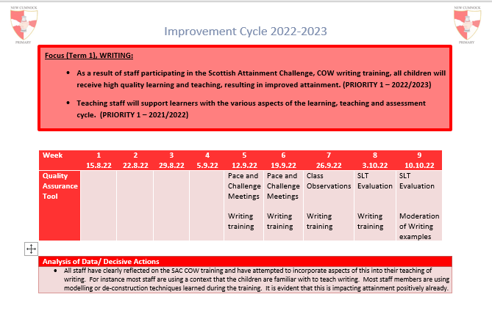  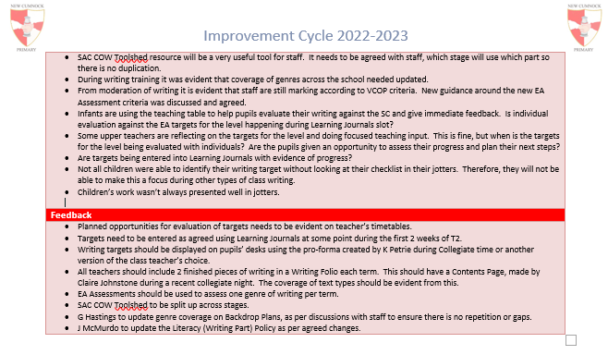  Impact  A class teacher commented that having the expected practice outlined within the policy has also contributed to raising attainment in Writing,  “A review of the writing policy ensures consistency across a level and allows each pupil to experience a range of genres to raise attainment.”  Sharing Good Practice Sessions  Progress  As part of our quality assurance activities, the Senior Leadership Team supervised classes to allow class teachers to visit their colleagues during writing time.  Impact  All staff involved in these felt that these sessions contributed to raising attainment in Writing as they allowed staff to gain ideas in relation to teaching strategies and resources for supporting learners across all levels in their classroom.  “I think it is always good to see how other people teach as you can use/adapt their ideas. Sometimes you get a bit set in your ways and it’s good to get some inspiration. It is also useful to see how writing is developed at different stages.”  “I observed a great lesson and got the resources from the CT to use in my own practice so this will provide something a bit different that I otherwise wouldn't have thought to use.”  Targeted Literacy Support (PEF)  Progress  Targeted literacy support, using The 5 Minute Box resource, was provided by a Classroom Assistant (PEF) across the session to develop core literacy skills (learn the initial sounds, common words and blend to read words) within groups of P2 learners.  Impact  As in previous years, the results have been very positive. The progress of children’s recognition of their initial sounds is outlined below:  Primary 2 August December March May NOTES  Pupil 1 61% 97%***  Pupil 2 4% 11% 28% 30% Attendance  Pupil 3 21% 66% 90% 90%*** Attendance  Pupil 4 35% 88% 88% 95%*** Attendance  Pupil 5 57% 95% 100%*** Attendance  Pupil 6 50% 69% 88% 90%*** Attendance  Pupil 7 76% 83% 100% 100%*** Attendance Late coming  Pupil 8 30% 40% 59% 86% Inconsistent. Possible ASD  Pupil 9 76% 95%*** Late coming  Summary of progress  - 7 out of 9 children, learned almost all of their sounds (over 90%)  - 7 out of 9 children are now able to blend sounds to read words and have started a reading book.  Class teachers reflected positively on the impact of the Classroom Assistant intervention:  “The children involved in the intervention had various barriers impacting their progress. These include poor attendance (one below 50% and one below 60%), late comings and possible underlying intrinsic difficulties. Taking this into consideration I am delighted with the impact on attainment within this group.”  “Mrs Brown has a lovely, nurturing manner with the children. They were keen to spend 1 to 1 time with her in a quiet environment to learn these core skills.”
Next Steps | - Embed the Writing section of our Literacy Policy.  - Implement our new reading scheme, Project X.  - Undertake staff training and book study in relation to reading.  - Whole school participation in the Scottish Book Trust’s reading accreditation programme.

Improvement Priority  (Expressed as outcomes for learners) | By May 2023, it will be evident from a range of qualitative and quantitative data, that a targeted group of P5-P7 pupil’s will have made the best possible progress in relation to their mental wellbeing, through the development of a ‘communication friendly environment’. | Rationale for improvement priority based on evidence  - For the past 3 years we have been developing a relational approach to behaviour across the school.  - The number of children diagnosed/referred for assessment in relation to Autistic Spectrum Disorder, has increased considerably this session.  - The number of children with significant speech and language issues will increase next session.  - Through staff consultation, they identified that they require further Professional Learning to develop effective communication with our young people.  - Parents commented on a recent questionnaire, the need for mental health support within the school for all children.
NIF Priorities  Improvement in children and young people’s health and wellbeing | NIF Driver  Teacher Professionalism | HGIOS/ HGIOSELCC QI’s for self-evaluation  1.2, 1.3, 2.2, 2.3, 2.4 and 3.1
Progress and Impact | Summary of Impact  This session the staff have participated in a variety of training opportunities and working parties to develop and implement a Communication Friendly environment across the school. Children’s mental wellbeing was assessed at the beginning and end of the session to measure the impact of the interventions, using a range of quantitative and qualitative data.  The Glasgow Wellbeing Profile  Progress  The Glasgow wellbeing profile was used by all children in the school in October 2022 and May 2023. As a result of the October 2022 profile, all children with a score lower than 75% were given the opportunity to discuss their concerns with the Senior Leadership Team. By triangulating the views of the child, teacher and SLT, targeted groups were identified and short term targets were implemented to improve the child’s overall wellbeing within the school. Results from May 2023 were used to gauge impact. Due to a variety of factors that can affect a child’s wellbeing, targeted pupils were given the opportunity to discuss any improvements/ barriers since supports have been implemented.  Impact  Affiliation Agency Autonomy Health & Safety  Pre Post Impact Pre Post Impact Pre Post Impact Pre Post Impact  Focus Group Pupil 1 62.5% 82.5% +20% 60% 85% +15%  Pupil 2  Pupil 3 70% 65% -5%  Pupil 4  Pupil 5 57.5% 87.5% +30%  Pupil 6  Pupil 7  Pupil 8 60% 97.5% +37.5% 72.5% 77.5% +5% 50% 97.5% +47.5%  Pupil 9  Pupil 10 60% 85% +25%  Pupil 11  Pupil 12  Pupil 13  Pupil 14 72.5% 77.5% +5% 62.5% 67.5% +5% 70% 92.5% +12.5%  Pupil 15 70% 80% +10% 72.5% 85% +12.5%  Pupil 16 60% 85% +25% 65% 95% +30% 62.5% 90% +27.5%  Pupil 17 72.5% 100% +27.5%  Pupil 18  Pupil 19  Pupil 20 67.5% 90% +22.5% 57.5% 80% +22.5%  Pupil 21 50% 65% +15% 65% 82.5% +17.5% 45% 80% +35%  Pupil 22  Pupil 23 67.5% 97.5% +30%  Pupil 24 20% 97.5% +77.5% 62.5% 100% +37.5% 65% 97.5% +32.5% 52.5% 97.5% +45%  Pupil 25 45% 97.5% +52.5% 55% 100% +45% 50% 100% +50%  Pupil 26 47.5% 97.5% +50% 67.5% 95% +27.5% 47.5% 97.5% +50%  Pupil 27 67.5% 80% 12.5% 70% 87.5% +17.5% 62.5% 97.5% +35% 70% 97.5% +17.5%  Pupil 28 60% 85% +15%  Pupil 29 57.5% 67.5% +10% 62.5% 70% +7.5% 40% 70% +30%  Pupil 30  Pupil 31 30% 82.5% +52.5% 45% 87.5% +42.5% 50% 75% +25% 27.5% 77.5% +50%  Almost all targeted pupils showed an increase in their scores when carrying out the Glasgow wellbeing profile in May 2023. Through discussions with targeted pupils, almost all pupils shared that the supports they received promoted their overall wellbeing in school.  Staff Training  Progress  All staff, including our Classroom Assistants, completed training with our Educational Psychologist in relation to Autism. As a result of this training, staff completed case studies for their classes, identifying barriers and possible supports for our targeted group. Further to this, through the development of our Communication Friendly Classrooms, different approaches were implemented and resources were made readily available to support all pupils. A targeted class was used as a case study to measure the impact of the interventions put in place.  Case Study Example (Whole Class)  AIM To create a classroom environment which is accessible for all learners.  PLAN Context The identified class has a number of pupils with social/ emotional barriers to learning which in the past has made it difficult for them to remain in class and take part in learning experiences with their peers. Furthermore, the class often display low level behaviours which have the potential to distract others. The following supports with focus on Establishing routines/ Safe environment, Identify and implement pupil working groups, Challenge- Slowly increase expectations and Develop relationships with other adults in the school.  DO Describe what happened when you ran your test from the above plan. Week 1-3 (Establishing routines/ Safe environment) - Plan of the day visible on promethean board. - Sensory materials available if needed - Small tasks set during transitions (Early morning table facts, Paths Pupil of the Day, Newsround, drawing task etc…) - Social stories used to support Pupil 1 in staying in class. - Now and Then board used for Pupil 1. - Safe space identified in class - Reward time for Pupil 1 for completing tasks. - Observation chart for Pupil 1 to establish strengths and barriers to learning. Week 4-8 (Identify and implement pupil working groups) - Literacy and Numeracy working groups identified and implemented. - Pupil 1 work to be annotated to show how much of task was completed independently or with support (stored in file). - Pupil 2 and Pupil 3 to check in with HLP on a weekly basis Week 8-12 (Challenge- Slowly increase expectations) - Natural consequences for negative behaviours (allow opportunities to earn back). - Planned challenges as part of school day. Use social stories to share ideas of how to appropriately act during the situation (i.e. favourite seat has been taken in ICT, what should you do?) - Start to promote staying in class more and only go to the DEN for reward time at the end of the day (Pupil 1). Week 12-14 (Develop relationship with other adults in the school) - Further develop relationship with class teacher. - Senior Leadership Team to work in the room next to the class to be able to quickly support class if needed.  STUDY - NME - Communication Friendly Approaches - Relationship Policy - Inclusive Practice  ACT Finding class work too difficult has been a factor in pupils becoming dysregulated. Focus groups to be identified to remove barriers to learning for our identified learners. Almost all pupils have responded very well to clear routines, expectations and boundaries within the class. Ensuring the correct classroom dynamics creates a calm environment where our identified learners are motivated to model positive classroom behaviours. Due to two adults supporting this class, this has been easier to manage.  Impact  The targeted class showed an increase in attainment within all priority areas (Numeracy= +33%, Reading=+15%, Writing=+26%, L&T, 21%). 3 pupils who were previously extracted from class due to social/emotional barriers to learning, have participated in learning full time within the classroom environment. Quotes from parents regarding approach and impact include:  “My child feels safer within the class environment and looks forward to coming to school.”  “My child is becoming more confident knowing that pupils who demonstrate big behaviours are receiving the correct support.”  Neurosequential Model in Education  Progress  Our Inclusive Practice Policy was reviewed and updated to create a new inclusive approach, which promotes pupil engagement and wellbeing through class/pupil specific, universal and targeted support (See below).  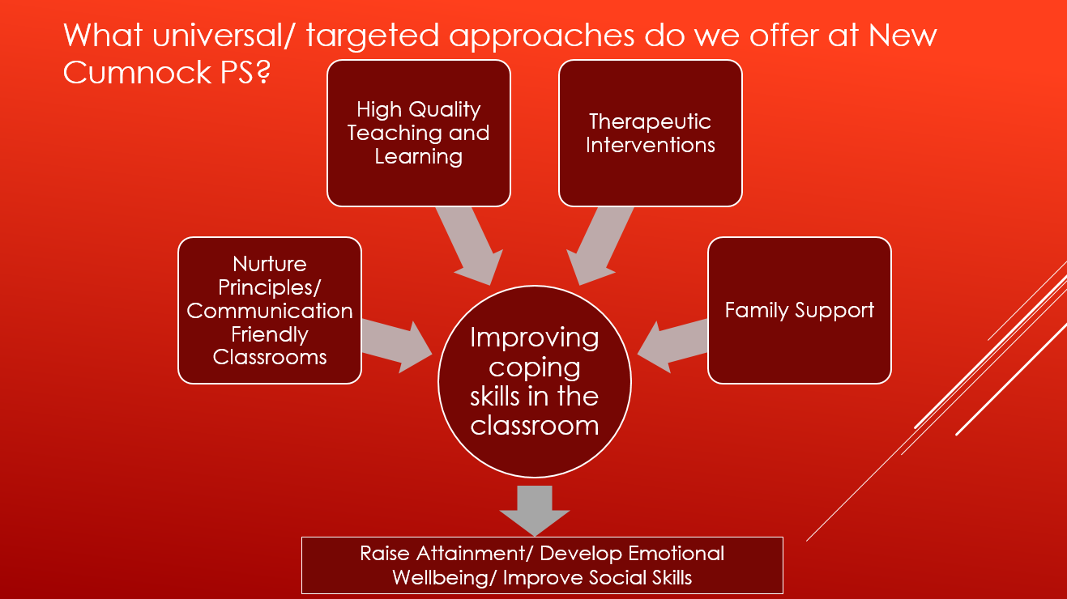  The neurosequential model in education forms part of the therapeutic interventions.  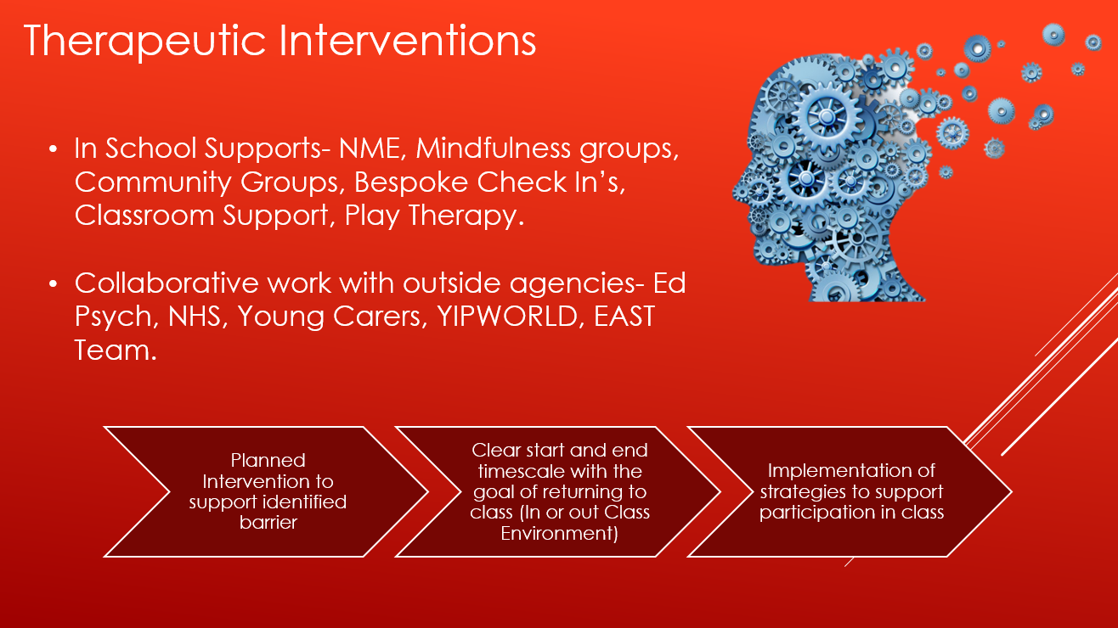  During the February in service day, all staff considered and identified how to incorporate NME approaches within the class environment to support the regulation of emotions. Through the Depute Head Teacher’s, Masters in Education, Mental Health and Education course, NME was researched to gauge the benefits it has on developing interpersonal communication and relationships. Some of these are outlined in the activity plan below.  Activity Plan  Restorative Approach to support ‘Pupil A’ who’s social/emotional difficulties acts as a barrier to positively engage in the school environment.  Rationale  The purpose of implementing the Restorative Approach is to: Understand other people’s behaviour and reflect on our own behaviour, develop self-compassion, empathy and compassion for others, and to find solutions to disagreements and potential conflicts. This will be implemented with Pupil A in the form of a 1 to 1 meeting with the Depute Head Teacher (identified key adult) when specific incidents happen in school.  Desired Outcome  Pupil A to develop openness to alternative ways of thinking, develop ways of supporting their social/ emotional needs and potentially engage more positively in the school environment.  Implementing the Restorative Approach  Stage 1: The Storytelling (Understanding that everyone has their own unique and equally valued perspective)  - Support Pupil A in using different strategies to enable them to regulate their emotions before engaging in the restorative conversation (Accessing a safe space/ NME approaches).  - Speak with all relevant stakeholders regarding the incident to gain different points of views to what happened.  - Identified Safe Space- The Nurture Room will be used to host the restorative conversation. A ‘meeting in progress’ sign will be used to ensure no disruptions.  - Establish expectations for the conversation (one person speaks at a time, listen to others when they are speaking, facilitator establishes when it is a person’s turn to speak, treat other people’s opinions with respect).  - Facilitate questioning to share different points of views (What were you doing/saying then? Before that/ after that/ and then what happened? Tell me more about that. Anything else? Your thoughts then? How were you feeling then? What did you see them do/hear them say?).  Stage 2: The Impact (Knowing that thoughts influence emotions and emotions influence actions/ Having and showing empathy and consideration)  - Facilitate questions to raise awareness of the impact on themselves and others (How has this affected you? What's been the hardest thing? Who else has been affected? How have they been affected? How do you know? How do you feel now? Anything else?).  - Promote relationship building and conflict resolution.  - Embrace qualities such as compassion, empathy, perseverance and open-minded thinking.  Stage 3: The Solution: (Identifying needs and unmet needs/Supporting a culture of collective responsibility for problem solving and decision making)  - Discussing alternative behaviours and potentially creating a plan for the future.  - Reiterate the expectation of how to engage in school.  - Feedback to relevant stakeholder if relevant (Staff, Parents, Pupils)  Impact  The majority of staff/pupils have been observed using NME strategies to support pupils in relating, reasoning and regulating. Through pupil case studies, bespoke strategies specific to individual pupils needs, have been effectively used to support pupils when they become dysregulated. High instances have been observed of pupils being able to self-regulate by using these strategies to quickly re-engage within the school environment. Through our quality assurance procedures, our current suite of therapeutic interventions have been evaluated and NME has been added as an approach that will be consistently applied to ensure universal and targeted support of all pupils. With the addition of NME as a therapeutic intervention, the school will now have more resources/strategies to provide a more bespoke approach to supporting learner’s individual needs.  Mental Health Champions  Progress  Unfortunately, our P6 pupils weren’t able to access the training until term 4. Online training for a targeted class was delivered, covering The Role of Wellbeing Champion, Kindness, Mental Health and Wellbeing, Mindfulness and Mindset.  Impact -  96% of our P6 children participated in 3 of the 4 sessions, with 71% (20 out of 28) of children completing all 4 sessions and receiving an award and title of Wellbeing Champion.  Quotes from staff and children:  “Wearing a lanyard will make me feel important.”  “It will give us more responsibilities and higher chance of being a Prefect or Captain next year. We can be a good example for the wee ones.”  “It helped my patience because we were talking to important people on Teams, it made me wait my turn and not shout out.”  “The training taught the children valuable skills about positive mindset and what mental wellbeing looks like. This will equip them with the skills and knowledge to deal with situations and support their peers in the playground.”  Classroom Assistant to support the mental wellbeing of targeted children (PEF)  Progress  Our Classroom Assistant provides targeted support to improve pupil’s coping skills within the class, leading to a more positive state of mental health and school engagement. This may include:  - Targeted in class support (Specific social/ emotional and academic support)  - Targeted support group (Planned extraction from class within a timeframe)  - Supporting a pupil with a differentiated Curriculum (Planned experiences to support disengaged pupils)  - Transitions (Supporting the transition from classroom to playground environment)  Impact -  Pre-intervention Data  - GMWP results in November 2022 highlighted that 29.8% of pupils scored lower than 75% in relation to one or more of the SHANARRI indicators.  - Within P5-7, 3 pupils were not engaging in the class environment and worked/participated outside of the classroom due to social/ emotional barriers to learning.  - Staff, parents and other children commented on the anxiety they felt when supporting or witnessing pupils demonstrating violent outbursts due their social/emotional needs.  Post-intervention Data  - 2 out of the 3 pupils are now accessing the class environment with planned support. Observations from the SLT and class teachers suggest improved engagement in both social and academic contexts. 1 out of the 3 pupils are now successfully accessing a differentiated curriculum.  - During parents night, P5 parents shared their appreciation for the in class support for a specific pupil and commented how their child feels safer and more confident within the class knowing that an adult is available to support the specific pupil.  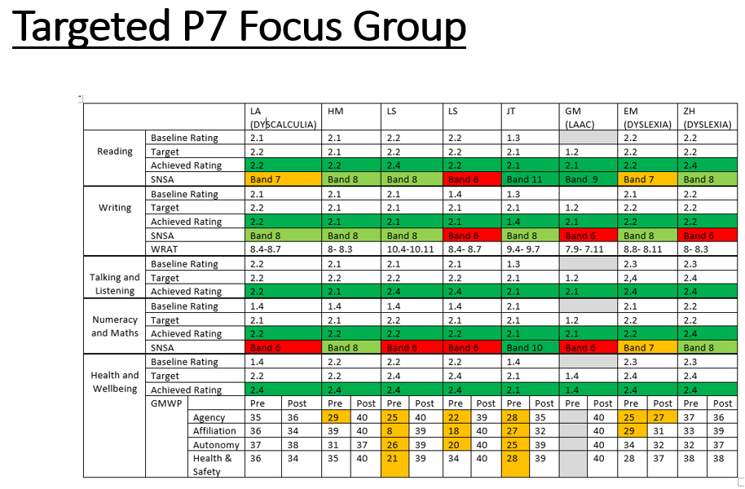  The table above shows the impact on the attainment of a small group of 8 P7’s that our Classroom Assistant supported on a daily basis. Out of 40 targets, 38 were achieved. Of that 38, 15 targets exceeded expectation.
Next Steps | - Glasgow Wellbeing Profile will continue to be used at the beginning and end of the school year as an assessment tool to ensure all pupils have an opportunity to share their feelings around their social/ emotional wellbeing in school. A similar approach will be explored to allow staff the opportunity to share their views on their own wellbeing and the impact this has in the classroom.  - NME supports will continued to be utilised within class and will be highlighted within class case studies to ensure consistent approaches when different staff are working with a class. The playground environment will now be evaluated to ensure these approaches are readily available within this context.  - Mental Health Champions will support younger pupils within the school with a main focus being in the playground environment.  - PEF Classroom Assistant will continue to be utilised to implement the schools Inclusive Practice Policy.

Improvement Priority  (Expressed as outcomes for learners) | By May 2023, most children within a targeted group, will have made the best possible progress in relation to literacy attainment, by re-establishing effective partnership working with the school and local partners to remove barriers to engagement. | Rationale for improvement priority based on evidence  Prior to COVID 19, parental engagement was identified by HMIe as one of our strengths. We worked effectively with local partners and agencies to remove barriers to engagement whilst meeting the needs of our families. However, through various forms of consultation this session it has become evident that due to the recent mitigations, opportunities for parental participation has been limited. Parents want more opportunities to be kept informed about their child’s progress and learning, they want more regular communication regarding school life and events, opportunities to learn together and advice to support their child’s learning.  As we know attendance naturally impacts attainment. This session 53% of our children, falling below the 90% threshold for attendance are from SIMD level 1 and 2. By working with these families to address barriers to engagement, we should naturally improve attendance, thus attainment.
NIF Priorities  Closing the attainment gap between the most and least disadvantaged children | NIF Driver  School Improvement and Parental Engagement | HGIOS/ HGIOSELCC QI’s for self-evaluation  1.5, 2.4, 2.5 and 2.7
Progress and Impact | Summary of Impact  This session we have successfully strengthened our partnership with our parents/carers which was impacted by Covid 19. Parents have been welcomed into the school to enjoy time in their child’s class to see learning taking place, watch their child in performances and act as Parent Helpers. For many of our infant parents, this was the first time they had been in the building due to Covid regulations. We have implemented a free Breakfast Club in a bid to improve hunger, wellbeing, attendance and attainment. We have established a Parents Group and Parental Empowerment group in which parents are receiving training opportunities and gaining employability skills. Our Poverty Proofing Agenda has been further developed and involves effective partnership working in an attempt to further reduce barriers for our young people.  As a result of the effective partnership working described above, to remove barriers to engagement (pupil and parental), most children within a targeted group for Writing and Listening and Talking have made the best possible progress. In Reading, the majority of children within a targeted group have made the best possible progress (SEE BELOW). It should be noted that Reading attainment across the school has been identified as an area for improvement next session.  Reading  Majority achieved in relation their individual target – 65%  Writing  Most achieved in relation their individual target – 75%  Listening and Talking  Most achieved in relation their individual target – 85%  Parental Engagement and Communication  Progress –  At the start of the school session we hosted a ‘Bring a Parent to School Day’, where our parents/carers were welcomed back into our school building to see their child’s learning environment and the learning taking place. We showcased learning within Literacy and Numeracy. Prior to visiting the classes, we took the opportunity to share a presentation with our infant parents/carers about phonics. Whilst visiting classes, we showcased some of the resources used and explained the pedagogy for our delivery of Literacy. All children were sent home with Literacy and Numeracy parental engagement packs provided to us by the Scottish Attainment Challenge team. Inside the packs was information about how the curricular areas are delivered in school and tips for parents to show how they could support their child with learning at home.  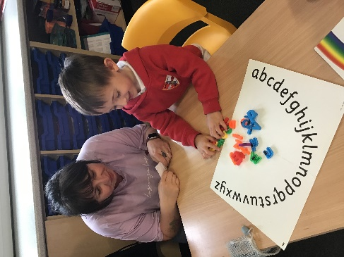  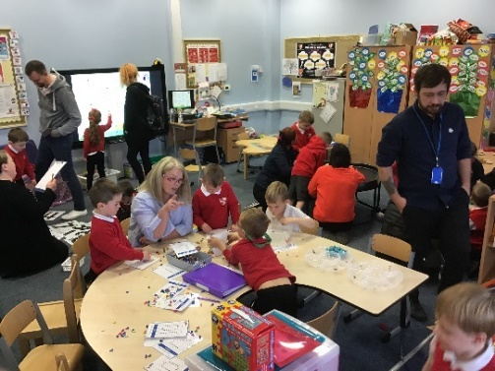  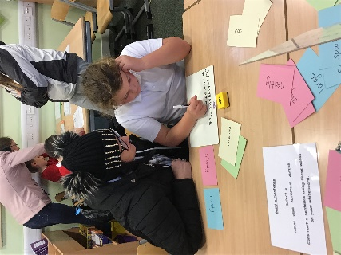  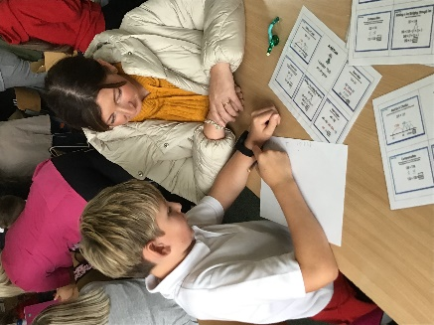  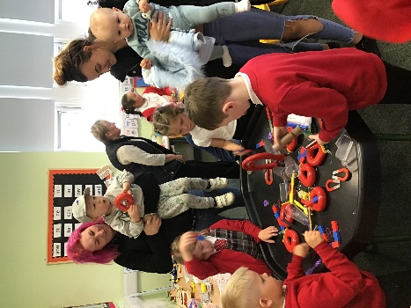  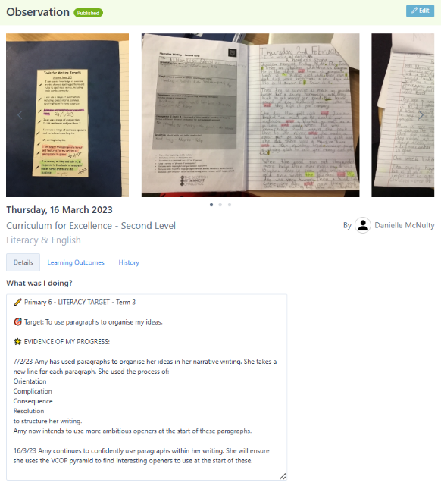  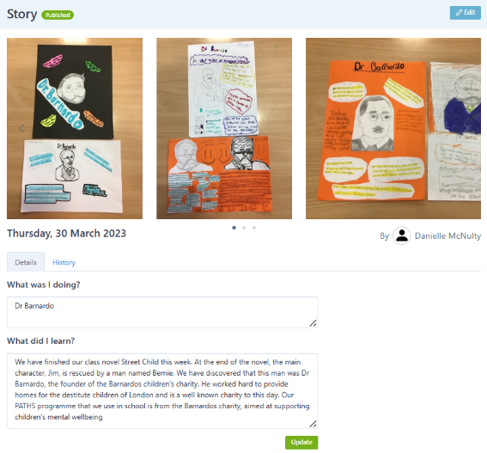  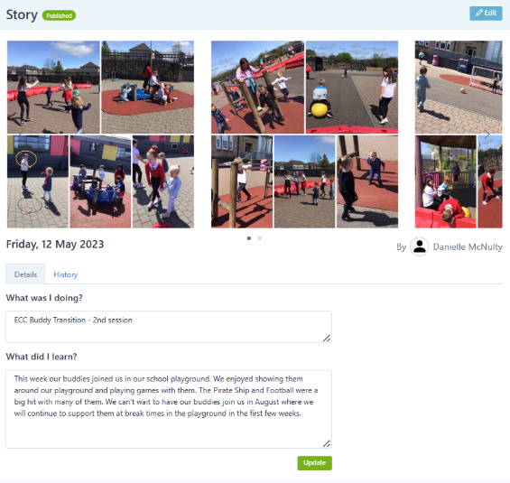  In order to ensure our parents/carers are kept informed about their child’s progress and learning, this session, we continued with the use of Learning Journals to share whole class learning. We also use this software to set Writing Targets with the children. These are reviewed across the session and the parents are able to track their child’s progress. Parents are encouraged to share Parental Contributions to show learning taking place at home. This has been a useful way of addressing Wider Achievement targets at Silver and Gold level.  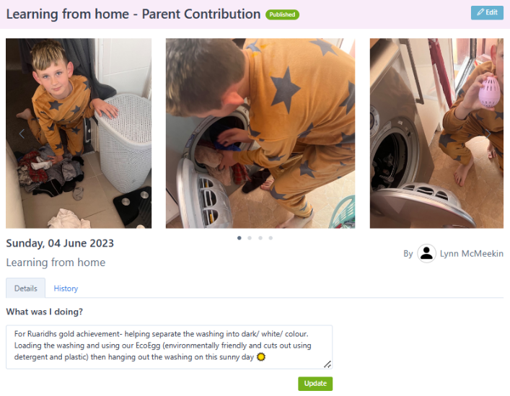  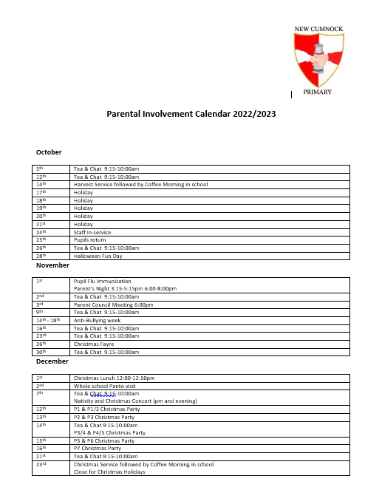  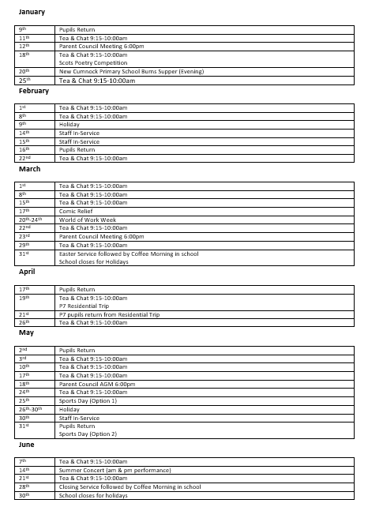  Parents have expressed they want more regular communication regarding school life and events. A Parental Involvement Calendar was published on our communication platforms at the start of the session to indicate important dates for the diary. We continue to report to our parents/carers on whole school events by sharing posts on our school blog, on our Twitter platform and some of these are further shared by our partners at the local newspaper.  Impact -  Parents and carers were asked if ‘Bring A Parent To School Day' helped them and their child – All agreed 100%.  “It always helps to see what everyone has been up to at school and also give us the chance to speak to the teachers.”  “It gave me as a parent a visual of how my daughter spends her day. She was able to show me her favourite places in the classroom.”  “Seeing her learning space for the first time made things alot easier for her to explain what she was doing in class and how the class worked, as she started just after covid.”  When asked about the benefits of parents/carers coming into the school, parents commented:  “Parents can ask what the kids are learning after seeing the class layout and having seen how the teaching is delivered, so the same set up for learning can be done at home.”  “It was good to see how learning is delivered to enable me to help my son at home or at least try to.”  “Think if a parent is not confident in coming to ask for help if struggling at home allows them to have the confidence to ask face to face. You end up building a better relationship with parent/teacher and have better engagement with parent/teacher too, as parents make more an effort to come in and see their child within school.”  Parents were asked if the Literacy and Numeracy information packs sent home after ‘Bring A Parent To School Day’ were useful – Most agreed 85%  “Another opportunity to incorporate new ideas and approach to the homework schedule already in place, educational support materials are always useful.”  “They were helpful. As how my daughter is learning is very much different to the way I learned to do things at school. So it made homework easier as I was following the way she learns at school so there was no confusion.”  “Packs helps as learning changes all the time.”  Parents were asked if they felt that Learning Journals meet the purpose of acting as a communication tool with our parents to report on the class/your child's learning – Most agreed 85%  “Learning journals are useful as parents because we have the opportunity to indirectly enhance their learning opportunities by focusing on subjects the kids may struggle with, using the journal as a tool to understand their strengths and weakness.”  “Enjoy seeing what he is doing as my son isn't always the best at telling me what he is doing. Good seeing photos of him clearly enjoying being at school.”  “Love the learning journals and being able to see what my daughter has been getting up to all week. It gives us conversation starters about how her day has been at school and she is always pleasantly surprised that I can tell her what she's been learning and creating.”  Parents were asked if the Parental Involvement Calendar we shared with our families was useful – Most agreed 88%  “I like to have a diary of events so that I can plan ahead and swap work days if possible.”  “It lets you plan out and work appointments around what's happening at the school.”  “It helped to plan ahead with working days to enable me to get time off.  Breakfast Club  Progress –  This session, we were keen to establish a Breakfast Club as research has shown that there are positive links between Breakfast Club provision, educational achievement, attainment and behaviour in school children. A successful funding bid to the New Cumnock Development Trust secured us £10,000 to establish and run our Breakfast Club with no cost expected from our families. These funds have been used to pay for staff, food, resources and outside agencies to provide activities at Breakfast Club.  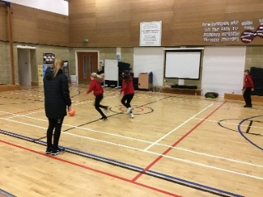  Our demographic of children who attend the Breakfast Club, do so for different reasons:  - Children who would benefit from a healthy breakfast.  - Children of working parents who require the support of children care in the morning to get to their work.  - Children who were identified as having high levels of late arrivals to school.  - Children who find transitions from the playground to school difficult.  - Children who would benefit from an emotional check-in prior to school starting  Impact –  From the 101 children we have on our school roll who are SIMD 1+2, 20 of them attend Breakfast Club weekly (20%). An average of 21 pupils attend on a daily basis.  This session we targeted children who are constantly arriving late for school in the mornings through Breakfast Club. An attendance review of 5 targeted children showed 100% reduction in school late comings between September and April. With Breakfast Club starting in January, it is evident of the positive impact this has had on overcoming late arrivals to school for these pupils.  Pupil A  Sep Oct Nov Dec Jan Feb Mar Apr  lates 2 1 4 4 2 1 0 0  Pupil B  Sep Oct Nov Dec Jan Feb Mar Apr  lates 4 6 3 3 5 1 0 0  Pupil C  Sep Oct Nov Dec Jan Feb Mar Apr  lates 7 6 5 5 0 0 0 0  In a Glow Form to pupils, staff and parents about Breakfast Club, the following feedback was gained.  Pupils: From our target group of 18 children (2/class)  94% believe attending Breakfast Club helps them to arrive at school on time.  94% enjoy a healthy breakfast.  67% use it as an opportunity to check in with Mrs Bradford.  94% believe that as a result of attending Breakfast Club, they are then mentally prepared to start their day.  83% would definitely return if Breakfast Club continues to run next year. 17% were a maybe.  Quotes from children:  'It helps my mum so she can just drop me of and go to work.'  'It helps me wake up early so I don't sleep in.'  'Mrs Bradford always asks me how I've been doing and feeling.'  'It puts me in a better mood.'  Staff:  75% believe attending Breakfast Club helps them to arrive at school on time.  100% enjoy a healthy breakfast.  100% use it as an opportunity to check in with Mrs Bradford.  88% believe that as a result of attending Breakfast Club, they are then mentally prepared to start their day.  Quotes from staff:  'I have a child who is much happier about coming into the classroom at 9am, or before, due to her soft start at the breakfast club.'  'A child in my class was persistently late prior to breakfast club starting. He is never late anymore.'  'Children who in the past have been frequently late are now accessing Breakfast Club and no longer missing part of their morning lesson in class.'  'Pupils attending from my class benefit from the opportunity to check in with Mrs Bradford. It’s a good opportunity for a consistent check-in when as there are less time constraints and interruptions.'  Parents/carers:  100% believe attending Breakfast Club helps them to arrive at school on time.  Quotes from parents/carers:  'My granddaughter enjoys going so she is up and ready a bit more easily in the morning. She would not eat a breakfast at home.'  After school clubs  Progress –  After school clubs have been re-established this session and are either being delivered by teaching staff or partner agencies such as Active Schools.  Throughout the session, we have tried to run a variety of clubs for different age groups and to cater for all needs. These groups have included:  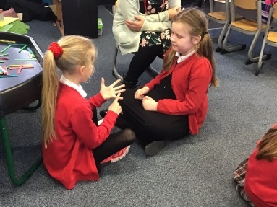  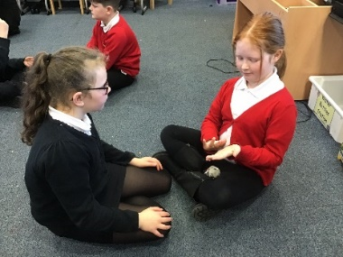  - Homework Club  - Active Schools - Multisports  - Football  - Drama - School production of Oliver! JR  - Choir  - British Sign Language  - ICT  - Sticky Fingers – Emotional Literacy (ELSA)  - Bikeability  - Recorder  Each of these clubs have been well attended, with some running for a short 4 week block and some running right throughout the school year. Through addressing Article 15 of the UNCRC as our Right of the Fortnight, children had the opportunity to express which clubs they would like the opportunity to attend after school which we will keep in mind when planning next session. These included cheerleading, cooking and badminton.  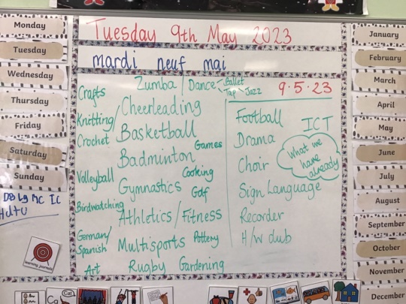  Impact –  Pupils and parents were asked to provide some feedback on After School clubs for us to take into account for next session. Most common responses included:  *More sports clubs to be on offer  *Homework Club to return as this helped many families  *Club availability for all stages in the school  *Straight from school 3-4pm is most suitable  *More variety needed, for example crafts, baking and sewing  Family Learning Opportunities  Progress -  Our Home Link Practitioner has played an invaluable role this session by helping children and families through a range of supports and interventions. The diagram below outlines the vast role T Bradford has undertaken this session.  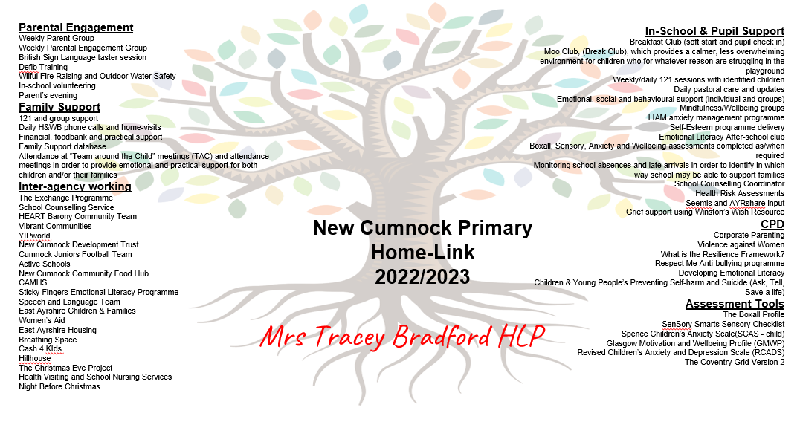  Part of the Home Link Practitioner’s role this year was to work with other agencies to provide Family Learning opportunities. A very successful partnership was with Vibrant Communities who run family holiday programmes during the Easter holidays, addressing school holiday hunger as well as helping to improve attainment in numeracy, literacy and health and wellbeing.  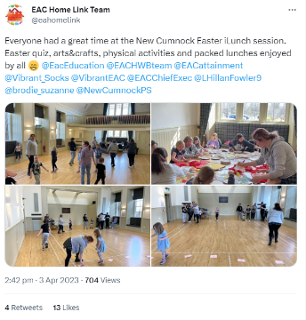  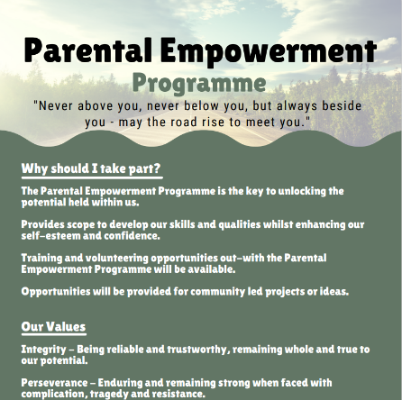  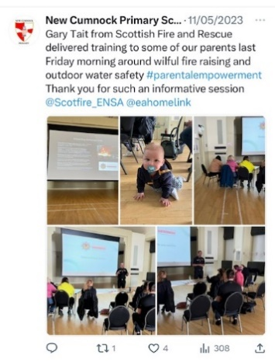  In addition to this programme, T Bradford also successfully ran Parental Empowerment groups weekly, where parents/ carers have had the opportunity to develop skills and knowledge in Defibrillation, Cardiopulmonary resuscitation, British Sign Language, Wilful Fire raising and outdoor water safety (in association with Scottish Fire and Rescue).  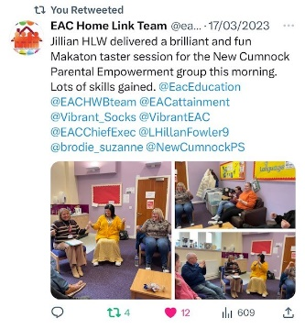  This session we have successfully established a Parent’s Group who meet each week, as not only a welcome space to meet other parents and be welcomed into the school, but to develop skills and be part of driving forward school important. Not only have these parents supported us in in organising and Book Banding of our school library, they also made crafts to be sold at our Christmas Fayre. In addition to this, they attended a cooking class using East Ayrshires Clean Green Cookbook, which helped to promote affordable, clean and green recipes. This was very well received and we are already planning our next cooking session using the cook book. These parents have also supported us in a Parent Helper role this session, from supporting on community litter picks to walking to the pool for swimming lessons and attending on trips. Their support is invaluable.  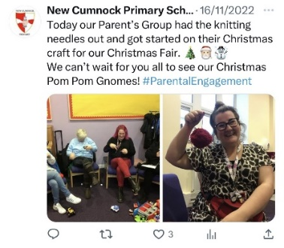  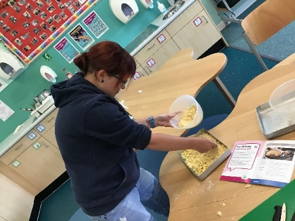  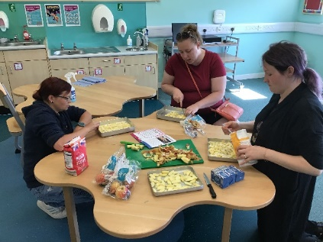  Our Parent Council continues to be a strong support to our school. Due to the work in relation to parental involvement and engagement this session, we have seen it grow in numbers with new parents joining and a wide representation of our families in attendance.  Impact –  In a recent GLOW Form, parents were asked to rate the quality of support they receive from our home link practitioner from 1 to 5, with 5 being the highest. Tracey scored an average score of 4.83. Some positive comments made by parents include:  - “She is great with the kids and is great to talk to about any concerns.”  - “I received help from Tracey on multiple occasions for a variety of things and she's always done her best to support me and my 2 boys, she goes above and beyond to help parents and kids.”  - “That she is always there to listen to you and give advice no matter what.”  - “The HLP within the school has had a massive impact on my son by having someone we can speak to about any issues we have at home or at school to help support him.”  - “Our HLP always makes herself available and makes herself known to the children. She is very friendly and has a great attitude towards the children.”  - “Her calming ability with my child and the care and consideration taken while fulfilling his needs.”  Parents reported positively on the Family Learning opportunities organised by our Home Link Practitioner:  “Parent group gives us a chance to unwind and get support from other parents.”  “They help us gain more skills.”  9 families participated in the Easter iLunch programme. Feedback was gained by those in attendance.  Evaluation Question % of families rating 4/5 on a scale of 1-5 (1 being not at, 5 being a great deal)  As a family, how much did you enjoy taking part in the ilunch activities? 100%  Did you find the text messages and phone calls you received from your contact person helpful? 100%  As a family how many hours did you spend together taking part in the ilunch activities? 50%  How much has being part of the Ilunch programme helped you to support your child with their learning? 100%  How much did you enjoy the lunches? 100%  Some quotes from the families include:  “We liked the bug hunting, keep up the good work yous are brilliant.”  “We all had a great time, our favourite game was the numbers game with the circles.”  Feedback was also gained from parents participating in Parental Empowerment through use of Glow Form:  “Parent group gives us a chance to unwind and get support from other parents.”  “Helps us gain more skills.”  Poverty Proofing Agenda  Progress –  Our Clean Green Schools team have been responsible for sorting through our lost property stations and returning items that are found to their owners. At the end of each term, items that were not named were then washed and dried, before being packaged for our free uniform bank which is displayed in our main office of the school. We remind our parents of this uniform bank at the start of each term. Our Home Link Practitioner will regularly access the uniform bank to support our vulnerable families who we have identified as not wearing school uniform.  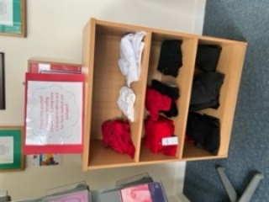  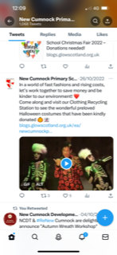  At key points in the year, we ran a Halloween Costume Swap Shop as well as a Winter Jacket Project. We work closely with our local reuse hub, ‘Phase 2’ and any extra items we have left over are donated there or alternatively, we direct our families there throughout the school year.  This session, Mrs McNulty met with Vicky McWilliams to discuss Period Poverty Proofing our school. This will be established in our school with Ambassadors selected from each of the upper classes. Products will be purchased and made accessible to all and a point of contact will be made for period products to be accessed in bulk prior to a holiday.  This session Mrs McNulty and Mrs Bradford established a partnership with Laura Greer from the RBA Financial Inclusion Team.  Impact –  Our Pupil Council were asked to comment on the impact of our clothing support:  “I can’t believe how much school uniform we have available, there isn’t an excuse to wear it when we have all this here.”  “I like having the clothing bank inside the school as some people can be embarrassed to get help with clothes. This way, they can come into school and get it and no one else will know.”  “It’s great that we help on special occasions like Halloween and special times like Christmas. These costumes can be expensive and not everyone can afford to get new ones but what we have on offer is like brand new!”  Since Laura’s visit to school, we have submitted a total of 7 referrals for Financial Support for our families.  This session our families have benefited from a wide range of outside agency support. During the Christmas period this included:  - Hillhouse in Kilmarnock provided 22 children with an extra Christmas parcel.  - The Night before Christmas Campaign enabled 17 of our children to receive a Christmas Eve gift.  - A total of £1,665 in vouchers were given out to 17 families to help them with their Christmas shopping.  - £1,590 worth of Farmfoods vouchers were received by families through the kindness of NCDT to help with their food shopping.  - Our Parent Council have made contributions to P7 Leavers Hoodies, P7 Residential and transport for school trip, thus keeping the cost of these events down for our families.
Next Steps | - The Home Link Practitioner and Principal Teacher will create more opportunities for parental involvement and engagement, for example, Families Connect – Literacy (Parents and children) workshops.  - Financial Inclusion Team to be utilised throughout the session.  - Period Poverty Proofing agenda – Vicky McWilliams. Ambassadors to allocate – products to be ordered and made available in locations around school.  - The kitchen requires a blast chill to provide food tubs at the end of lunch.  - A ‘Share Trolley’ will be established in the lunch hall to reduce waste.  - In order to support our more vulnerable families in providing engaging learning opportunities in the home, we will create home learning packs for our most vulnerable families.  - Host workshops on ‘How to support your child at home’ (addressing Reading/Spelling/running a Lending Library).

Improvement Priority  (Expressed as outcomes for learners) | By May 2023, almost all children at early and first level will have improved understanding of positive school-leaver opportunities available in New Cumnock and the surrounding area, and develop their skills for work, learning and life. | Rationale for improvement priority based on evidence  When reviewing our Curriculum Rationale as a whole staff during session 2020-2021, we explored, ‘What Makes New Cumnock unique?’ We realised that our curriculum didn’t reflect the positive school leaver opportunities within the village or local area as well as it could. As a staff we feel it is important to provide the children with the knowledge and skills required for local trades/jobs should they wish to undertake them when they are older.  During session 2021-2022 we reviewed the second level curriculum to develop the children’s understanding of positive school-leaver opportunities available in New Cumnock and the surrounding area, thus develop children’s skills for work, learning and life. This session we hope to progress this further into early and first level to ensure progression across all stages.
NIF Priorities  Improvement in employability skills and sustained, positive school leaver destinations | NIF Driver  School improvement | HGIOS/ HGIOSELCC QI’s for self-evaluation  1.2, 2.2, 2.7 and 3.3.
Progress and Impact | Summary of Impact  This year we planned experiences across the First and Early level curriculum to facilitate learning about positive school leaver destinations within our village and the surrounding local area, carrying on from our work in 2021/22 session where we focused on Second level curriculum. We developed our First and Early level backdrop plans to reflect local opportunities, linking them in with both current and new interdisciplinary contexts. The variety of experiences and activities provided to children have allowed almost all pupils to develop skills for learning, life and work using our local context to provide relevance and enjoyment. As well as developing the curriculum, we organised a celebration of local employability through World of Work week. Almost all children took part in workshops related to engineering, agriculture and creative industries, as well as planned opportunities for enterprising education with a focus on problem solving, decision making and team work. Our classes were also able to experience trips out of school to further facilitate this learning. After consultation with pupils, staff identified that almost all pupils across Early and First level have an improved understanding of positive school-leaver opportunities available in New Cumnock and the surrounding area.  Classes collated pupil voices to evidence and support their teacher judgements for this priority:  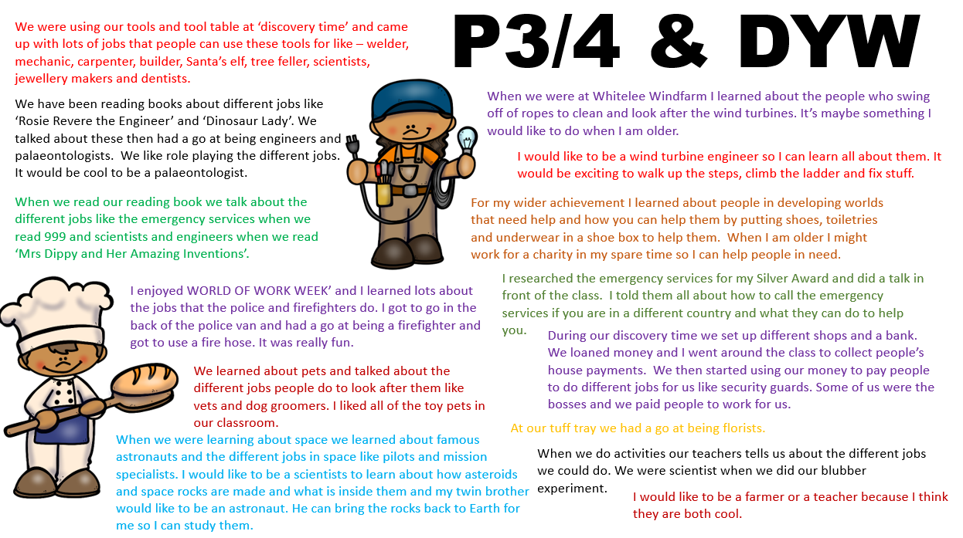  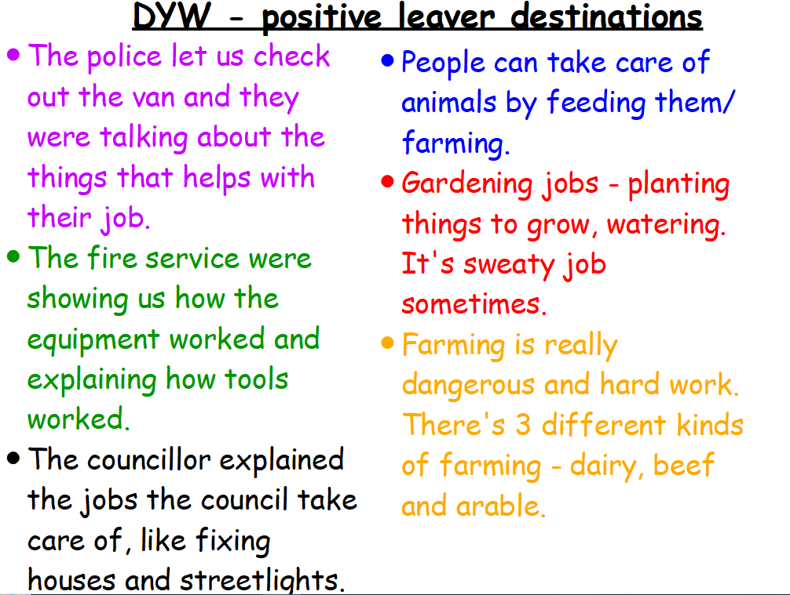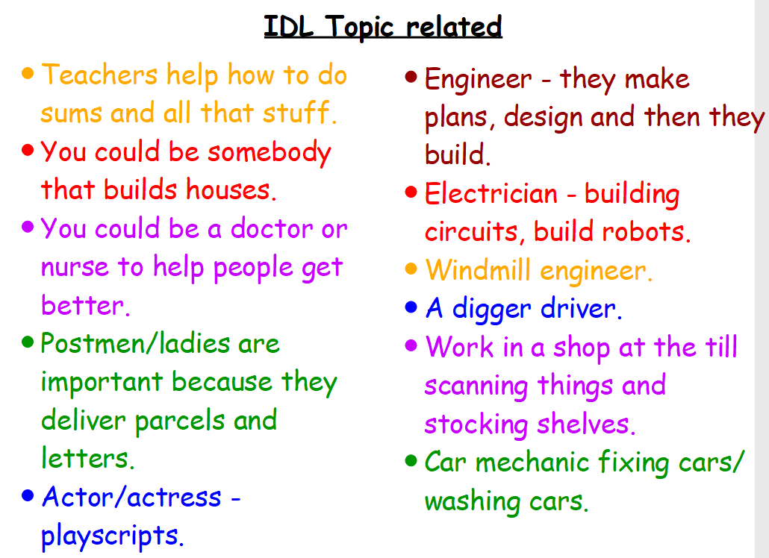  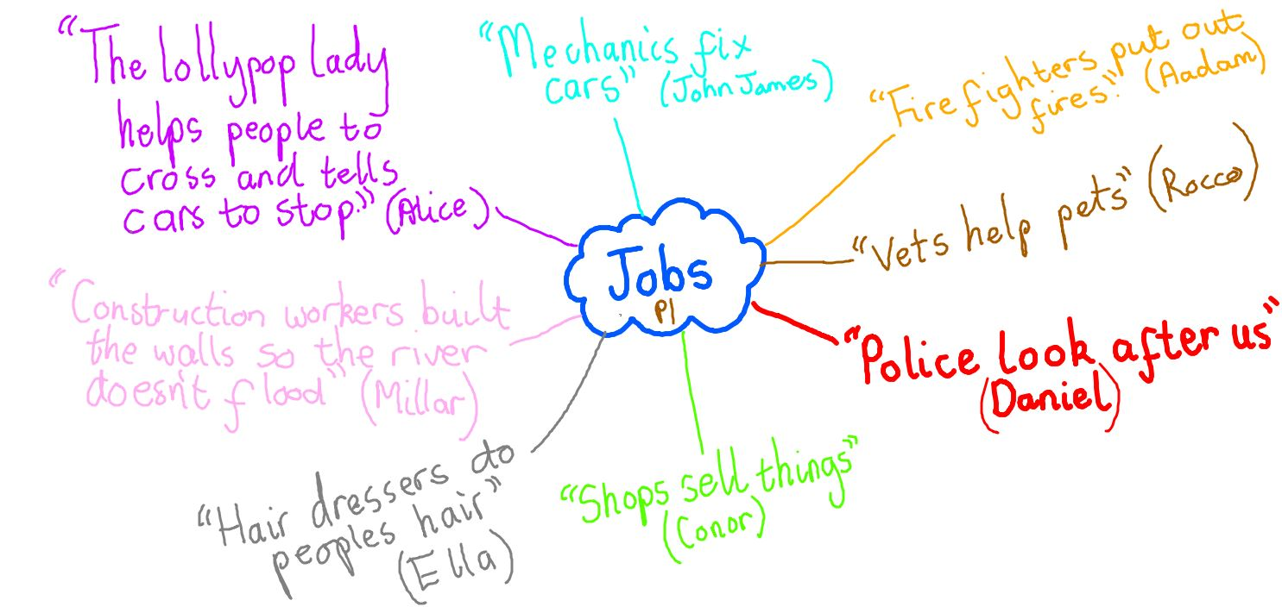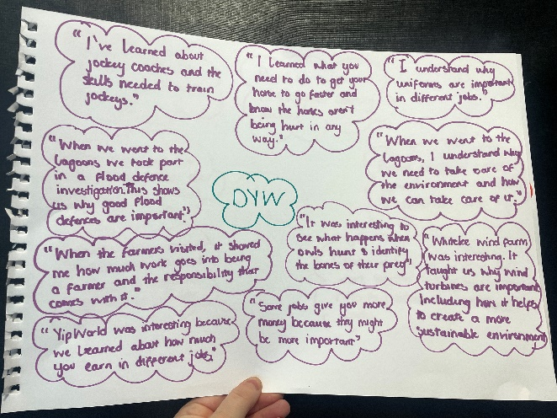  Outlined below are some of the actions that enabled us to achieve this priority:  Partnership working with local organisations to improve experiences for children  Progress –  In consultation with staff, we explored local career opportunities for 1st and Early level pupils using the context “People Who Help In Our Community”. We wanted our 1st and Early level curriculum experiences to draw from a familiar and relevant context, reflecting opportunities within the public and 3rd sector that pupils will have experience of. This involved recruiting local police and fire service to work with our pupils, along with local councillors from East Ayrshire Council and Clean Green Schools representatives.  We continued our relationship with Dumfries House and organised a curricular trip that supported our learning around farming and agriculture for Primary 2. Alongside this, P2 had the opportunity to visit Dean Castle Country Park to learn about the job of a park ranger and our Primary 4/5 class visited Whitelees Windfarm to further develop their learning about jobs in renewable energy and sustainable development, which is also a major sector for careers in New Cumnock.  We have continued our leadership groups with Rights Respecting Schools, Clean Green Schools and Eco Schools. Almost all children consulted who participate in these groups expressed that they enjoyed the responsibilities and opportunities leadership groups provide them with. We were thrilled to receive the East Ayrshire Youth Award for Climate Change Champions in January, demonstrating our pupils’ confidence, creativity, and employability skill development, over the past 2 years. As well as this, we have achieved our Silver Rights Respecting School Award and our 3rd Green Flag award, further demonstrating our commitment to developing all our children’s skills for work, life and learning.  Impact –  Pupils across the school said:  “It was so much fun visiting Dumfries House. We got to learn about jobs on the farm like looking after the animals and driving the tractor. We learned about how important it is to grow food that we can cook with. I want to be an agricultural engineer when I am older and work with tractors and trailers on the farm.” (P2)  “When we went to Whitelees windfarm we got to have a tour of the windmills. They were massive! We learned about the job of an engineer and all the different types of engineers. We have a windfarm in New Cumnock so I might work there when I’m older.” (P4)  “I like being part of the Clean Green Schools group because I am helping my community with the litter picking and the we are going to be making poo bag caddy’s for the village. I like that I get to work with the older pupils and that I am given some responsibility.” (P3)  “I am so proud that we received the East Ayrshire Youth Award for Climate Champions. We have worked so hard as a school to make sure we are following our action plan! It was amazing going to the award ceremony. We got to speak to lots of inspirational people and local councillors. I was a little nervous, but I just smiled and went on stage because I was representing my school.” (P7 House Captain- Pine)  Local partners said:  "I was delighted to be asked by New Cumnock Primary School for World of Work Week. The young people are truly so inspiring when it comes to Climate Change, and I loved sharing my projects so far to the classes on how East Ayrshire Council is tackling climate change. Also, what an honour it was to hear about all the excellent work the young people are doing in the school and community to help combat climate change." (Natasha Caldow, Clean Green Schools)  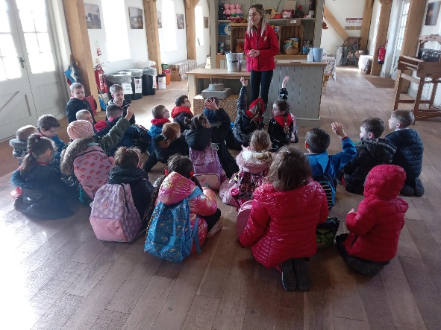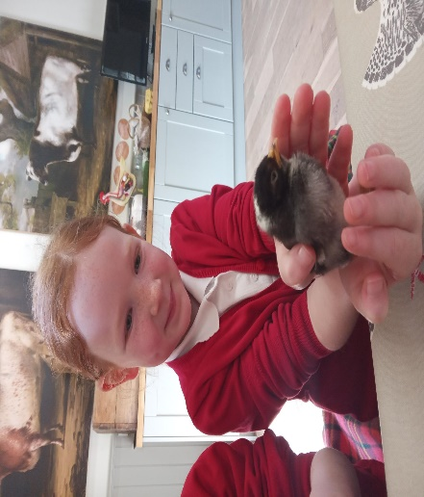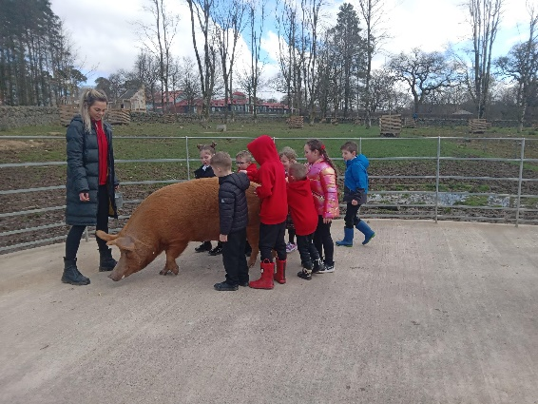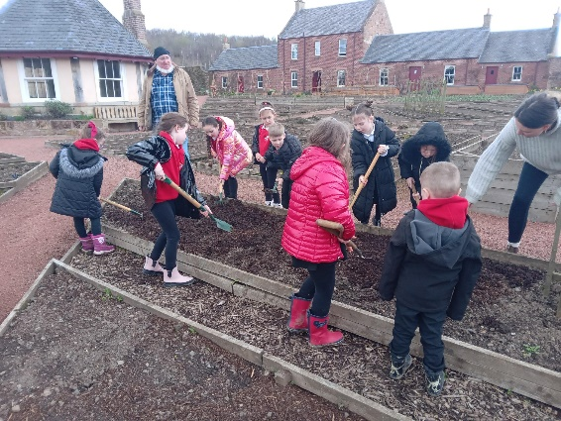  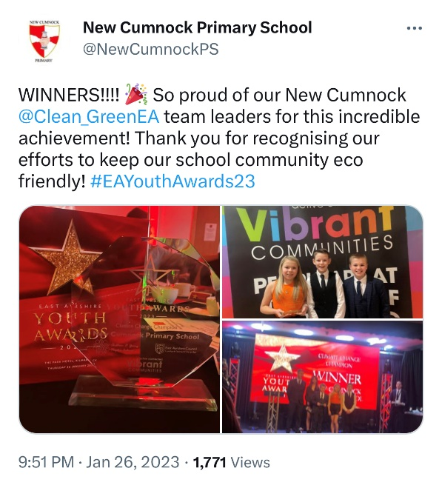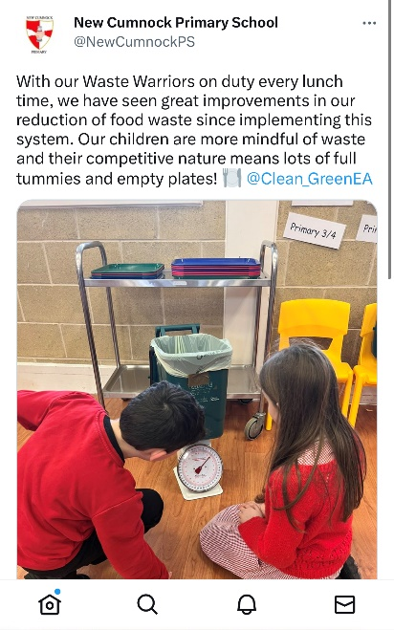  Developed curriculum at 1st and Early level with progressive skills within suitable contexts  Progress –  To ensure progression across the 1st and Early level, and to link in with our Progression framework already completed for 2nd level, a backdrop plan was created for DYW, pulling together bundles of outcomes from current school curricular plans. We distributed IDL contexts for DYW based on these bundled outcomes and class teachers integrated these into their medium term planners.  During consultation with parents, they felt that communication, wellbeing, numeracy, problem solving and leadership were the most important skills to develop for employability. Following this, we have tried to include opportunities to develop these skills in our curriculum, including mental health week, leadership groups, literacy and numeracy support for targeted pupils, and play or active learning opportunities to develop problem solving.  Impact –  Our teachers reflected on the positive impact of developing our 1st level curriculum:  “I think doing DYW activities within our class allows the children to explore jobs and have time to discuss them to help further their knowledge and skills. My P3/4s wanted to know what they need to be good at to do various jobs and what skills they would need. They were also keen to find out if they would need to go to university to do specific jobs.”  “Linking DYW learning and skills to our existing curricular plans is helpful. It allows us to plan effectively and track progression through the levels as well as provide a meaningful context to the children’s learning.”  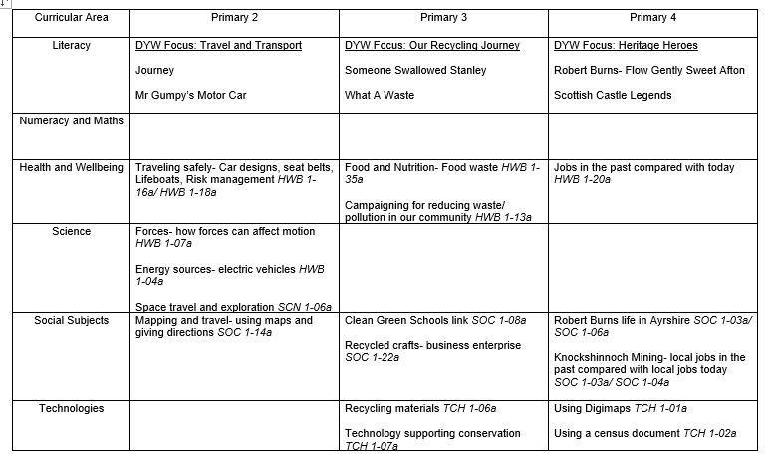  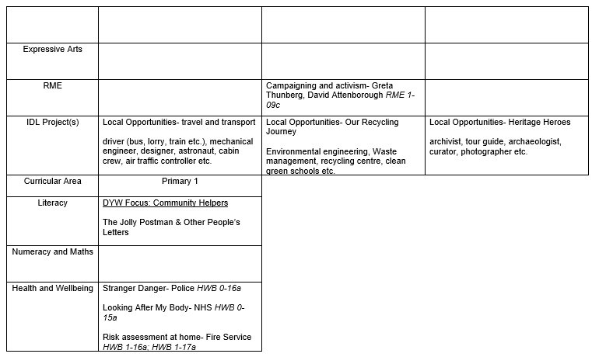  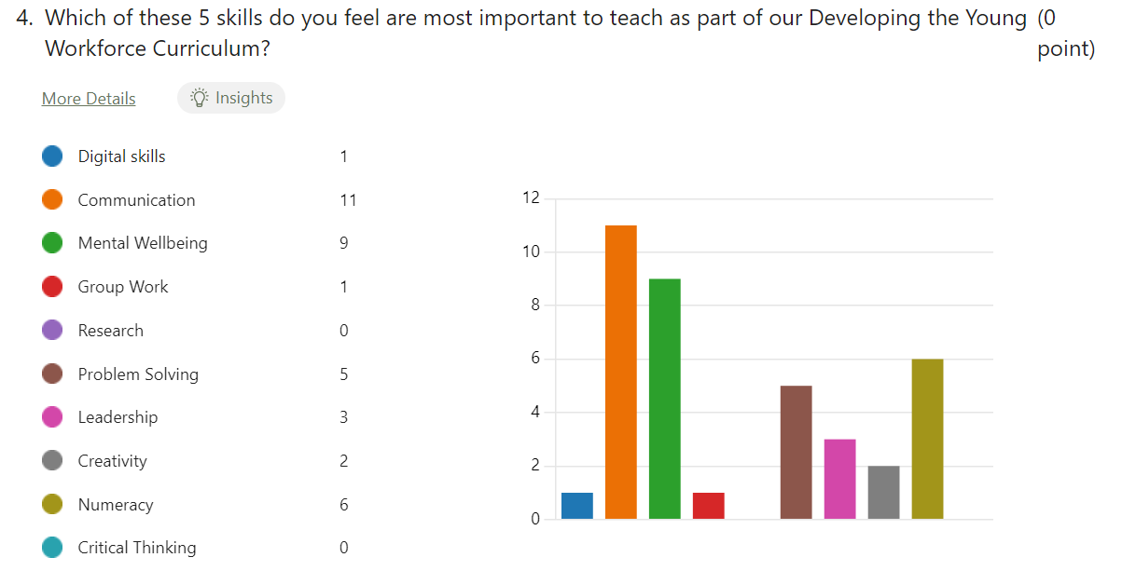  Class participation in World of Work Week  Progress –  We decided to celebrate our DYW progress by hosting our 2nd annual World of Work week, involving the whole school with our local partners. We were visited across the week by representatives from Police Scotland, Fire Scotland, Local Councillors (Councillor McMahon, Councillor Kyle, and Councillor Watts), Clean Green Schools Representative, The Red Cross, FossilFields Racing Stables, Ayrshire College and YipWorld. Pupils also took part in class activities to develop enterprising skills including tasks from NatWest bank MoneySense and Skills Development Scotland.  Almost all children consulted across the school commented on how much they enjoyed the learning experiences across the week and how it has developed their knowledge about employability skills and opportunities in their local area.  Impact –  Pupils across the school said:  “It was so much fun learning about the jobs involved in horse racing. I never realised how long it took to train a horse and all the jobs involved with this. World of work week is great at school because it lets us talk about and research some of the jobs we want to do when we grow up. It would be good to have more trips out into the community to see all the jobs in action, like going up to the farm and seeing the job of the farmer.”  “I liked it when the fire engine came to school and got to sit in it. The sirens were really loud! The policeman was really funny and he put some of the big boys and girls in the back of the van. I liked learning about all the different jobs.”  Our teachers reflected on how the World of Work week has impacted their practice:  “Pupils were given the opportunities during world of work week to research job opportunities, with an emphasis on our local area. There were rich discussions in class regarding the difference between skills and qualification. This learning was linked back to the wider achievement grids we have in school and other opportunities like leadership groups that could develop their skills. It’s great to see pupils and staff starting to make all these connections between various initiatives.  “World of work week was a worthwhile experience for all the children and they really enjoyed it, asking lots of questions to the visitors and learning about their roles. We had a good range of visitors and activities during the week and this helped to deepen the understanding of the variety of jobs available. It helped me to plan play activities linked with the jobs of our visitors to extend the learning further.  Parents commented on the success of the week:  “World of work week is a great opportunity for children to see all the different job roles available in the community, and find out about the jobs their parents do. I look forward to next year and seeing how I can support the school with this.”  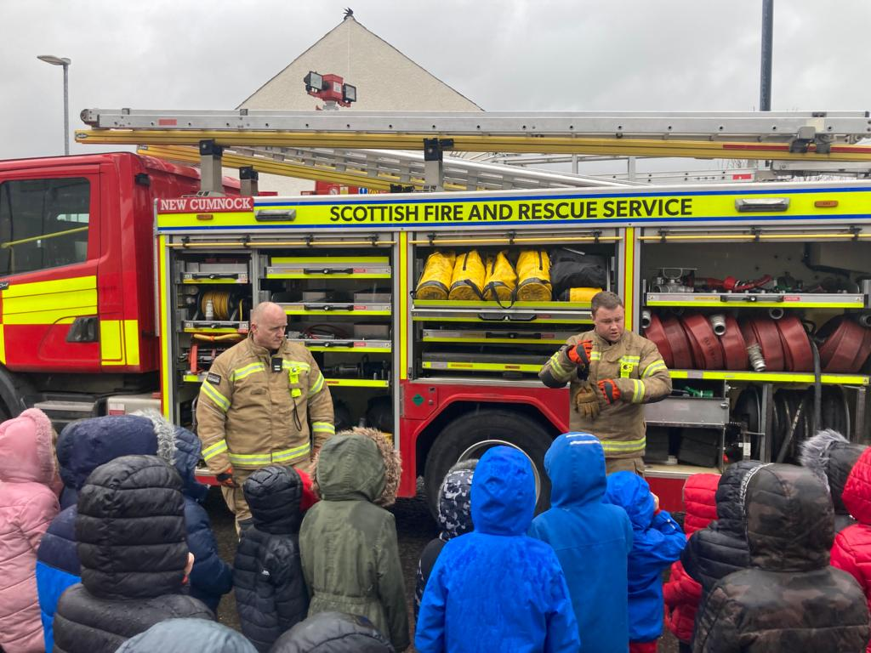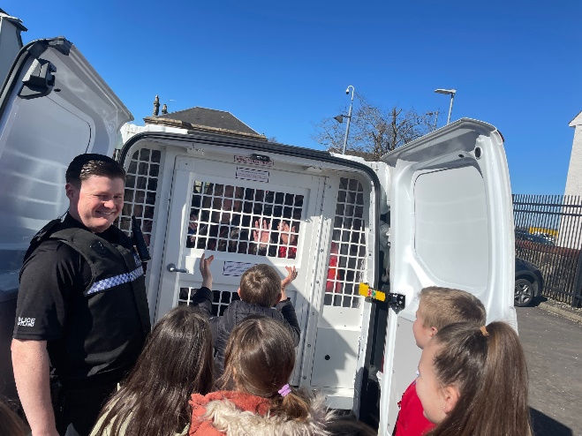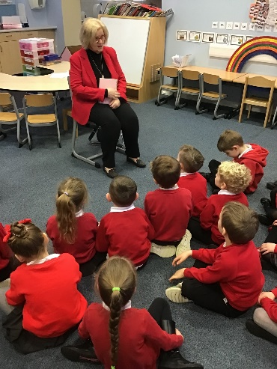  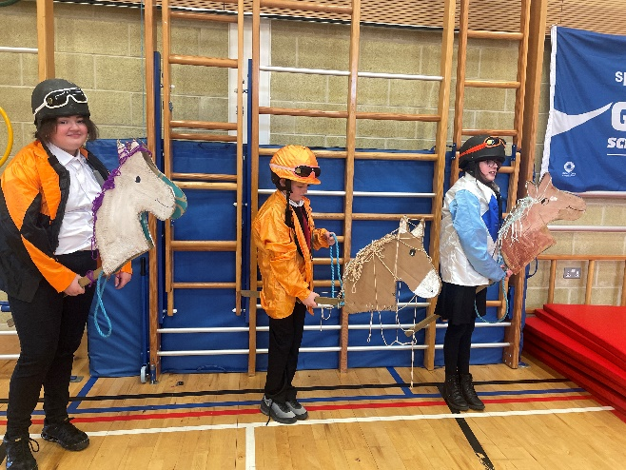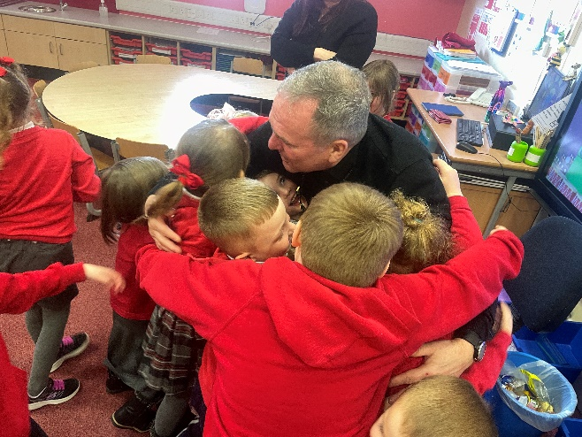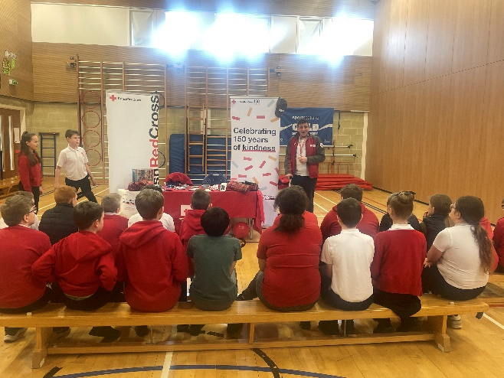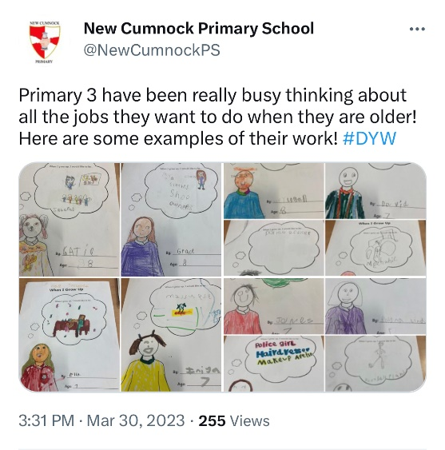
Next Steps | - Continue to embed enterprising approaches throughout the curriculum, through the use of DYW backdrop plans for Early, First and Second level.  - Foster strong links with businesses and organisations within our community for partnership working.  - Develop links between the local and national contexts for DYW through knowledge of 16+ leavers destinations (college, university, apprenticeships).

Pupil Equity Fund: Evaluation
Approach/Intervention | Impact  Report on how you have improved outcomes for learners impacted by poverty | What evidence do you have of positive impact?  Outline the data that supports your findings.
Home Link Practitioner | Pupil and Family Targeted Support  Across the session our Home Link Practitioner provides targeted support for our young people and families who require it. Information is gathered from a variety of tools, including conversations, observations, Boxall Profiles and Wellbeing Assessments. Using this information, individual Action Plans are created outlining areas of strength and identifying target areas that require support.  Breakfast Club  SEE PRIORITY 2 FOR INFO  Group Interventions  - Our HLP has led various group interventions across the session. This includes a P7 boys group which focused on building confidence and dealing positively with your emotions.  - The Girl's group was aimed at helping the children to identify and manage their emotions. They learned tools and techniques to support self-regulation and practiced mindfulness and appropriate social interaction.  Partnership Working  SEE PRIORITY 2 FOR INFO | Pupil and Family Targeted Support  Total Targets since September 2022 = 126  - targets met = 102 (81%)  - targets not met = 6 (5%)  - targets still ongoing = 10 (8%)  - parents refused to engage = 8 (6%)  In a recent GLOW Form, parents were asked to rate the quality of support they receive from our home link practitioner from 1 to 5, with 5 being the highest. Our HLP scored an average score of 4.83. Some positive comments made by parents include:  - She is great with the kids and is great to talk to about any concerns  - I received help from T on multiple occasions for a variety of things and she's always done her best to support me and my 2 boys, she goes above and beyond to help parents and kids ❤️  - That she is always there to listen to you and give advice no matter what  - The HLP within the school has had a massive impact on my son by having someone we can speak to about any issues we have at home or at school to help support him  - Our HLP always makes herself available and makes herself known to the children. She is very friendly and has a great attitude towards the children  - Her calming ability with my child and the care and consideration taken while fulfilling his needs  Below is a graph that shows the various types of support that has been accessed by our families.  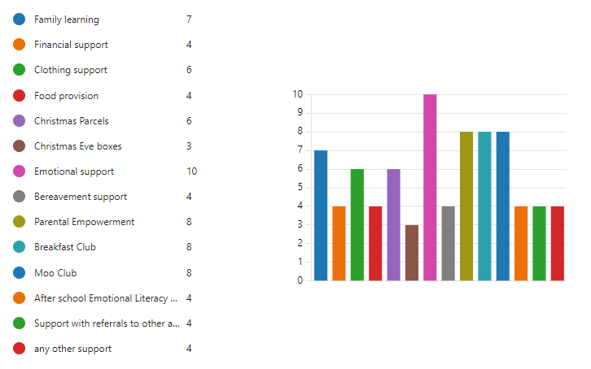  Breakfast Club  SEE PRIORITY 2 FOR INFO  Group Interventions  Summary of Impact:  - 2 children showed significant improvement in all areas  - 2 children showed improvement in 3 out of 4 areas  EM – Initially didn’t understand the GMWP and answered everything a 10. This skewed his final results.  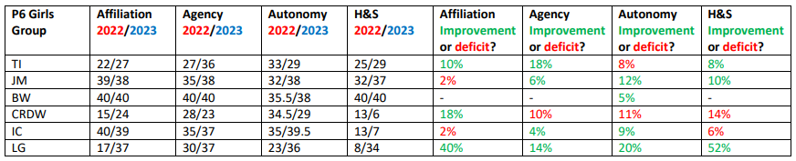  Summary of Impact:  - 1 child showed improvement in all areas  - 2 children showed improvement in 3 out of 4 areas  - 1 child showed improvement in 2 out of 4 areas  CRDW – C refused to work with anyone and preferred to always work alone. (C is also accessing 121 supports in school and has been referred to her GP around her concerning behaviour and thoughts both at home and in school.)  IC - I can be very anxious and finds it difficult to speak openly in front of the bigger characters in the group  Partnership Working  SEE PRIORITY 2 FOR INFO
Early Years Practitioner | Focus Groups for Numeracy and Literacy  Across the session the Early Years Practitioner has been heavily involved in the planning, development, and enhancement of play within Primary 1. The Early Years Practitioner has worked closely with the class teachers to support with literacy and numeracy focus sessions. She extracts small groups to complete tasks and uses active learning where possible to help raise the attainment of our young people.  Pupil Led Learning  The learning situations that have occurred due to the Early Years Practitioner being responsive to the interests of the children, have also increased engagement and attainment as children are learning about topics that they are interested in.  Impact in Attainment  Although we have a lot of ‘soft’ data that indicates having an Early Years Practitioner within the infant department is impactful, our attainment data does not support this. Unlike last year, this year’s data shows a decline in attainment in all areas within P1. As a result the attainment gap in our children from our highest and lowest SIMD areas has increased.  Although we have taken into account the fact that we have a very different cohort this session with a variety of barriers that could be impacting attainment (speech and language issues, attendance etc), we have decided that we don’t have enough evidence to prove that our Early Years Practitioner role is having a big enough impact on our young people to keep this role on next session. | Focus Groups for Numeracy and Literacy  Since undertaking these focus groups, class teachers report:  - a more positive attitude towards learning  - increased engagement  - an increase in confidence and self-belief.  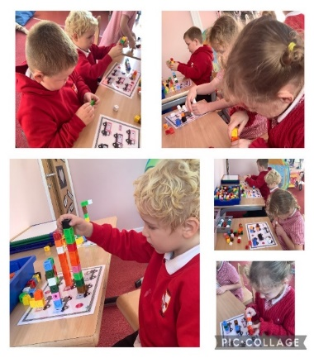  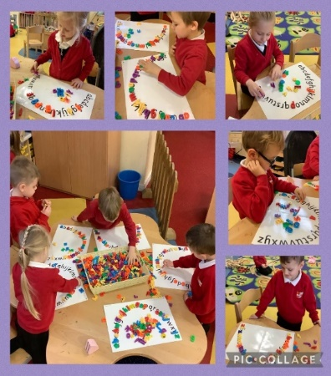  Pupil Led Learning  A GLOW FORM was administered to parents to get some feedback regarding the EYP role. 100% of parents who completed it agreed that it has been worthwhile to have an Early Years Practitioner supporting learning in the Primary classroom.  “I think this approach sets realistic expectations of P1 children, it also helps the transition from nursery to a more structured learning environment.”  “A loves Lorraine and enjoys spending time with her in the class. A enjoys reading and she likes to read stories with Lorraine and A says Lorraine does lots of fun stuff.”  “I feel the early years practitioner has played a massive part in my sons learning journey throughout Primary 1. Allowing him to explore all aspects of the curriculum through play has definitely helped him improve academically. I thank Lorraine very much for being such a massive part of his journey! Fantastic early years practitioner!"  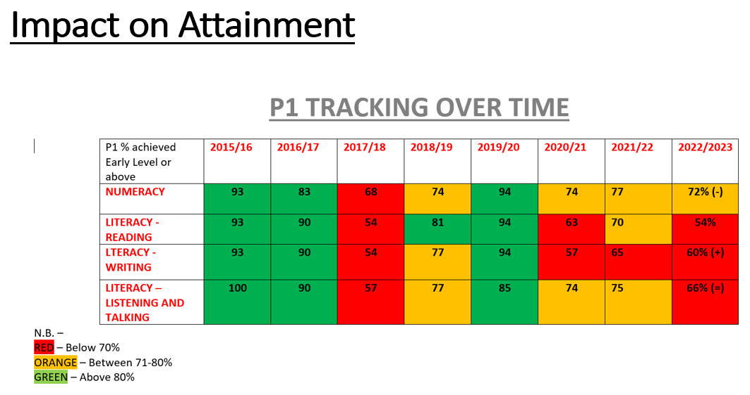  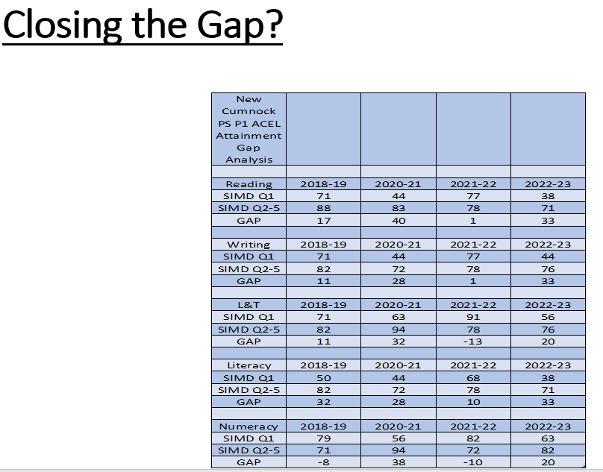

Establishment Self Evaluation: How Good is Our School? 4 Quality Indicators
Quality Indicator 1.3 Leadership of Change | 5
Quality Indicator 2.3 Learning, Teaching and Assessment | 4
Quality Indicator 3.1 Ensuring Wellbeing, Equality and Inclusion | 5
Quality Indicator 3.2 Raising Attainment and Achievement | 5

Establishment Capacity for Improvement
Leadership and Management: How good is our leadership and approach to improvement?

“The very effective leadership of the head teacher supported by the strong teamwork among staff which creates the conditions for further school improvement”.
(HMIE January 2018)

The relationship identified above is key to the success of this area. Staff, children, parents and partners are appropriately well involved in the school’s self-evaluation processes as it seeks to improve its work further. The school’s annual quality assurance calendar contains a wide range of appropriate approaches for the school’s management team to gather information and data about the quality of learning and teaching, and children’s progress, helping to shape the School Improvement Plan moving forward. From the School Improvement Plan it is evident that leadership at all levels is a strong feature of the school’s work and results in continuous improvement across the curriculum. Quality Career Long Professional Learning is very well planned and takes full account of PRD arrangements linked to the GTCS Professional Standards and to the School Improvement Plan. This includes three members of staff who have continued to successfully participate in system wide leadership across the authority this session. Staff and pupils have continued to benefit from their knowledge and expertise. Wider Achievement groups allow children to exercise choice and develop leadership skills. Within all classrooms there is some evidence of children being encouraged to lead learning across subject areas. As a result, children within all classes have learned new skills, taken greater ownership of their learning and have developed personal attributes such as improved confidence.

Learning Provision: How good is the quality of care and education we offer?

An inclusive and nurturing ethos is evident throughout the school and this ensures that most children are happy and have opportunities to learn and achieve. A variety of creative teaching approaches are used across all stages, with a particular focus on play based learning in P1 and P2. In most classes, teachers successfully relate learning to real life situations to assess children’s understanding of skills and to make learning more meaningful to the children. Across the school, assessment is integral to our planning of learning and teaching. Staff continue to identify opportunities within their short term planning, to ensure protected, quality time, to support learners with the various aspects of the learning, teaching and assessment cycle. Moderation activities and sharing good practice sessions for staff also supported them to carry out this process effectively. Processes for assessment and reporting are manageable and effective in informing improvements in learning and teaching. A few years ago, we effectively reviewed our planning system in collaboration with all staff. As a result, planning is proportionate and manageable and clearly identifies what has to be learned and assessed across all curricular areas. Effective planning also ensures that our Curriculum Rationale, which we reviewed 2 sessions ago, and the Principles of Curriculum Design, are being adhered to. Over the past few years all staff have been committed to developing effective partnership working in an attempt to remove barriers to parental engagement and as a result improve outcomes for our pupils. The role of our Home Link Practitioner has been key to this, by successfully engaging families in family learning opportunities and providing targeted and universal support to those children and families who need it.

Successes and Achievements: How good are we at ensuring the best possible outcomes for all our learners?
Achieving our Silver Rights Respecting School award last session has allowed us to further develop our Relationships policy and ensure all staff have a shared understanding of wellbeing and children’s rights. All members of staff model positive behaviour successfully and as a result have created a nurturing environment within their classrooms and across the school for our children. All staff know what is expected in relation to statutory duties and are actively involved, often in partnership with parents, partners and pupils, in fulfilling these duties. Due to all staff working hard to create an inclusive learning environment throughout the school, this has led to improved outcomes for almost all children. So much so we were awarded our Silver Inclusive Practice award two sessions ago. This session we have developed our inclusive practice further due to the implementation of our Communication Friendly School. We will undertake our accreditation for this in November 2023. Attainment in Literacy, Numeracy and Health and Wellbeing is tracked using East Ayrshire’s tracking and monitoring system to ensure learners are making good progress from their prior levels of attainment. Groups and cohorts are well supported to raise attainment through specific targeted interventions. Overall, staff are confident that most children are making good progress over time. All staff recognise the need to support children to understand the skills and capacities they are developing through participation in achievement opportunities. There is evidence through our Wider Achievement folios that some children are applying and increasing their achievements through active participation in their local community. Creativity skills are actively encouraged and developed across the school and across the curriculum. As a result there are opportunities for children to lead their own learning. As a school we are digitally well resourced. Our children show confidence and are responsible in the use of technologies. Digital technologies is used to enhance and personalise learning in school where appropriate. As a result we were awarded our Digital Schools Award two sessions ago. Through a range of opportunities including Wider Achievement groups and whole school initiatives involving effective partnership working, our children have experiences that connects them to employment, helping to shape their thinking for their future. The development last session of our 2nd level Backdrop Plan, and this session our early and 1st level planners for Developing the Young Workforce will ensure these experiences are consistent. This session our P7 pupils were one of four schools to be awarded the Silver Award for East Ayrshire’s Clean, Green School award. Due to special recognition in the Energy category last year, we were also nominated for a Youth Award, which we went on to win. Our young people have achieved great success within Music and Drama this session, with children achieving in Burns regional and national competitions for solo and group performances, and a cohort of children from P4 to P7 performing our first ever musical performance, “Oliver” for the public.

