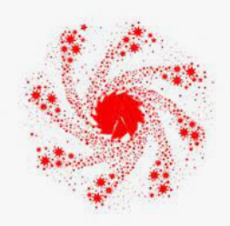

NOVEMBER

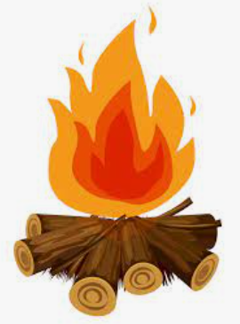





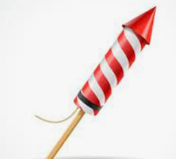 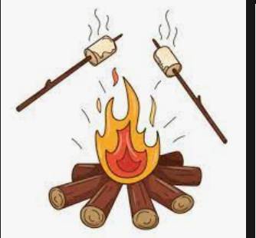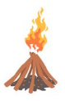

  

  

  

 

  

*Gunpowder goujons = chicken goujons or vegetable fingers*

*Bonfire bangers = pork/ veg sausages in finger roll Firework fries = chips*

*Catherine wheel corn= corn on the cob Big bang biscuits = cookie*

Big Bang Biscuits

**Fun Fact- Bonfire night is celebrated because of the failed gunpowder plot where Guy Fawkes tried to blow up the Houses of Parliament**

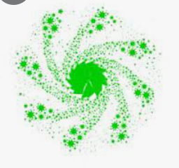    

   

Firework Fries

Catherine Wheel Corn

    

Gunpowder Goujons

Bonfire Bangers

    

Friday 3rd November



 

 

 

 

 

 

 

 

 

 

  

  

  

  