New Cumnock Primary School Parent Council presents:

In honour of King Charles’ Coronation…

Thursday 4th May 2023

6-7.30pm

School hall (Enter via the Community Entrance)

New Cumnock Primary School

(Enter through Community Entrance)

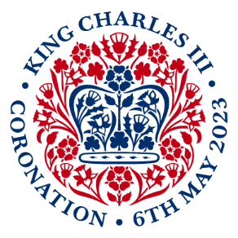

Interactive online Kahoot! quiz – bring your own device and make sure you have access to your data!

Family Quiz Night

Tuck shop and tea/coffee for sale. Don’t forget to bring your own cup!

Entry - £5 per team (max. 6 players) payable at the door

* Prizes for our winners (and losers!)
* Raffle tickets on sale
* Goody bags from ‘Body Shop by Louise’ on sale