New Cumnock Primary School presents

Thursday 23rd February 2023

6pm-8pm

New Cumnock Primary School

(Enter through Community Entrance)

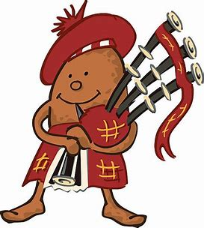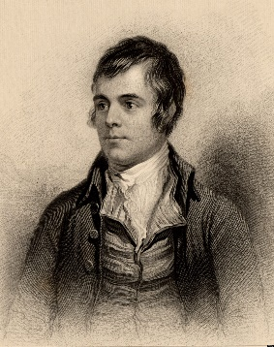

Burns Candlelight Tea

Fun for all the family!

Tea, coffee, shortbread and biscuits will be served.

Come and celebrate our National Bard with us

Class Poetry Competition winners performing

Scots songs performed by our school choir

Tickets available to purchase from school:

* Adults - £2
* Children - £1