New Cumnock Primary School Parent Council

Saturday 26th November 2022

10am-12pm

New Cumnock Primary School

(Enter through playground gates

at the back of the car park)

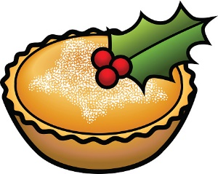

* Tea, coffee, hot rolls, shortbread and mince pies for sale
* Class crafts
* School Choir
* Santa’s Grotto

Don’t miss out on our:

* Bottle stall
* Raffle
* Festive Tattoo Station
* Preloved toy stall
* Festive Face Painting

This year is set to be our biggest and best fair yet!

We can’t wait to welcome our supporters and small businesses.

Come and visit us to see:

* Face painting - Colby Burgoyne
* Ayrshire Roads Alliance & JRSOs
* Dr Bike
* NCDT – Girls Group
* NCDT – Reuse Hub
* Little Miss Bows - Hope Gibson
* Crafts - Sophie Rinaldi
* Afton Tealights
* Jodie's Bows - Jodie Stobbs
* Luscious Beauty by Kirsty (Body Shop) - Kirsty MacIndeor
* Rainbow Melts - Libby Reilly
* RBA Candle Enterprise - Ellie Gallacher
* Sweetie Cones - Sheryl Graham
* Crafts - Kate Lindsey
* Toys - Shona Ferguson
* New Cumnock Calendars - Christine Wilson
* My Candle Co – Morag Young

Christmas Fair