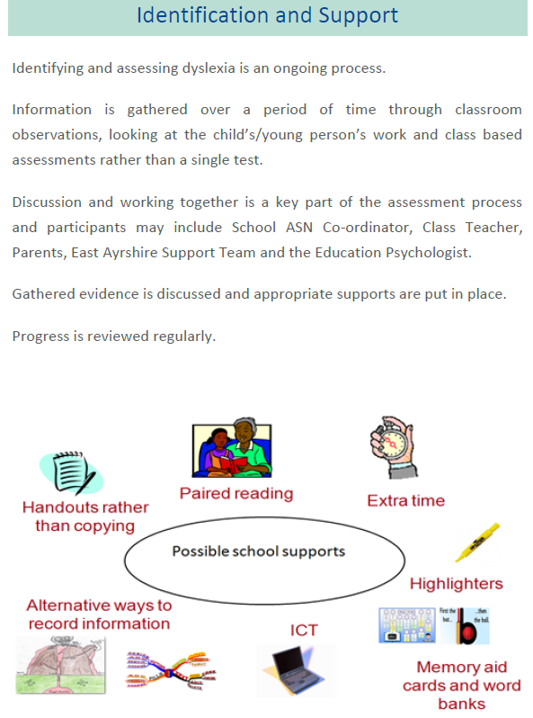

Evidence gathered and supports put in place are unique to your child and this will be discussed with you regularly.

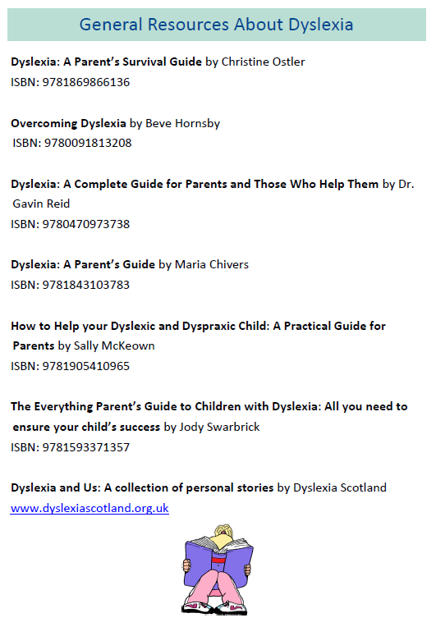

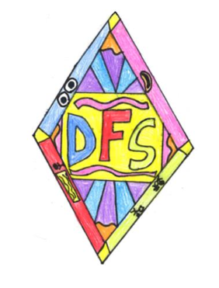

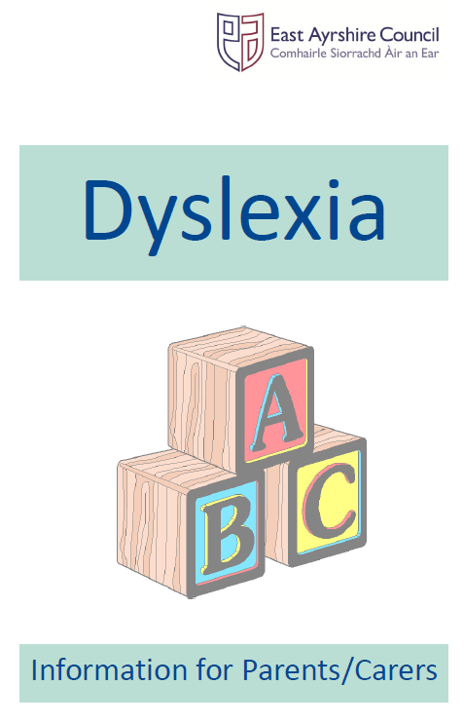





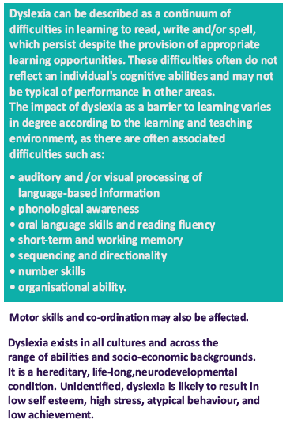

At New Cumnock Primary School we aim to support all learners and create a dyslexia friendly environment. Our flexible teaching and learning approaches will benefit all. Regular assessment and feedback allows staff to implement additional strategies for those who learn differently.

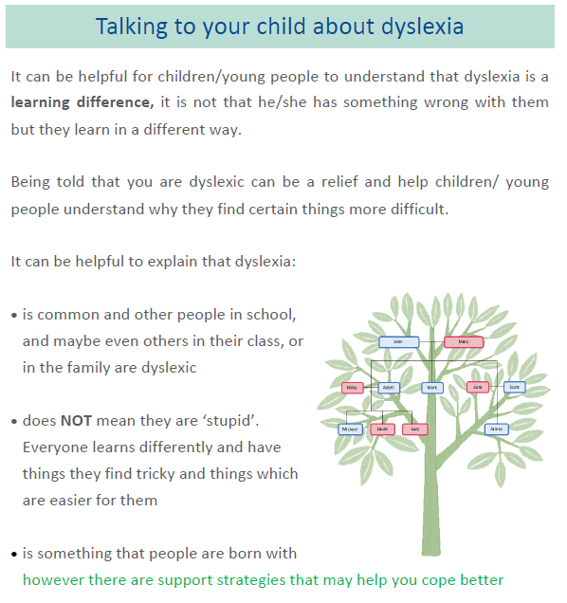

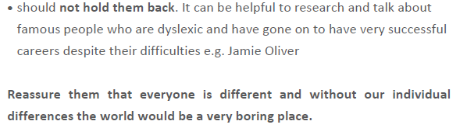



**New Cumnock Primary School have been awarded East Ayrshire’s Inclusive Practice (DFS) Silver Award**

**What is a Dyslexia Friendly School?**

DFS aims to facilitate and encourage

· Whole school awareness of what dyslexia is and how we can support learners with dyslexia.

· Whole school responsibility for supporting learners with additional support needs (ASN).

· Empowerment of teachers to meet the needs of all learners.

· Early identification of learners at risk of ASN and appropriate intervention strategies suited to meet individual’s needs put in place.

· Confidence and consistency in using East Ayrshire Dyslexia and Literacy Difficulties Assessment Guidelines.

· Effective use of East Ayrshire monitoring and tracking systems.

· Inclusive learning environments.

· Resilience in learners.

· Positive and effective Parent/Carer partnership.