Dear Parent/Carer
SECOND LEVEL RELATIONSHIPS, SEXUAL HEALTH and PARENTHOOD
There have been many positive changes in Relationships, Sexual Health and Parenthood (RSHP) practice in recent years. Evaluations have shown that there is much about RSHP that children and young people like and enjoy in relation to their learning within RSHP at school.
However, learners also identified shortfalls in key areas such as the breadth of topics, relevance to the pressures they face in current-day relationships and a sense that RSHP is often not a ‘real’ subject, that it is occasionally tagged on, or given low priority.
This meant there was a need to reflect on how learners needs are met in an everchanging context, whether this is in terms of concerns we may have for children and young people, negative experiences of social media or partner violence – or positive cultural shifts, including increased awareness of the rights of learners with disabilities or LGBT young people.
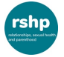

RSHP – https://RSHP.scot/

To reflect evaluations and changes in society, the Scottish government have produced a new national RSHP resource to:
- Address the need to improve the quality, relevance, consistency and coverage of RSHP Education.
- Reflect the values and principles which should underpin teaching and learning of RSHP Education. This means taking account of the diversity of learners and making explicit a commitment to the rights of young people including young people with disabilities, girls and young women, and LGBT young people.
- Sit within a recognition that RSHP Education supports the broader ambition of improving health outcomes for the population.

You can find out more about the learning activities used in this national resource and view the curriculum for Excellence Experiences/Outcomes and Benchmarks for Relationships, Sexual Health and Parenthood at Second level by visiting https://rshp.scot/second-level/

Our local authority is committed to the provision of quality teaching in Relationships, Sexual Health and Parenthood education in accordance with National Guidelines. It forms a key element of personal, social and health education in schools and is an important part of children’s preparations for adult life. The purpose of RSHP is to provide the learners with an understanding of how to maintain positive relationships. In addition, pupils are encouraged to consider how thoughts, feelings, attitudes, values and beliefs can influence decisions about relationships.
Taking into account the age and stage of children and young people, it is important to use a common vocabulary to describe our emotions, feelings and body parts. The suggested vocabulary staff will encourage second level children to use is shown below:
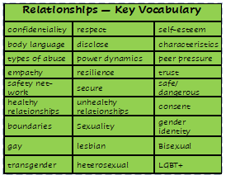
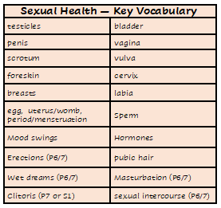

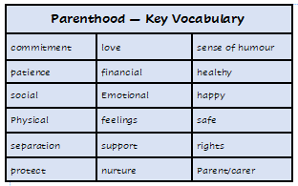

Parenthood
Yours sincerely,
J McMurdo
Head Teacher

