Dear Parent/Carer
FIRST LEVEL RELATIONSHIPS, SEXUAL HEALTH and PARENTHOOD
In line with East Ayrshire Council guidance, we are contacting you to inform you that this year as part of the First Level Health and Wellbeing curriculum our children will be learning about Relationships, Sexual Health and Parenthood (RSHP). The topic is fully in line with Curriculum for Excellence and includes the study of the following experiences and outcomes:

I am aware of how friendships are formed and that likes, dislikes, special qualities and needs can influence relationships. HWB 1-44a

I understand positive things about friendships and relationships but when something worries or upsets me I know who I should talk to. HWB 1-44b

I know that there are people in our lives who care for and look after us and I am aware that people may be cared for by parents, carers or other adults. HWB 1-45a

I am aware of the need to respect personal space and boundaries and can recognise and respond appropriately to verbal and non-verbal communication. HWB 1-45b

I recognise that we have similarities and differences but are all unique. HWB1-47a

I am aware of my growing body and I am learning the correct names for its different parts and how they work. HWB 1-47b

I am learning what I can do to look after my body and who can help me. HWB 1-48a

I am learning about respect for my body and what behaviour is right and wrong. I know who I should talk to if I am worried about this. HWB 1-49a

I am learning about where living things come from and about how they grow, develop and are nurtured. HWB 1-50a

I am able to show an awareness of the tasks required to look after a baby. HWB 1-51a

Our local authority is committed to the provision of quality teaching in Relationships, Sexual Health and Parenthood education in accordance with National Guidelines. It forms a key element of personal, social and health education in schools and is an important part of children’s preparations for adult life. The purpose of RSHP is to provide the learners with an understanding of how to maintain positive relationships. In addition, pupils are encouraged to consider how thoughts, feelings, attitudes, values and beliefs can influence decisions about relationships.

Taking into account the age and stage of the child, it is important to use a common vocabulary to describe our emotions, feelings and body parts. The suggested vocabulary staff will encourage first level children to use is shown below:
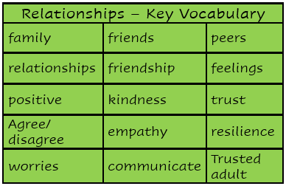
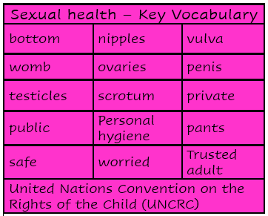

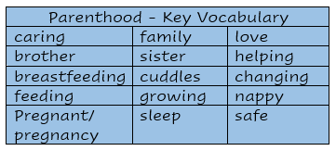

Parenthood
Yours sincerely,
J McMurdo
Head Teacher

