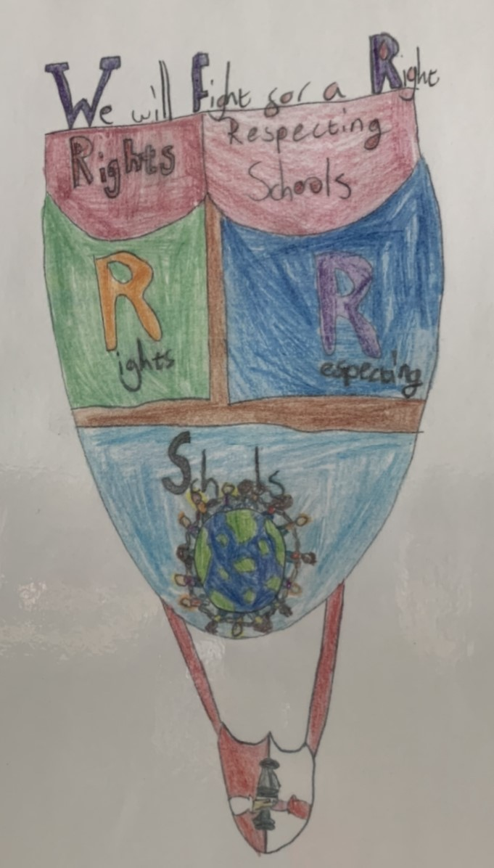

Why do we want Rights Respecting Schools at New Cumnock Primary School?

A Rights Respecting School means promoting global citizenship. At NCPS, we strive for equity and this means everyone will have lots of opportunities for success!

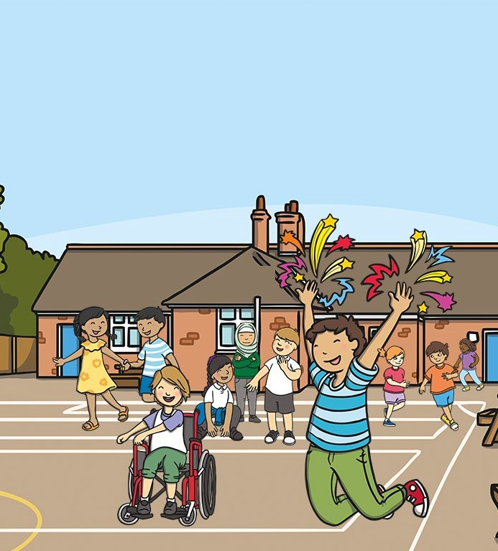

**What is a Rights Respecting School?**

Information for Parents and Carers

At New Cumnock Primary School, we take a relational approach to learning and a Rights Respecting School improves relationships through inclusive activities and discussions between peers.

Through the areas studied, children and young people are involved in raising awareness about social justice issues, at home and abroad. They become ambassadors for equity and rights and take part in campaigns and activities to help to bring about change.

There are so many great reasons for us to become a Rights Respecting School!

A Rights Respecting School means happier children and at NCPS, happy children equal happy learning.

In a Rights Respecting School, relationships are based on mutual respect; everyone is equal, and everyone’s opinion is valued.

A Rights Respecting School ensures children feel safe and are aware of the important things in life they should have.

By actively promoting the values of respect, dignity and non-discrimination, that are at the heart of the UNCRC, children’s self-esteem and wellbeing is strengthened.

A Rights Respecting School means children play an active part in school life. This means children have a voice at NCPS.

Please support us in our journey to becoming a Rights Respecting School.

Talk to your children about what they know and are learning about the UNCRC.

Ask how you can help and be part of our school community as we work together to achieve our Silver Rights Respecting Award.

Further information can be found on UNICEF UK’s website:

https://[www.unicef.org.uk/rights-respecting-schools/](http://www.unicef.org.uk/rights-respecting-schools/) the-rrsa/

What do schools have to do to become a Rights Respecting School?

What Is a Rights Respecting School?

What do schools have to do to become a Rights Respecting School?

Rights Respecting Schools is an initiative run by UNICEF UK based on the UN Convention on the Rights of the Child (UNCRC).

It is a series of three levels of award that schools work towards achieving:

Bronze, Silver and Gold.

What Is the UN Convention on the Rights of the Child?

The United Nations Convention on the Rights of the Child is a statement of children’s rights. It has 54 articles that cover all areas of a child’s life and it sets out the political, civil, economic, social and cultural rights that all children are entitled to. The Convention came into force in the UK in 1992.

Achieving any of the Rights Respecting School awards is not just about proving that as a school we have completed a task or covered set criteria, it is about a commitment to placing the rights of the child at the centre of everything we do throughout the school and in all areas of school life.

Together adults, children and the school community learn about children’s rights and put them into practice every day.

In Rights Respecting Schools, children’s rights are promoted and realised, adults and children work towards this goal together.

The journey to receiving the Gold award can take three to four years.

UNICEF UK works with schools as they work towards becoming Rights Respecting. UNICEF UK helps teachers work with children throughout the school on issues facing the world today. Topics include the plight of refugees, the environment and climate change.

UNICEF UK will also assess the school when it is ready for each award.

When we achieve Rights Respecting status, what next?

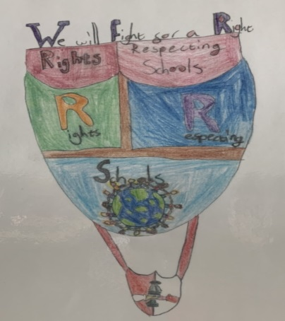Once a school has been awarded Silver and Gold accreditations these have to be reviewed after three years to ensure schools are still putting children and young people’s rights first in their school’s practice and ethos.