

Methodology

Children are taught to read using the Guided Reading approach. The teacher provides an overview of the text. This is known as a ‘walkthrough’. At the start of the lesson, the teacher is the only person with the copy of a book. The teacher has read the book prior to teaching and has identified the vocabulary (common words) to be introduced. The teacher helps the children to read the topic words in the book by drawing their attention to the picture clues. Time is taken to teach the children various comprehension strategies to help them gain a better understanding of the text. They also learn word attack strategies to enable them to decode words that they find difficult. After the initial walkthrough, the children have opportunities to read aloud. This happens in a group setting/with a partner. The teacher circulates to listen and provide feedback.

|  |
| --- |
| Word Attack Strategies   * Look at the first letter * Sound out the first few letters * Break the word into syllables * Look at the last letters * Read the sentence again * Look at the picture * Look at the shape of the word |

Introduction

The aim of this leaflet is to provide you with information about how your child is taught reading and writing at school and to allow you to support your child at home with this.

Principles of the Programme

The programme adopts an integrated approach and therefore has a direct link to the spelling and phonics programme. Children are taught to apply their knowledge of spelling and phonics within the context of reading and writing.

In Class

Children are taught to read through the process of guided reading using a variety of quality short texts, from a range of publishers. They are no longer following what is considered to be the traditional model of a ‘reading scheme’. The books are organised into levels. This is known as ‘banding’. Each band is represented by a different colour. Within each band there will be a variety of fiction and non-fiction texts that allow the children to experience many styles of writing. The basic guide within the banding is that most children start at the pink level and will progress to lime by the end of Primary two or in Primary three.

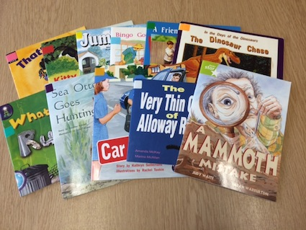

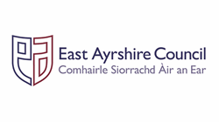

Writing

There will be one taught writing lesson per week that focuses on teaching a particular genre. Six writing genres are taught within Stage 1-3. Within each term three genres are covered. Narrative genre should feature in every term (this allows children the opportunity to write personal/imaginative pieces).

Children will also have opportunities to write daily for a variety of purposes and for a variety of reasons.

At Home

When your child comes home with a reading book you should encourage them to read aloud. Try to make use of the word attack strategies if they meet a tricky word. You can also help them make links to their spelling and phonics programme by encouraging them to find, read and write common words and words containing their phoneme within the reading book.

Active Literacy

A Guide for Parents

Stage 1-3

Reading and Writing