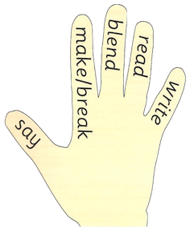

Introduction

The aim of this leaflet is to provide you with information about how your child is taught phonics at school and to allow you to support your child at home with this. A phoneme is the smallest unit of sound that can alter the meaning of a word. This can be in the form of a single letter or a joined phoneme e.g. p/b pin/bin ch/sh chop/shop

Spelling and Phonics are taught separately at this stage and a different methodology is adopted for each. As such, they have been outlined in separate leaflets.

Principles of the Programme

The programme takes a holistic, synthetic and integrated approach to phonics learning and it promotes daily Listening and Talking, Reading and Writing across the Curriculum.

In Class

Phonics is taught with one main focussed lesson in the week, followed by short daily activities to reinforce the learning. Initially two sounds are taught per week (Stage 1/Term 1). This is followed by one taught phoneme sound per week.

The Teacher introduces each sound in a context i.e. a story/song and then demonstrates the letter formation and word building through the use of a magnetic board and letters. The children are provided with a magnetic board to allow them to mirror the taught lesson and work independently/with a partner throughout the week.

Methodology

Children are taught to work with a partner to consolidate the taught lesson. This is called reciprocal teaching. They take turns to guide each other through the word building reading and writing process. This involves using the diagram below:

The child encourages their partner to say, make/break, blend read and write each word. The activity alternates between partners and they then check their partner’s work for correct formation and accurate spelling.

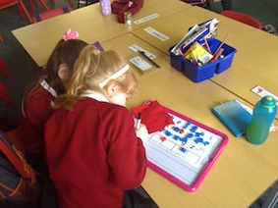

At Home

When your child comes home with a phoneme and list of words containing the taught phoneme, you could encourage them to find, read and write words containing that phoneme within their reading books, newspapers, magazines etc. A phoneme word maker sheet may be provided by the teacher to support this.

To reinforce the learning, you could also take turns to dictate simple sentences, which contain the phoneme words and take turns to be the ‘teacher’ and check each other’s work.

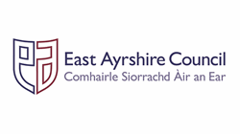

Active Literacy

A Guide for Parents

Stage 1-3

Phonics