NEW CUMNOCK PRIMARY

Dyslexia Friendly Schools
Policy
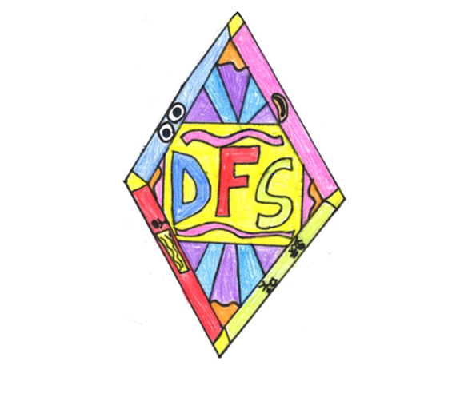

September 2019

Rationale and Aims
The staff at New Cumnock Primary School play a vital role in ensuring that the needs of all pupils with Dyslexia are met. We aim to support children through early identification, effective assessment and high quality provision of support.

One person in ten in the UK is thought to be dyslexic with 4% of the population believed to be severely dyslexic. In order to meet the needs of dyslexic children within our school, and enhance the learning opportunities for all, we are committed to being a Dyslexic Friendly School.

At New Cumnock Primary School we believe that children should be actively involved in their education and so staff work collaboratively with a DFS pupil group to provide quality learning and teaching.

Dyslexia Scotland defines dyslexia as:
“a continuum of difficulties in learning to read, write and/or spell, which persists despite the provision of appropriate learning opportunities. These difficulties often do not reflect an individual’s cognitive abilities and may not be typical of performance in other areas.” Dyslexia Scotland 2017

One of the basic principles of becoming a dyslexia friendly school is the expectation that teachers take immediate action when faced with learning needs, rather than refer for assessment and wait for a ‘label’. In a dyslexia friendly school all teachers are empowered, through training, policy and ethos, to identify learning issues and take front-line action.

At New Cumnock Primary staff strive towards creating a learning environment where multisensory approaches are at the core of learning. We take into account individual children’s learning styles and provide opportunities for children to express themselves and take ownership of their own learning.

Through close observation, and assessment procedures, we are able to quickly identify children who are experiencing difficulties and set in place strategies and supports to enhance their learning experiences and opportunities.

The impact of dyslexia as a barrier to learning varies. Some of the associated difficulties can be –
- Auditory and/or visual processing of language-based information
- Phonological awareness
- Oral language skills and reading fluency
- Short-term and working memory
- Sequencing and directionality
- Number skills and sequencing
- Organisational ability
Key Principles on which good practice is based
- Early identification
- Gathering of quality evidence
- Implement a variety of strategies to support children following on from teacher/learner discussions
- Close liaison with EAST and the Educational Psychological Services
- Equality of access to the curriculum
- Full involvement of children
- Recognition of the important role that parents play
- Well trained staff who are clear about dyslexia and actively seek to make our school a DFS school

Identification, Assessment and Evaluation
This is set out clearly in East Ayrshire’s Dyslexia and Literacy Assessment Process – See Appendix 1

Whole School Responsibilities
It is everyone’s responsibility to provide a curriculum accessible to all pupils. This curriculum should allow all pupils to progress and develop, and should empower the children to take responsibility for their own learning.

Roles and Responsibilities
ASN Co-ordinator should –
- Monitor the review progress in the Staged Intervention Process
- Monitor and evaluate the school’s provision for pupils with dyslexia and collaborate in leading whole school support and training
- Be responsible for implementing the school’s policy and practice on dyslexia
- Ensure that all staff are aware of, and have access to, the school’s policy on dyslexia and the national guidelines
- Ensure that all parents have access to, and are aware of, the school’s policy and practice on dyslexia
- Ensure that procedures are in place for early identification of literacy difficulties
- Work jointly with class teachers to identify and nurture children
- Work collaboratively with EAST and the Educational Psychological Services

Teachers should-
- Be aware of indicators which may suggest dyslexia
- Be aware of the school’s policy and practice on dyslexia, and of local and national guidelines
- Be confident in following East Ayrshire’s staged intervention process
- Support parents/carers in understanding concerns
- Implement East Ayrshire’s procedures when indicators are present
- Monitor progress and assess
- Listen to the views and concerns of the children
- Create a DFS friendly environment within their class
- Consult with support staff to meet the needs of pupils within their class
- Be committed to continuous CPD
- Take forward suggestions made by the DFS Rich Task Group
- Contribute to the creation, implementation and assessment of ILPs/CPs

Support Staff should –
- Be aware of indicators which may indicate dyslexia
- Be aware of the school’s policy and practice on dyslexia, and of local and national guidelines.
- Support the creation of a DFS culture
- Liaise closely with classroom teachers to actively support and encourage children within the classes.

DFS Co-ordinators should –
- Ensure there is provision of training for all staff
- Ensure that the website is maintained to inform parents/carers
- Encourage children to be actively involved in the DFS process and have regular meetings
- Provide support to all members of staff
EAST Team should –
- Be aware of the school’s policy and practice on dyslexia, and of local and national guidelines
- Support the class teacher, where necessary, with a range of appropriate identification and intervention strategies
- Liaise with teachers over the creation and implementation of ILPs
- Carry out appropriate paper work and assessments which aid in the identification and assessment of dyslexia
- Use dyslexia friendly strategies within classroom
- Liaise closely with ASN co-ordinator
- Support pupils identified by the school as in need of support above that which the class teachers can provide

Educational Psychological Services should –
- Work closely with class teachers and SMT to help identify and plan for children with dyslexia
- Assist class teachers with strategies to support the pupils within their class
- Give appropriate advice to children and their parents/carers where appropriate

The Identification Process
The identification process consists of 3 main elements –
- The gathering of information
- Joint professional consideration and discussion of evidence
- Joint planning and discussion with parents

Gathering Evidence
The gathering of evidence is central to the identification process.
The different ways information can be gathered are –
- Informal classroom observation by class teacher or SMT
- Pupil’s response to teacher’s strategies
- Examples of pupil’s work
- Completion of possible indicators of dyslexia checklist (appendix 2)
- Parental observations (e.g.family history or reading difficulties)
- Diagnostic assessment (e.g. Dyslexia Screening Test)
- Assessment Profiling (e.g. Pupil Assessment Profile)
- Observation and assessment by the Psychological services

Transition - ECC to Primary
A number of transition days take place to ensure smooth transition from the ECC to primary. There is close liaison between both establishments in order to ensure information about the children’s strengths and development opportunities are met. Members of New Cumnock Primary Staff visit the ECC to allow the children to familiarise themselves with staff members before their visit to the primary school.

Transition – Primary to Secondary
Children are given information about the range of support strategies (including ICT) available within Cumnock Academy and how to access them. We support children through the use of the Dyslexia Scotland Transition Pack. Visits to Cumnock Academy are arranged in order to allow children to familiarise themselves with the new building and routines, while having the security of their teacher there. P7 teachers also ensure that children are consulted about sharing information about their dyslexia with new peers. Meetings take place throughout P7 in order to transfer information and have supports in place for August. During this process parents are encouraged to be actively involved and are kept informed about developments.

Possible Indicators of Dyslexia and Supports
There is a DFS folder on staff shared area and on Glow there is a DFS tile which contains information about indicators of dyslexia as well as strategies teachers can put in place to support dyslexic children within their class.
Each class also has a folder containing information about the signs of dyslexia and strategies to use. Each fortnight a new strategy is identified for classes to focus on.

Further information can be found in/at -
- East Ayrshire’s Dyslexia Policy
- Standard Circular 102
- Dyslexia Scotland – www.dyslexiascotland.org.uk

Appendix 1

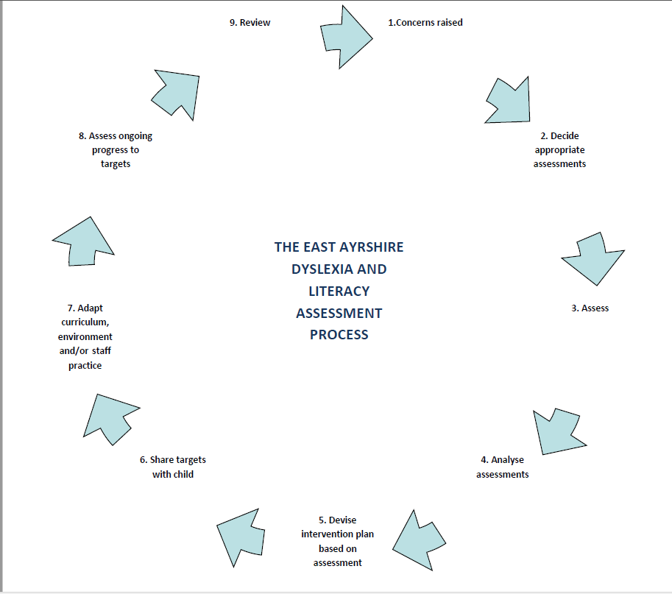
Appendix 2

Dyslexia Observation Profile
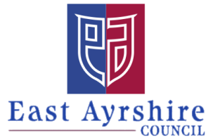
Early Level
Name of child |  | E.C.C or Establishment:
DoB: |  | Early Years worker or Class Teacher:
Stage: |  | Session:

General Development |  | Yes | No | Unsure | Comments
1 | Family history of dyslexia or difficulties with reading or spelling
2 | History of slow speech development / poor articulation
3 | Finds it difficult to find the correct word when talking
4 | Poor organisation skills (getting changed, school bag, desk/tray)
5 | History of hearing problems
6 | Poor co-ordination skills (gross and fine motor skills)
7 | Confusion between left and right
8 | Significant levels of frustration/ restless behaviour

Development of  Phonological Awareness |  | Yes |  | No |  | Unsure |  | Comments
1 | Can listen attentively
2 | Can keep a simple rhythm
3 | Can identify and generate rhyme |  |  |  |  |  |  | Please state whether identifying and/or generating
4 | Can distinguish words in a sentence orally
5 | Confuses syllables e.g. ephelant?
Literacy Development |  |  | Yes |  | No |  | Unsure |  | Comments
1. | Poor visual discrimination
2 | Shows an interest in reading
3. | Can recognise signs and labels within the environment
4. | Shows an interest in mark making/ drawing

Development of Comprehension/Talking & Listening |  | Yes | No | Unsure | Comments
1. | Shows an understanding of stories which have been read to him/her
2. | Contributes to discussions
3. | Can follow simple oral instructions
4. | Willingly and effectively joins in group activities

Numeracy Development |  | Yes | No | Unsure | Comments
1 | Has an understanding of positional language (under, above, on)
2 | Can sequence numbers orally
3 | Has an understanding of time sequences (today, tomorrow, yesterday etc)

Dyslexia Observation Profile
First and Second Levels
Name of child |  | Establishment
DoB |  | Class Teacher
Class |  | Date completed

General |  | Yes | No | Unsure | Comments
1 | Family history of dyslexia or difficulties with reading or spelling
2 | Displaying significant levels of frustration/ restless behaviour
3 | History of slow speech development / poor articulation
4 | Difficulty remembering and/or following instructions
5 | History of hearing problems
6 | Poor organisation skills (getting changed, school bag, desk/tray)
7 | Word finding problems when talking
8 | Confusion between left and right
9 | Poor co-ordination skills (gross and fine motor skills)
10 | Is often tired

Phonological Awareness |  | Yes | No | Unsure | Comments
1 | Can distinguish words in sentences
2 | Can distinguish the number of syllables in words
3 | Can hear the individual sounds or phonemes in a word
5 | Can recognise and generate rhyme |  |  |  | Please enter whether identifying and/or generating
6 | Can recognise and generate alliteration |  |  |  | Please enter whether identifying and/or generating

Reading |  | Yes | No | Unsure | Comments
1 | Reading is slow and hesitant
2 | Omits words or syllables when reading aloud
3 | Confuses letters that look similar (b/d, u/n/m/n)
4 | Confuses similar looking words e.g. for, from, form, of, off, them, then
6 | Reverses words (was/saw, on/no)
7 | Transposes words (left/felt)
8 | Loses the place when reading
9 | Lacks comprehension after reading
10 | Complains of letters or words moving on the page
11 | Difficulty with left to right visual scanning of text
12 | Can read big words but regularly misreads small words

Comprehension/Talking & Listening |  | Yes | No | Unsure | Comments
1 | Contributes to discussions about written text
2 | Contributes to general discussions
3 | Willingly and effectively joins in group activities

Spelling |  | Yes | No | Unsure | Comments
1 | Bizarre spelling errors that are hard to decipher
2 | Writes letters in the wrong sequence  (said/siad)
3 | Reverses letters or words  (was/saw)
4 | Omits letters
5 | Puts capital letters in the middle of a word
6 | Spelling is inconsistent – a word spelt several different ways in one piece of writing
7 | Can recall words in weekly spelling tests but is unable to retain them in class work

Writing |  | Yes | No | Unsure | Comments
1 | Marked difference between spoken and written language
2 | Handwriting is untidy and disjointed
3 | Experiences difficult when copying written work
4 | Loses the place when writing
5 | Has difficulty writing on lines
6 | Has difficulty sequencing/organising  Ideas
7 | Has difficulty with punctuation
8 | Lack of spacing in writing

Maths |  | Yes | No | Unsure | Comments
1 | Confuses similar numbers 9/6, 12/21
2 | Struggling with mental maths
3 | Has difficulty switching between mathematical processes
4 | Finds it difficult to remember times tables/ months of the year
5 | Has difficulty learning to tell the time

