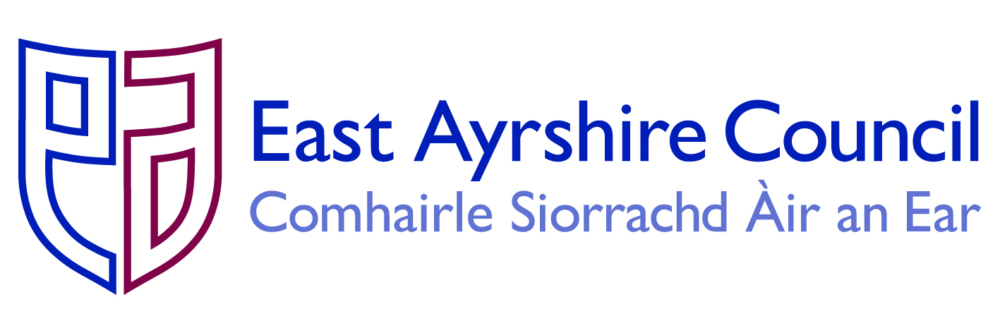

September 2021

Dear Parent/Carer,

FUN FAMILY LITERACIES
Fun literacy Activities for children, parents, grandparents and carers

We are pleased to offer families at New Cumnock Primary an exciting opportunity for you and your child/ren to take part in Vibrant Communities Fun Family Literacy workshops. Together as a family you will get to take part in a range of fun family literacy themed activities through our online Family Literacies YouTube channel.

Due to the pandemic, Vibrant Communities have adapted the way in which they deliver their workshops and have created YouTube clips which parents and children can access at a time that best suits.

Each programme is 4 sessions long and support packs are posted out to allow you to take part with your child/ren. Each workshop is pre-recorded on YouTube, so you can take part, at a time and day that suits you and your child/ren.

The workshops currently being offered are:

- The Hungry Caterpillar
- Roald Dahl
- Stop Animation
If you are interested in taking part, please complete the following Family Literacy Sign-up page at:
www.smartsurvey.co.uk/s/FamilyLiteracy2021/


Please contact Mrs Bradford on 01290 338404 at the school if you have any questions.

Kind regards,

