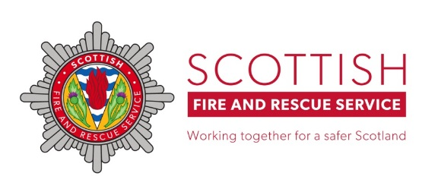
Dear Parents/Guardians,

As we approach the bonfire and firework season, Scottish Fire and Rescue Service and Police Scotland are working together to ensure the safety of our communities. In previous years, we have seen incidents of firework-related anti-social behaviour (ASB), and we are asking for your support in helping to prevent this.

Please take a moment to review the following guidance:

- Supervision: Children and young people should not handle, purchase, or set off fireworks.
- Behaviour: Do not allow your children to participate in or accompany others involved in ASB or disorder.
- Reporting: Please report any ASB or disorder you witness or hear about.
- Waste Disposal: Dispose of household and garden waste appropriately in the lead-up to bonfire weekend.
- Bonfire Materials: Report any large items (e.g. furniture, pallets) that could be used to build unauthorised bonfires to your local council for removal.
- Fireworks Sales: Report any unauthorised fireworks sellers to Police Scotland or Crimestoppers.
- Community Safety: Encourage young people to report fireworks misuse or deliberate fire raising anonymously via Fearless.org.

Fearless.org is a youth-focused platform run by Crimestoppers that empowers young people across Scotland to report crime anonymously and safely, helping to prevent antisocial behaviour and promote community safety.

Fireworks Legislation – Key Points:
- It is illegal for anyone under 18 to possess adult fireworks in a public place.
- It is an offence to supply adult fireworks to persons under 18.
- It is an offence to supply any fireworks to persons under 16.
- Throwing fireworks in public places, including roads, is strictly prohibited.

(Adult fireworks exclude caps, cracker snaps, indoor fireworks, novelty matches, party poppers, serpents, and throw downs.)

Our shared goal is to ensure that residents feel safe and protected during this period.

Any behaviour that endangers people or property will not be tolerated.

Thank you for your cooperation and continued support.

Kind regards,
Scottish Fire and Rescue Service
Police Scotland

POLICE SCOTLAND – 101
CRIMESTOPPERS – 0800 555 111
IN AN EMERGENCY – CALL 999
fearless.org

