Nether Robertland Primary – Session 2025/2026 Diary Dates
August |  | September |  | October
In-service Days | Monday 18th  Tuesday 19th | Parent Council AGM | Thursday 4th | Super Tattie’s Birthday – Themed Lunch | Thursday 2nd
Pupils Return | Wednesday 20th | House Captain Speeches | Friday 5th | Personal Learning and Achievement Assembly | Tuesday 7th
Meet the Teacher Week | Tuesday 26th to Friday 29th | Personal Learning and Achievement Assembly | Tuesday 9th | House Reward | Thursday 9th
 |  | P4 Bikeability – Introduction | Thursday 11th, 18th and 25th and 2nd and 9th October | School Fundraiser – Danceathon | Friday 10th
 |  | Class Yearly Overviews on Blogs | Friday 12th | October Holiday | Monday 13th to Friday 17th
 |  | September Holiday | Friday 19th | In-service Day | Monday 20th
 |  | September Holiday | Monday 22nd | Pupils Return | Tuesday 21st
 |  | Pupils Return | Tuesday 23rd | P5 Bikeability – Level 1 | Wednesday 22nd and 29th
 |  | Maths Week Scotland | Monday 22nd to Friday 26th | Come Dine With Me  Monday – Ash  Tuesday – Beech  Wednesday – Chestnut  Thursday – Hawthorn | Monday 27th to Thursday 30th
 |  | P1 Parent Workshop | Thursday 25th  5pm to 6pm | Pupil Flu Vaccination | Monday 27th
 |  | Macmillan Coffee Morning | Friday 26th  9.30am to 11.45am | Parents’ Afternoon | Wednesday 29th  3.30pm to 5.30pm
 |  |  |  | Halloween Disco | Thursday 30th  P1 – P3 - 6pm to 7.15pm  P4 – P7 - 7.30pm to 8.45pm
 |  |  |  | Wear a Halloween Costume | Friday 31st
 |  | Right of the Month – Article 7 |  | Right of the Month – Article 12
November |  | December |  | January
Parents’ Evening | Thursday 6th  6pm to 8pm | Reverse Advent Calendar | Monday 1st  to Tuesday 16th | Pupils Return | Monday 5th
Anti-Bullying Week – Power for Good! | Monday 10th to Friday 14th | Whole School Pantomime | Wednesday 3rd | Scots Language Week | Monday 19th to 23rd
Personal Learning and Achievement Assembly | Tuesday 11th | Choir to Morrisons | Thursday 4th | Burns Day – Themed Lunch | Friday 23rd
Children in Need – Wear Spots and Themed Lunch | Friday 14th | Personal Learning and Achievement Assembly | Tuesday 9th | Personal Learning and Achievement Assembly | Tuesday 27th
Book Week Scotland | Monday 17th to Friday 23rd | Christmas Concert | Tuesday 9th  Afternoon – 1.15pm to 3pm  Evening – 5.45pm to 7.30pm | Parental engagement events and school trip dates will be shared as soon as they are planned.  
P5 Day of Dance | Wednesday 19th | P7 pupils from P6/7D and P7H Christmas Party | Wednesday 10th
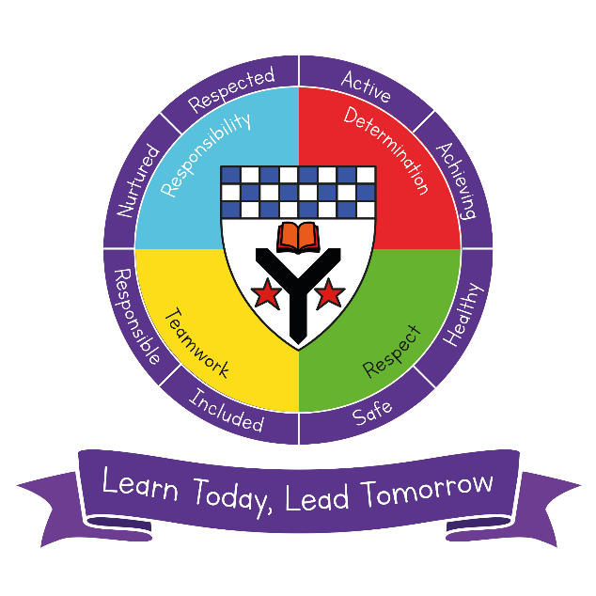 |  | P5MH, P6GM and P6 pupils from P6/7D Christmas Party | Thursday 11th
 |  | Christmas Lunch and Christmas Jumper Day | Friday 12th
 |  | Pupils Christmas Shopping Event | Monday 15th
 |  | P4H and P4W Christmas Party | Monday 15th
 |  | P3T and P3K Christmas Party | Tuesday 16th
 |  | P2S and P2P Christmas Party | Wednesday 17th
 |  | P1B and P1R Christmas Party | Thursday 18th
 |  | House Reward | Friday 19th
 |  | Dress as You Please –  Last day of term | Friday 19th  School closes 2.30pm
Right of the Month – Article 31 |  | Right of the Month – Article 24 |  | Right of the Month – Article 9
February |  | March |  | April
Scottish Assembly | Friday 6th | World Book Day | Thursday 5th | Spring Disco | Wednesday 1st
February Holiday | Monday 9th | World Book Day – Themed Lunch | Thursday 5th | House Reward | Thursday 2nd
In-service Day | Tuesday 10th | STEM and World of Work Fortnight | Monday 9th to Friday 20th | Report Cards | Thursday 2nd
Pupil Return | Wednesday 11th | Personal Learning and Achievement Assembly | Tuesday 10th | Last day of term – Dress as You Please | Thursday 2nd  School closes 2.30pm
Children’s Mental Health Week | Monday 9th to Friday 13th | Red Nose Day | Friday 20th  TBC | Easter Holiday | Friday 3rd – Friday 17th
Safer Internet Day | Wednesday 11th  (Adapted date) | Big Walk and Wheel Week | Monday 23rd to Friday 3rd April | Pupils Return | Monday 20th
Bring and Buy Sale | Thursday 19th |  |  | P7 Parents’ Information Evening | Thursday 23rd
 |  |  |  | P1 to P7 Photographs | Wednesday 22nd and Thursday 23rd
 |  |  |  | Personal Learning and Achievement Assembly | Tuesday 28th
Right of the Month – Article 21 |  | Right of the Month – Article 36 |  | Right of the Month – Article 28
May |  | June |  |   
P6 Bikeability – Level 2 | Thursday 30th April  Thursday 7th, 14^{th,} 21^{st,} 28th and last session on 4th June | Parents’ Evening | Tuesday 2nd  6pm to 8pm
May Day Holiday | Monday 4th | Sports Day | Tuesday 2nd  10.45am – P4 to P7  1.45pm – P1 to P3
Pupils Return | Tuesday 5th | P7 Freshers Disco | Thursday 4th
In-service Day | Thursday 7th | Personal Learning and Achievement Assembly | Tuesday 9th
P7 Residential Trip | Monday 18th to Friday 22nd | P7 Show | Thursday 11th  Afternoon – 1.30pm to 3pm  Evening – 6.30pm to 8pm
Super Hero Day – Themed Lunch | Thursday 21st  3.30pm to 9pm | Bump Up Day | Friday 12th
P7 Transition days | Wednesday 27th and Thursday 28th | End of Term Success Showcase | Monday 15th
Parents’ Afternoon  3.30pm to 5.30pm | Thursday 28th | Beach Themed Lunch | Thursday18th
 |  | House Reward | Thursday 25th
 |  | Last Day of the Session – Dress as You Please | Friday 26th  School closes at 1pm
Right of the Month – Article 28 |  | Right of the Month – Article 17

