P7 Homework – Monday 2nd March 2026

Spelling:

LI- To be able to say and spell commonly misspelled words accurately

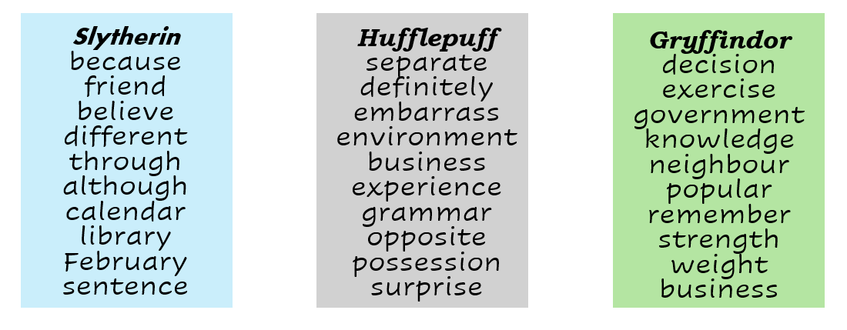

LCWC (3) then write a sentence using each of your words.

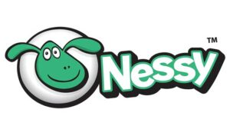
Maths and Numeracy:

LI- To be able to develop my accuracy in using the operations

Login to Nessy using the login card that has been printed off for you.
Then, complete 2 of the lessons in the maths application in Nessy!

Reading/Talking:

LI- To be able to develop my comprehension skills

Login to Nessy using the login card that has been printed off for you.
Then, complete 2 of the lessons in the reading application in Nessy!

