Primary 7B Homework Overview 16/2/25
Spelling | Reading | Numeracy and Mathematics
This week we are looking at the spelling of connectives.  Spelling List  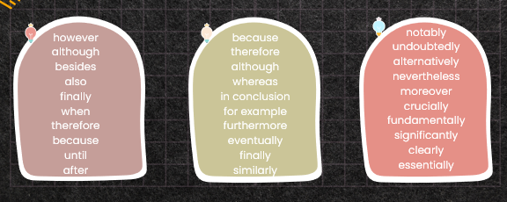  Spelling Task 1:  Copy each word 3 times in your spelling jotter – LOOK COVER WRITE CHECK (LCWC), using your spelling strategies to help remember each word.  Spelling Task 2:  Use each of the connectives in your spelling list in a sentence. (10 sentences).  Remember – in P7 you should be producing sentences of a high quality. Can you use adjectives or adverbs in your sentence? Can you use properly punctuated direct speech in your sentence? | Read this article on the CBBC newsround website:  https://www.bbc.co.uk/newsround/articles/czd0zg7y491o  LI- Understanding a factual text  Read the article on the CBBC website “Should Parents Be Banned From Using Mobile Phone in Play Centres?” (https://www.bbc.co.uk/newsround/articles/cx2j4e880vdo)  You can either read the article on your own or read it with someone at home.  Can you answer the following questions:-  1. What is the name of the play centre that has banned adults using?  2. Where is the play centre?  3. What do you think the word “confiscated” means?  4. What does the play centre want people to do instead of using their phones?  5. Do you think banning parents from using mobile phones at play centres in a good idea. Use opinion language when giving your views and justify your views by giving reasons. | In numeracy we have been working on Fractions, Decimals and Percentages!  Have a go at this game on Top Marks.    