Primary 7 Homework Overview 2/2/2026
Burns | Spelling & Numeracy
Well Done to everyone for the effort that you put in to learning your Burns’ poem and congratulations to our finalists.  We are looking forward to our Burns Supper on Friday which will conclude our Scots’ poetry focus. | In spelling we are working on the phoneme “w”.  In numeracy we have been learning about adding fractions.  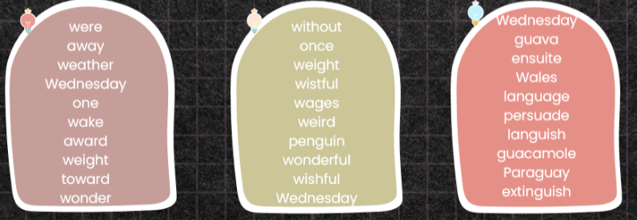  Tasks:  - LCWC (3 times)  - Use your own group’s words to write an interesting paragraph. Your paragraph should be at least 4 sentences long.  - Complete the adding fractions sheet that you have been given.

