P7A Homework – 26th January 2026

Spelling:
LI- To be able to say and spell “v” words accurately

Otto: lovely, living, five, even, give, above, we’ve, I’ve, they’ve, seventeen

Buster: you’ve, we’ve, they’ve, twelve, seventeen, active, remove, starve, heave, swerve

Ava: eventually, vain, vein, moreover, heavy, civilisation, adjective, grieve, halve, believe

LCWC (3) and then choose 1 activity from the sheet to complete – different one from last week.

Maths:
LI1- To be able to simplify fractions
LI2- To be able to convert improper fractions and mixed number fractions

Complete one of the fractions worksheets attached. Choose your own level and try and challenge yourself.

Reading/Talking:
LI- To be able to develop my accuracy and fluency in reciting poetry

Rehearse Burn’s Poem – Tam O’ Shanter
All:
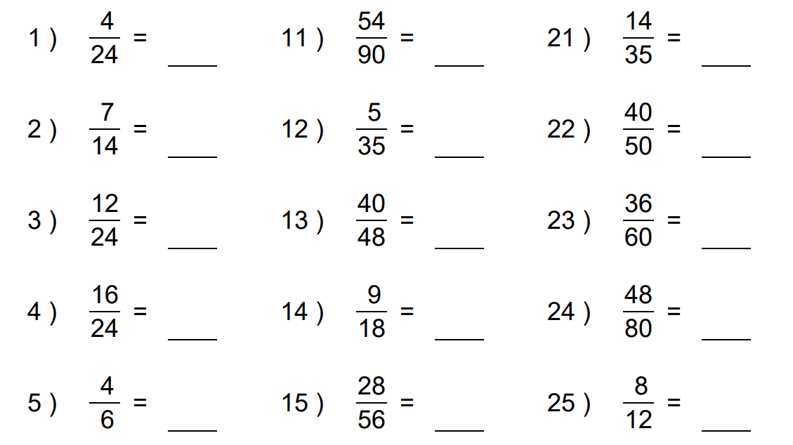

Some:
