Name: ​ ​ Date: ​

Tam O'Shanter: Critical Analysis

1. Deconstructing the Narrative

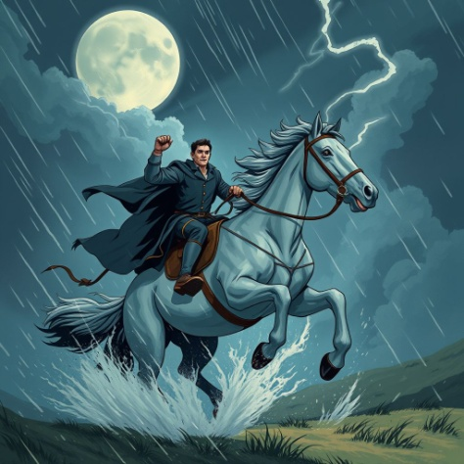 | Robert Burns crafted a narrative that moves from a cosy pub to a terrifying chase. Instead of simply retelling the story, analyse the structure of the plot.  Task: Identify the three key turning points in the narrative. Focus on cause and effect—how did one decision lead to the next?

Plot Stage | Event Analysis (What happened and why?)
The Inciting Incident
(Why was Tam on the road?)
The Climax
(The critical mistake)
The Resolution
(The price paid for escape)

2. Scots Language Detective 🏴󠁧​󠁢󠁳󠁣󠁴󠁿
Robert Burns wrote in Scots not just because it was his spoken language, but because it adds texture, rhythm, and authenticity to the tale.

Translate the following key terms into Standard English, then analyse their impact.

Scots Term | English Translation | Context (Where does this appear in the story?)
Kirk
Fou
Cutty-sark

Why do you think Burns chose to write this specific poem in Scots rather than Standard English? How does it change the 'sound' or mood of the poem?

3. Atmosphere & Setting

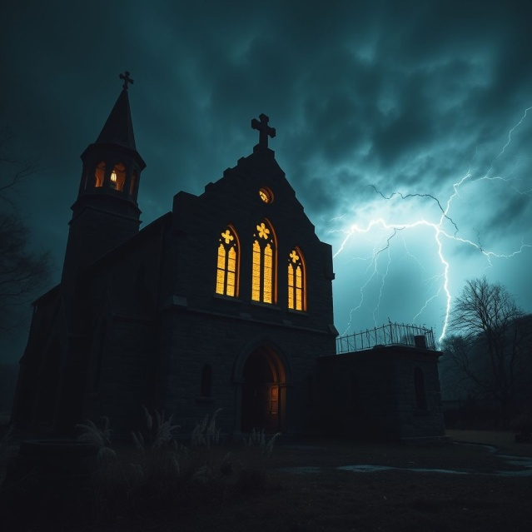
  🧠​ | Concept: Pathetic Fallacy  This is a literary technique where the weather or environment reflects the mood of the story or the character's internal feelings.
  How does the storm outside mirror the events happening inside the Kirk? Explain the connection.

4. Evaluate the Characters
Tam is the protagonist, but is he a hero? Critically evaluate the actions of the characters.

"Tam's escape was due to luck, not bravery."

To what extent do you agree with this statement? Justify your answer with evidence from the plot.

Meg the horse suffers a permanent physical injury (losing her tail) because of Tam's mistake. What might Burns be suggesting about the consequences of reckless behaviour?

5. The Official Record: Incident Report
Imagine the morning after the events. You are the Constable of Ayr. You must write a Formal Incident Report based on Tam's rambling statement.

Challenge: Translate the supernatural chaos into formal, objective language (e.g., instead of "monsters dancing," use "suspected disturbance of the peace").

INCIDENT REPORT: ALLOWAY KIRK

Reporting Officer: Constable [Your Name]

Summary of Events:

Damage Report (Property/Animals):

Answer Key

2. Scots Language Detective 🏴󠁧​󠁢󠁳󠁣󠁴󠁿
Answers should mention authenticity, rhythm, or the ability of Scots to sound more expressive, spooky, or humorous than formal English.

3. Atmosphere & Setting
The chaos of the wind and lightning mirrors the wild, chaotic dancing of the witches inside. It builds tension before the chase.

4. Evaluate the Characters
Students should identify that Meg did the work/running, and Tam's only action was a foolish shout. He survived because of the horse and the running water rule, not his own skill.

It suggests that our reckless actions often hurt those who support us (innocents) rather than just ourselves.

5. The Official Record: Incident Report
Answer:
Model answer would use formal tone: 'Subject T. O'Shanter alleged observing illegal gathering at ruins. Suspect 'Nannie' pursued subject to Doon Bridge. Subject's horse sustained injury (amputation of tail).'

