Name: ​ ​ Date: ​

Tam O'Shanter: Homework Activity

1. The Tale of Tam

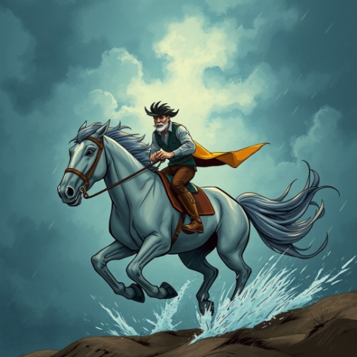 | Robert Burns' famous poem tells the story of a man who stayed too late at the pub and had a terrifying journey home.  Instructions: Read the passage below and fill in the blanks using the word bank to complete the summary of the story.

Word bank: Ayr, tail, Nannie, Kirk, storm, bridge

Tam O'Shanter was drinking with his friends in the town of __________ and lost track of time. When he finally left, he had to ride his horse, Meg, through a terrible thunder __________.

On his way home, he rode past Alloway __________, an old church where he saw witches and warlocks dancing. He foolishly shouted at a witch named __________ because she was wearing a short shirt. The witches chased him, but he escaped by crossing the __________ over the river. Sadly, poor Meg lost her __________ to the grasping witch!

2. Scots Language Detective 🏴󠁧​󠁢󠁳󠁣󠁴󠁿
Robert Burns wrote in Scots to make his characters sound real and lively. Match the Scots words from the poem to their English meanings.

Word Bank: Kirk, Fou, Guid, Cutty-sark

 | Definition | Word
1. | A church (where Tam saw the witches)
2. | Drunk or very full
3. | Good
4. | A short shirt or petticoat

3. Character Thinking
Think about the choices the characters made that night. Answer the questions below in full sentences.

Tam is described as a hero by some, but foolish by others. Why do you think he shouted "Weel done, Cutty-sark!" when he should have stayed quiet?

Meg the horse is the only innocent character in the story. How did she show bravery during the chase?

4. Witness Report: The Chase
Imagine you are the local police officer in Ayr the next morning. Tam has come to report the attack. Fill in the details for the Wanted Poster based on Tam's description.

Suspect Name: | Nannie (The Witch)
Last Seen At:
Distinguishing Features:
(What was she wearing?)
Warning to Public:
(What do the witches do at night?)
Answer Key

1. The Tale of Tam
Cloze:
Tam O'Shanter was drinking with his friends in the town of Ayr and lost track of time. When he finally left, he had to ride his horse, Meg, through a terrible thunder storm.

On his way home, he rode past Alloway Kirk, an old church where he saw witches and warlocks dancing. He foolishly shouted at a witch named Nannie because she was wearing a short shirt. The witches chased him, but he escaped by crossing the bridge over the river. Sadly, poor Meg lost her tail to the grasping witch!

2. Scots Language Detective 🏴󠁧​󠁢󠁳󠁣󠁴󠁿
Vocabulary Practice:
1. Kirk
2. Fou
3. Guid
4. Cutty-sark

4. Character Thinking
Answers will vary. Students might suggest he was drunk (fou) and forgot the danger, or that he was so amazed by the dancing he couldn't help himself. It shows he is a bit reckless.

She carried Tam safely through the storm and the witches. She ran as fast as she could to the bridge and sacrificed her own tail to save her master.

5. Witness Report: The Chase
Last Seen: Alloway Kirk. Features: Wearing a short shirt (cutty-sark). Warning: They dance in the ruins and chase travellers.

