Primary 7 Homework Overview 12/1/2026
Burns | Spelling & Reading
Our focus for the month of January will be Burns and Poetry! Our P7 poem is: Tam O’ Shanter.  We are looking for 2 finalists from each class for the final with the rest of the school. However, this doesn’t mean only 2 of you have to learn and recite your poem. We will also be using the poem as our first listening and talking assessment this term  We know that not everyone feels confident presenting at the Burns Supper. Please don’t worry. We can do this in class. See below for things your teacher will be looking for in the assessment.  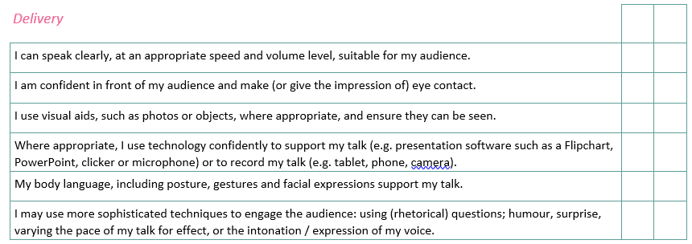 | 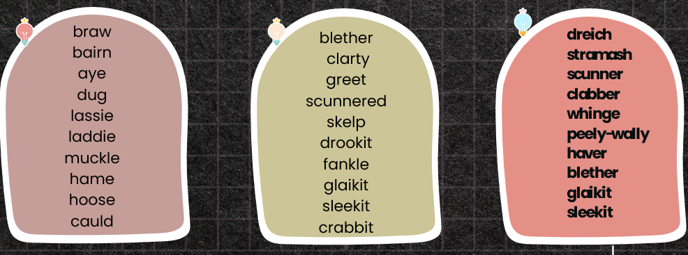  Tasks:  - LCWC (3 times)  - Use any of the Scots words given this week to write an interesting paragraph. Your paragraph should be at least 4 sentences long.  - Complete the Tam O’Shanter Homework Activity you have been given.

An Extract from Tam o’Shanter – Robert Burns

When chapman billies leave the street,
And drouthy neebors neebors meet,
As market-days are wearing late,
And folk begin to tak the gate;
While we sit bousin, at the nappy,
And gettin fou and unco happy,
We think na on the lang Scots miles,
The mosses, waters, slaps, and stiles,
That lie between us and our hame,
Whare sits our sulky, sullen dame,
Gathering her brows like gathering storm,
Nursing her wrath to keep it warm.

This truth fand honest Tam o' Shanter,
As he frae Ayr ae night did canter:
(Auld Ayr, wham ne'er a town surpasses,
For honest men and bonny lasses.)

**********

But to our tale:—Ae market night,
Tam had got planted unco right,
Fast by an ingle, bleezing finely,
Wi' reaming swats that drank divinely;
And at his elbow, Souter Johnie,
His ancient, trusty, drouthy crony:
Tam lo'ed him like a vera brither;
They had been fou for weeks thegither.
The night drave on wi' sangs and clatter;
And ay the ale was growing better:
The landlady and Tam grew gracious
Wi' secret favours, sweet, and precious:
The souter tauld his queerest stories;
The landlord's laugh was ready chorus:
The storm without might rair and rustle,
Tam did na mind the storm a whistle.

Care, mad to see a man sae happy,
E'en drown'd himsel amang the nappy:
As bees flee hame wi' lades o' treasure,
The minutes wing'd their way wi' pleasure;
Kings may be blest, but Tam was glorious,
O'er a' the ills o' life victorious!

But pleasures are like poppies spread,
You seize the flow'r, its bloom is shed;
Or like the snow falls in the river,
A moment white—then melts forever;
Or like the borealis race,
That flit ere you can point their place;
Or like the rainbow's lovely form
Evanishing amid the storm.
Nae man can tether time or tide:
The hour approaches Tam maun ride,—
That hour, o' night's black arch the key-stane
That dreary hour he mounts his beast in;
And sic a night he taks the road in,
As ne'er poor sinner was abroad in.

