Primary 7 Homework Overview 03-03-25
Spelling | Maths and Numeracy | Topic/IDL
LI- The phoneme “v”  Spelling List  China: very, every, volcano, seventeen, you’ve, twelve, village, favourite, halve, above  Germany: village, vision, voice, eventually, moreover, massive, adjective, captive, grieve, believe  Saudi: village, adjective, eventually, violin, vacuum, aardvark, adaptive, advantageous, cardiovascular, creatively  Spelling Task 1:  Copy each word 3 times in your spelling jotter – LOOK COVER WRITE CHECK (LCWC), using your spelling strategies to help remember each word.  Spelling Task 2:  Use your spelling words to write a paragraph about one of the following topics:  Natural Disasters or Drongan | LI- To be able to develop my skills using the different operations  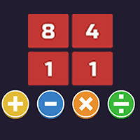  https://www.coolmathgames.com/0-number-solver  INSTRUCTIONS:  -google cool maths games  -click numbers section for games  -multiplication games  -24 number solver | Over the next 5 weeks, you are tasked to create your very own model volcano.  Please do not go out and buy things for this task. Try and use recycled material and if you require any extra materials, ask your teacher if they can help!  DUE FOR 24th MARCH 2025!  