Primary 7 Homework Overview 4.2.25
Spelling | Writing | Numeracy and Mathematics
This week we have explored different ways the sounds ‘s’ can be represented.  LI- To say and spell persuasive words accurately  Spelling List  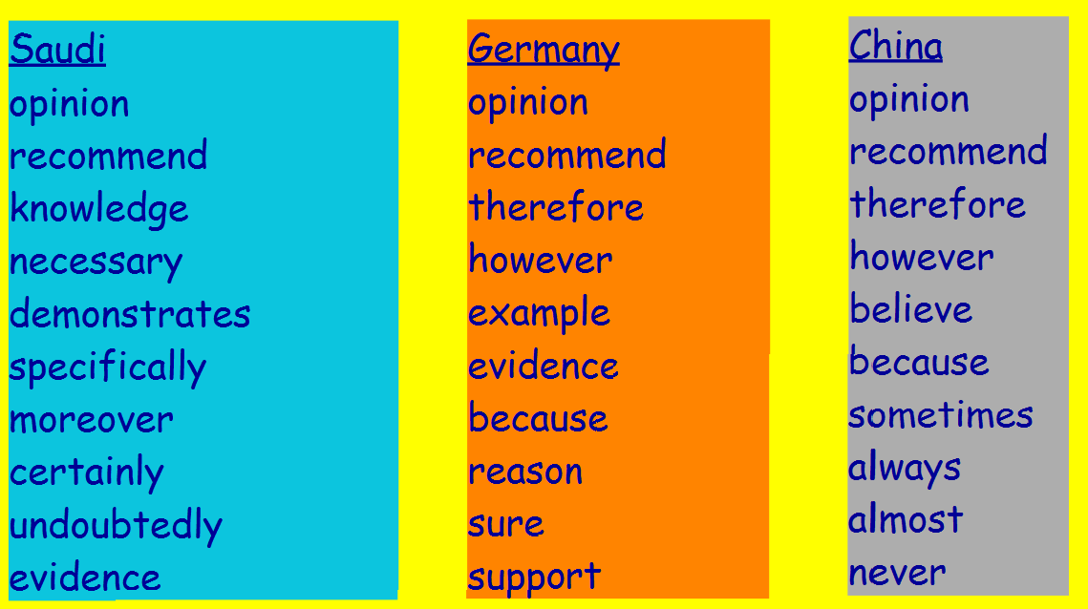  Spelling Task  Copy each word 3 times in your spelling jotter – LOOK COVER WRITE CHECK (LCWC), using your spelling strategies to help remember each word.  . | L.I. Using persuasive language  Write 6 sentences using persuasive language to give your opinion on a subject.  Use the poem Tam O’Shanter as inspiration for your writing.   | LI- addition of 3 numbers  Complete the magic square below. All rows (horizontal, vertical and diagonal must add up to the same number) Can you identify the magic number?  