Primary 7 Homework Overview 18/09/23
Spelling | Reading | Numeracy and Mathematics
Spelling Homework Jotter  This week we are learning a new set of common words  Copy each word 3 times in your spelling jotter, using your spelling strategies to help remember each word.  Spelling Task:  Record the activity below in your spelling jotter.  We are working on diacritical marking in class. A single sound is shown by a dot, a joined phoneme by a line and a split phoneme by a rainbow.  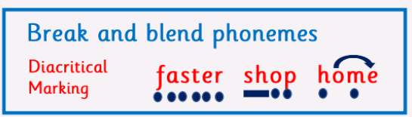  Choose 5 of your spelling words to diacritically mark. | Reading Homework  Bug Club  Please read to the end of your Bug Club book.  - | In class we have been developing our skills in using the four operations.  Please follow the QR code to play a mental maths game.  Practise all 4 operations and challenge yourself when choosing which times tables to work on.

