Primary 7 Homework Overview 11/09/23
Spelling | Reading | Numeracy and Mathematics
Spelling Homework Jotter  This week we have explored different ways the sounds ‘j’ can be represented.  Copy each word 3 times in your spelling jotter, using your spelling strategies to help remember each word. Have a look at the spelling strategies below!  Spelling Task:  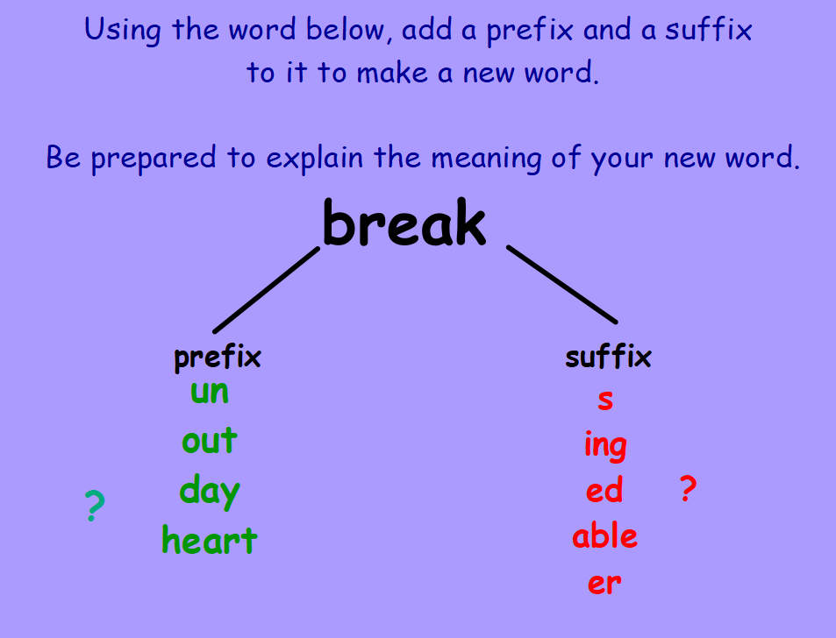  Record the activity below in your spelling jotter.  Challenge: Can you add a prefix or suffix to any of your spelling words? Record in your results. | Reading Homework  Bug Club  Please read as much of your reading book as you would like to. I hope that you are enjoying the story. | In class this week we will be working on our 8 times table. Follow this QR code to play “Hit the Button”. Select 8 times table questions. Try to beat your own score.

