Primary 6 Homework Overview 16/09/24
Spelling | Reading | Numeracy and Mathematics
Spelling Homework Jotter  Copy spelling words x3  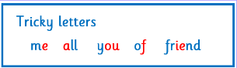  Do any of your spelling words from this week have a tricky part that you find hard to remember? Can you create a mnemonic to help you remember this part and this word?  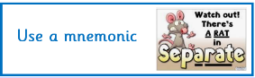  *If you want to challenge yourself, can you make mnemonics for more than one word?  Green Orange Red  laughter calmly halves satisfied salmon palm behalf pattern attach answer aunt laugh calm half happened battle began traffic pattern calmly have after father another about task happy animal carry began | Please see Reading Pages. | Times Tables  Scan the QR code to take you to websites to practise your times tables!  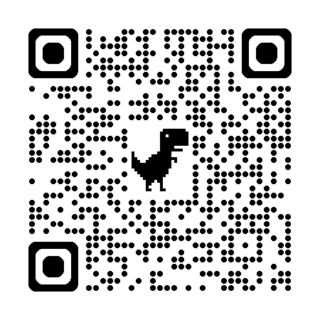  Can you copy and complete the multiplication grids? Use your knowledge of times tables to help you!  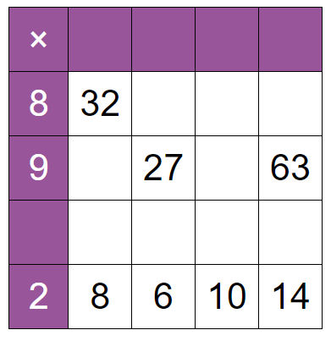  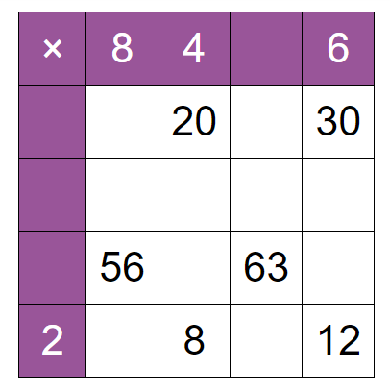
Spelling List (16th September 2024)
Green | Orange | Red
laughter  calmly  halves  satisfied  salmon  palm  behalf  pattern  attach  answer | aunt  laugh  calm  half  happened  battle  began  traffic  pattern  calmly | have  after  father  another  about  task  happy  animal  carry  began

