Primary 6 Homework Overview 02/09/24

Each week, homework tasks will be posted on the class blog. To access the blog, scan the following QR Code or click on this link;

<https://blogs.glowscotland.org.uk/ea/mrsmitchell/>

Download the word document to your device to open links. Please keep this overview for reference.

|  |  |  |
| --- | --- | --- |
| Spelling | Reading | Numeracy and Mathematics |
| Spelling Homework Jotter  This week we have explored different ways the sounds **‘ai’** can be represented.  Copy each word **3 times in your homework jotter**, using your spelling strategies to help remember each word. Have a look at the spelling strategies below!  **Spelling Task**  Record the activity below in your spelling jotter.    Challenge: Can you add a prefix or suffix to any of your spelling words? Record in your results | Read allocated pages. | Times Tables Rock Stars  Primary 6 and 7 are taking part in a free trial, and a competition. Use the QR code, or the link below (if using school blog), to access the game.  <https://ttrockstars.com/schools/>    **Us**  Username: ­_______________  Password: _______________ |

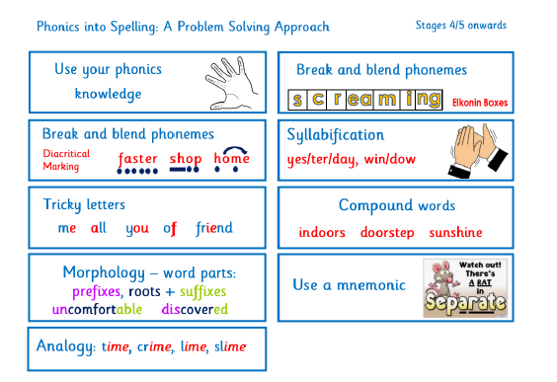Spelling List 02/09/24

|  |  |  |
| --- | --- | --- |
| RED | YELLOW | GREEN |
| aim  rain  train  paint  paid | their  eight  where  table  April  breakfast  valley  they  crayon  today | straighten  aeroplane  beige  reign  dangerous  angel  breakable  greatness  disobey  Ayrshire |